Supplementary
S1 Preparation of samples, chromatographic and mass spectrometry (MS) conditions
Blank-free plasma and serum samples were stored at -80°C, thawed, spiked with MTX, 7-OH-MTX and the internal standard (MTX-d₃) and protein precipitated with methanol. Samples were centrifuged at 10,000g for 10 minutes, the supernatant removed and dried in a concentrator (Eppendorf concentrator plus) at room temperature and reconstituted in 50µl water prior to LC-MS/MS analysis. An autosampler auto-injector (Agilent 1200 series Autosampler with Thermostat, Cheadle, UK) was used to inject 5µl of sample. Chromatographic separation was performed using a Thermo Scientific Hypersil GOLDTM HPLC column maintained at 25°C on an Agilent 1200 series HPLC on-line to the MS (Agilent® 6460 triple quadrupole). The mobile phase consisted of acetonitrile (ACN) with 0.1% formic acid (B) as the organic component and water with 0.1% formic acid at the aqueous phase (A), the gradient elution timetable is shown in Table S1.
Time after injection (min) | Buffer A (%) | Buffer B (%)
0.00 | 92 | 8
1.00 | 92 | 8
4.00 | 50 | 50
5.50 | 50 | 50
5.60 | 5 | 95
8.00 | 5 | 95
8.21 | 92 | 8
11.00 | 92 | 8
Table S1. Gradient elution timetable.
The MS operated in positive ion mode and MTX/7-OH-MTX were detected using the following SRM transitions: 455.1 > 308.1 for MTX, 471.1 > 324.1 for 7-OH-MTX, and 458.1 > 311.1 for MTX-d₃ as described previously (1).
S2 MTX Assay Optimisation and Re-evaluation of Adherence Measurement
The HPLC-SRM-MS assay was optimised by discarding 7-OH-MTX measurement and increasing the MTX transition dwell time. The subsequent LLOQ of the optimised assay was 0.1 nM with precision (CV%) ≤3.5%, accuracy was within ±20% and signal:noise ratio > 10 in serum and plasma.
S3 Recruitment flow chart for the MEMO study from RAMS
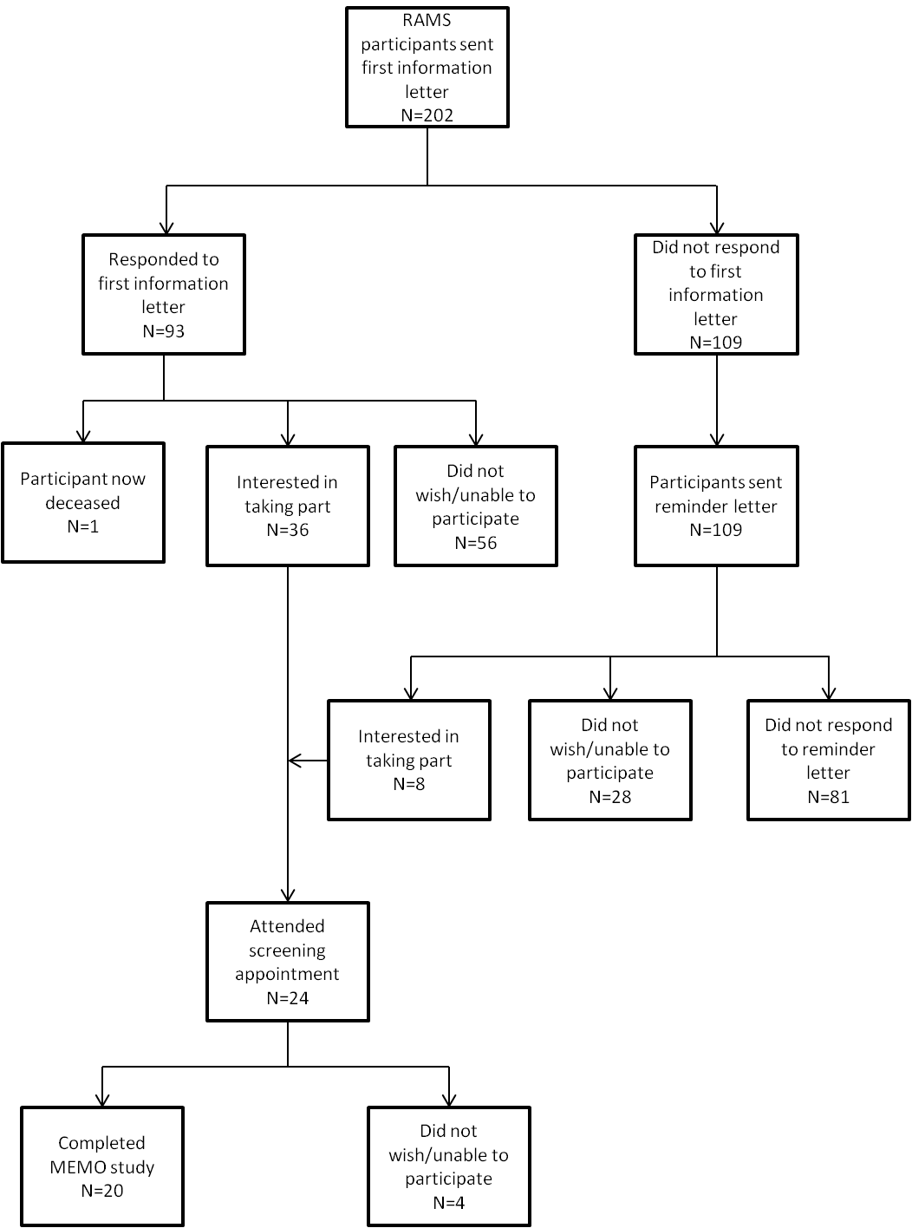

S4. Compartment models used to fit the plasma data for MTX and 7-OH-MTX. 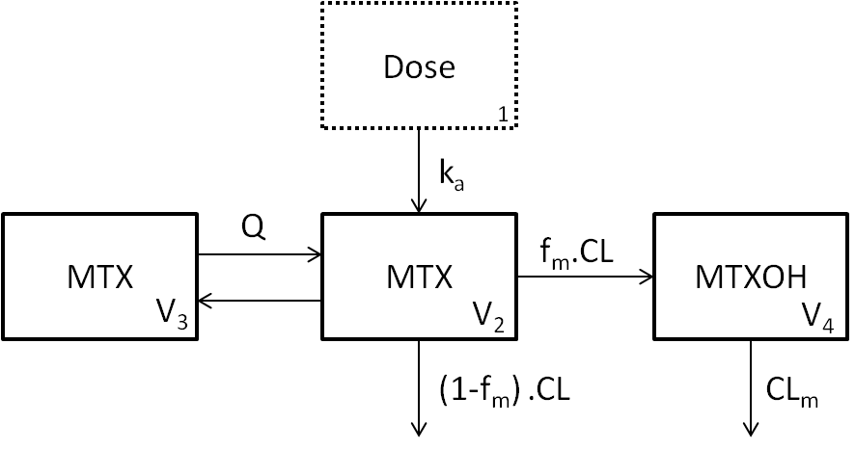
K_{a} = absorption rate constant, CL = apparent MTX clearance, CL_{m} = apparent 7-OH-MTX clearance, V = volume of distribution, f_{m} = apparent fraction of MTX converted to 7-OH-MTX and Q = intercompartmental clearance. Compartment V4 was not structurally identifiable therefore apparent formation and clearance of 7-OH-MTX were estimated (f_{m}/V4 and CL_{m}/V4 respectively).
S5. Population mean results from the pharmacokinetic modelling and the amount of variability within the model that is explained by each parameter.
Parameter |  | Estimate | Relative Standard Error (%)
Population mean
 | CL/F (l/h) | 6.75 | 7.0
 | V₂/F(l) | 30.3 | 9.9
 | Q/F (l/h) | 0.449 | 20.2
 | V₃/F(l) | 65.8 | 46.0
 | k_{a} (h⁻¹) | 1.19 | 24.1
 | f_{m}/V₄ (l⁻¹) | 0.00439 | 15.4
 | CL_{m}/V₄ (h⁻¹) | 0.0563 | 8.2
Variability (CV%)
 | CL/F | 20.2 | 49.0
 | V₂/F | 24.2 | 63.2
 | Q/F | 36.3 | 79.0
 | V₃/F | 45.7 | 116.0
 | k_{a} | 42.3 | 107.0
 | f_{m}/V₄ | 57.8 | 41.6
 | CL_{m}/V₄ | 22.4 | 60.0

CL = clearance. F = bioavailability. Q = intercompartmental clearance. V = apparent volume of distribution. Ka = absorption rate coefficient, fm = apparent fraction of MTX converted to 7-OH-MTX, CLm = apparent clearance of 7-OH-MTX.
Supplementary S6. Simulated data of 1,000 hypothetical individuals showing the proportion of subjects with predicted concentrations of MTX above the LLOQ following ingestion of 5mg (a), 7.5mg (b), 10mg (c), 12.5mg (d), 15mg (e), 17.5mg (f) and 20mg (g) MTX orally given LLOQ values as shown in the inserted box.
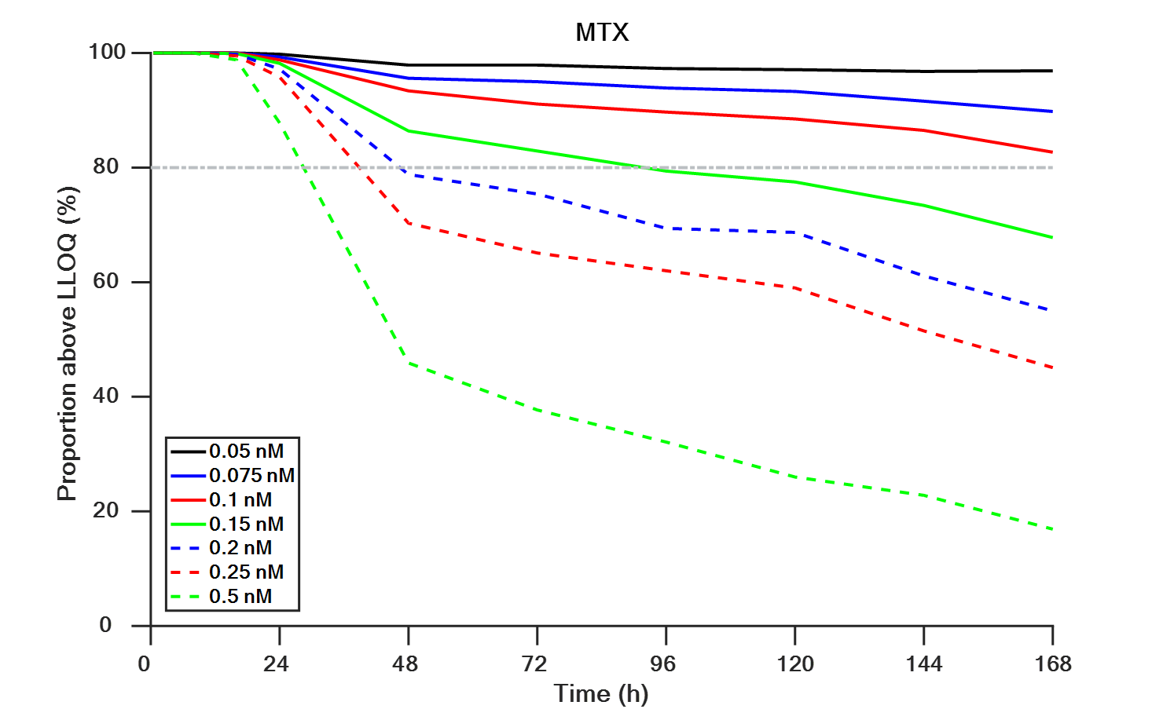S6a)
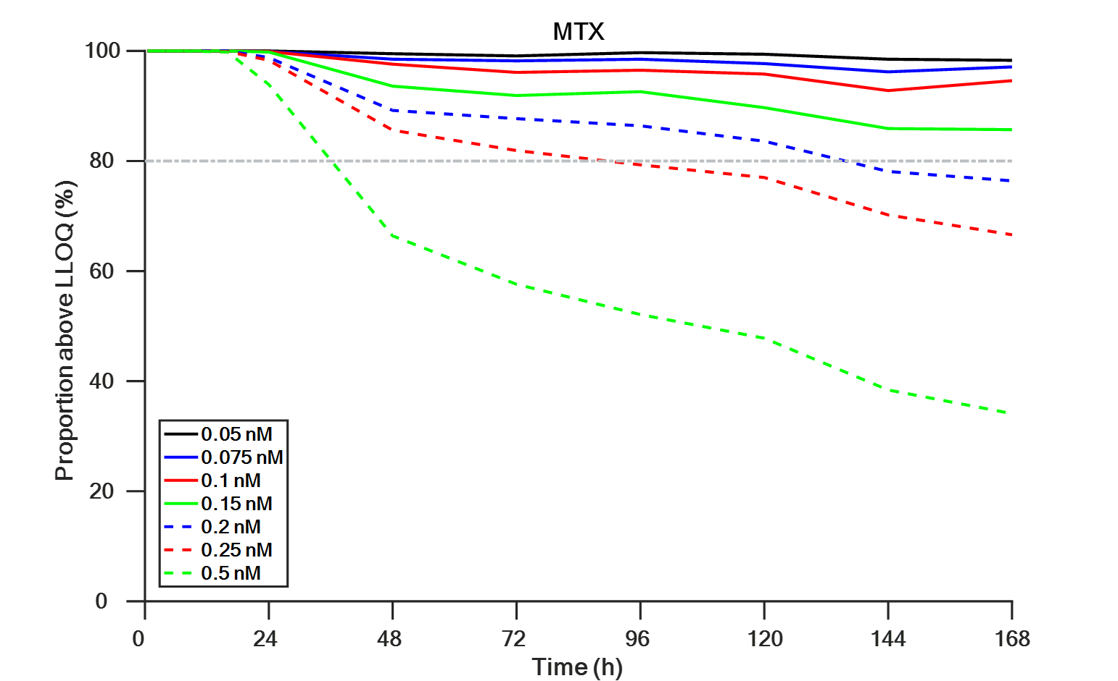S6b)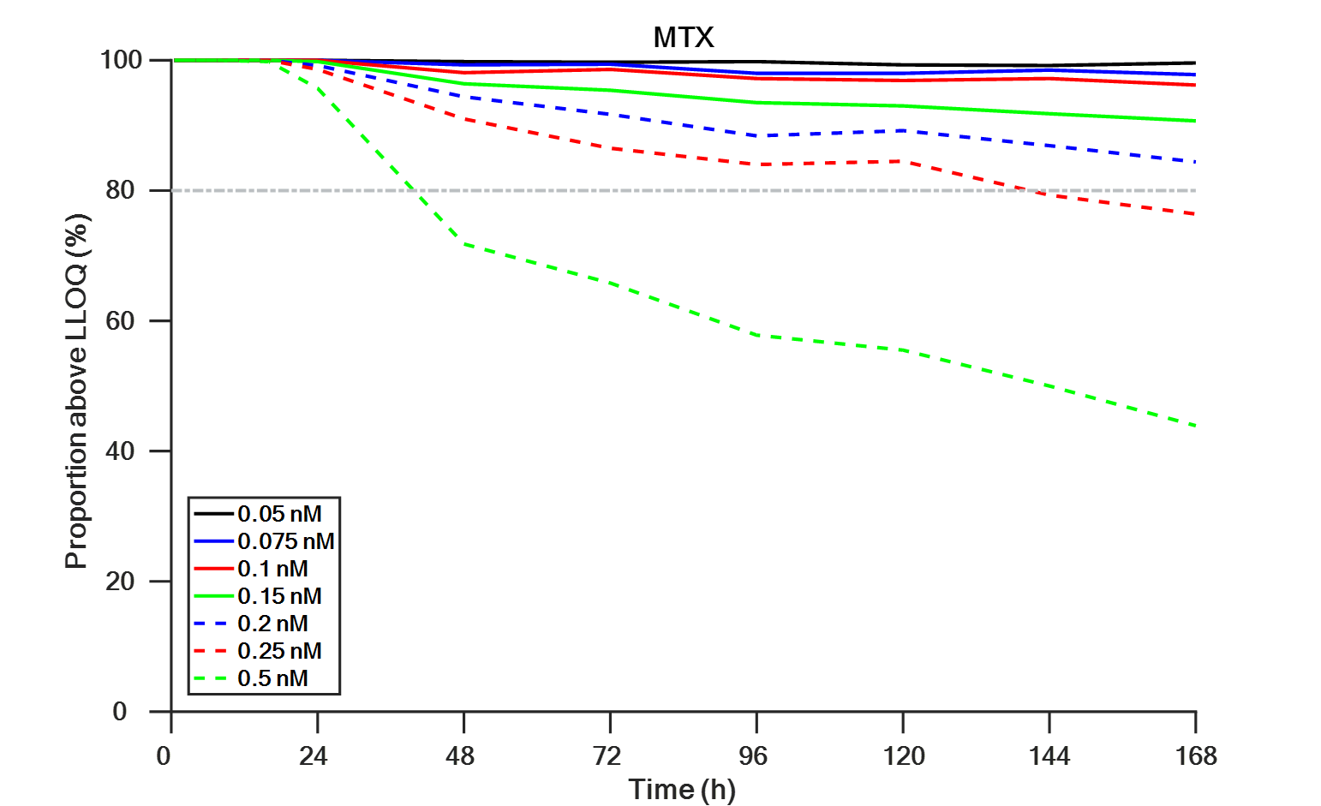S6c)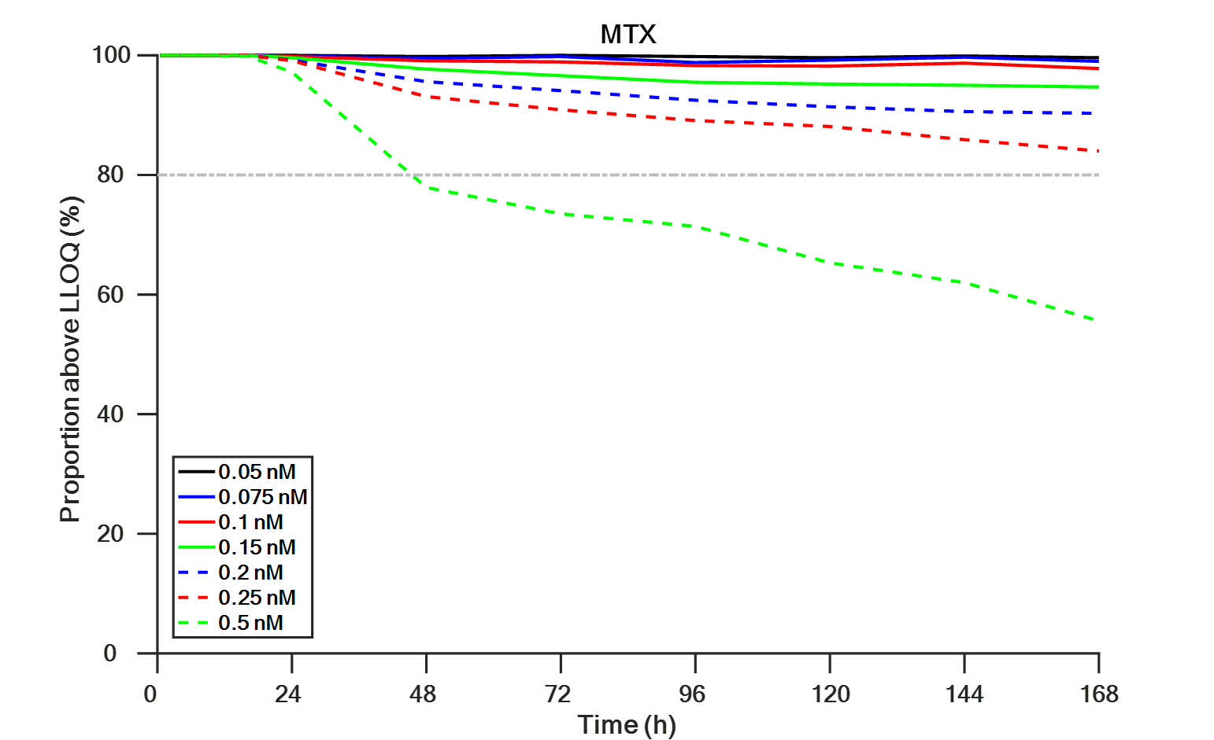S6d)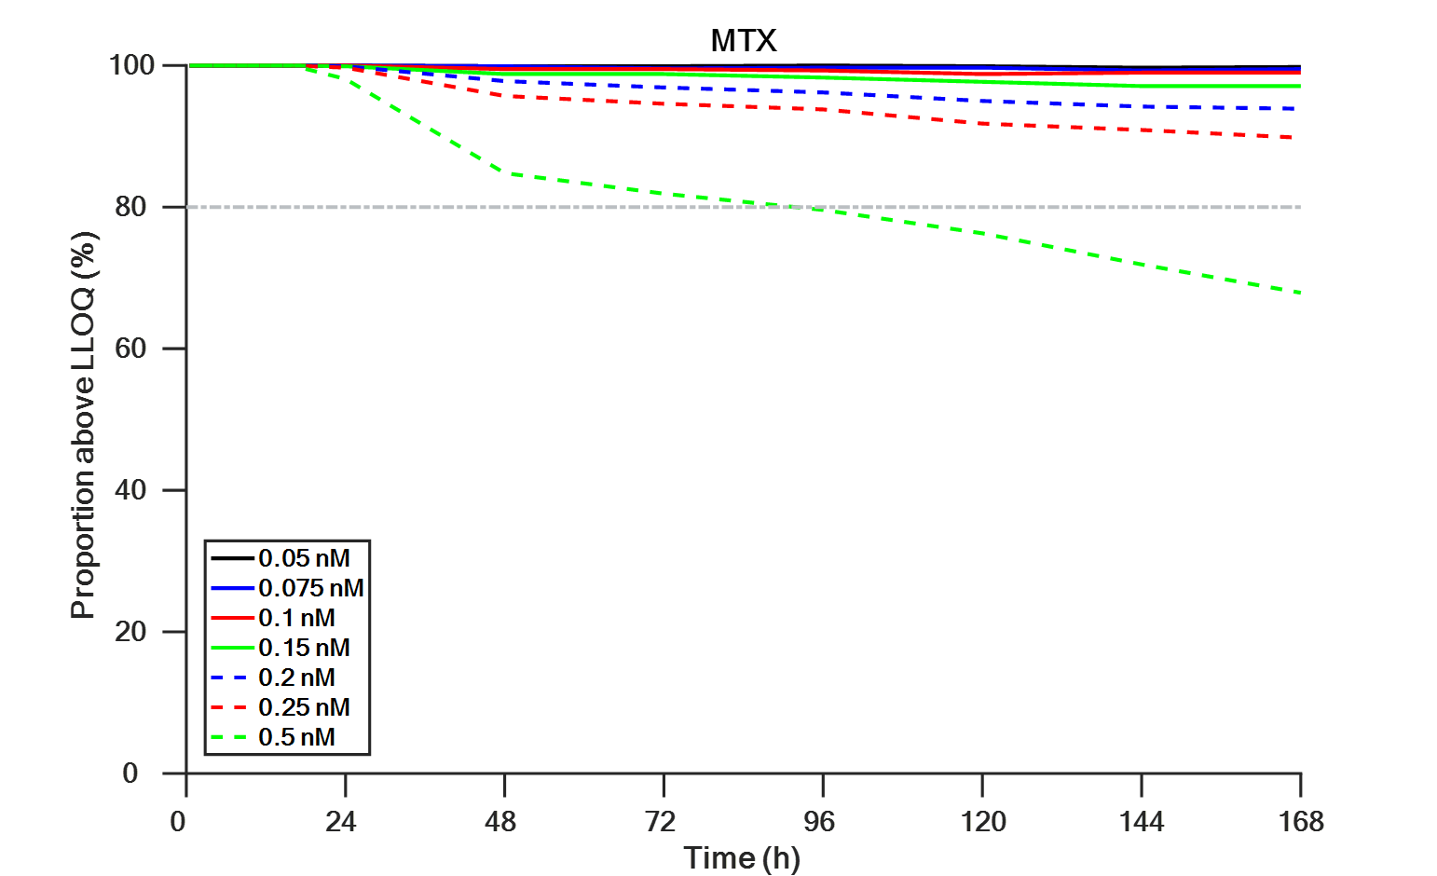S6e)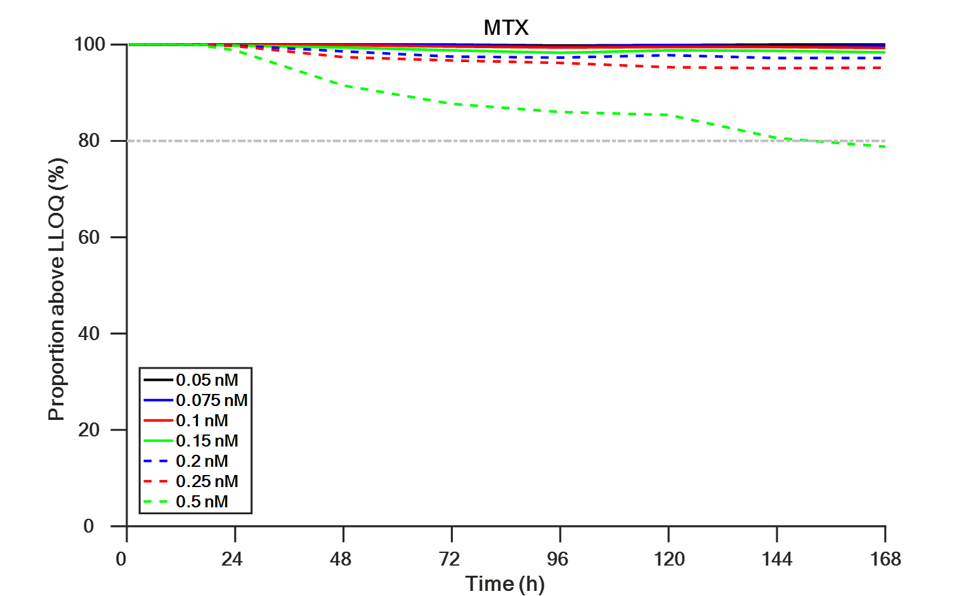S6f)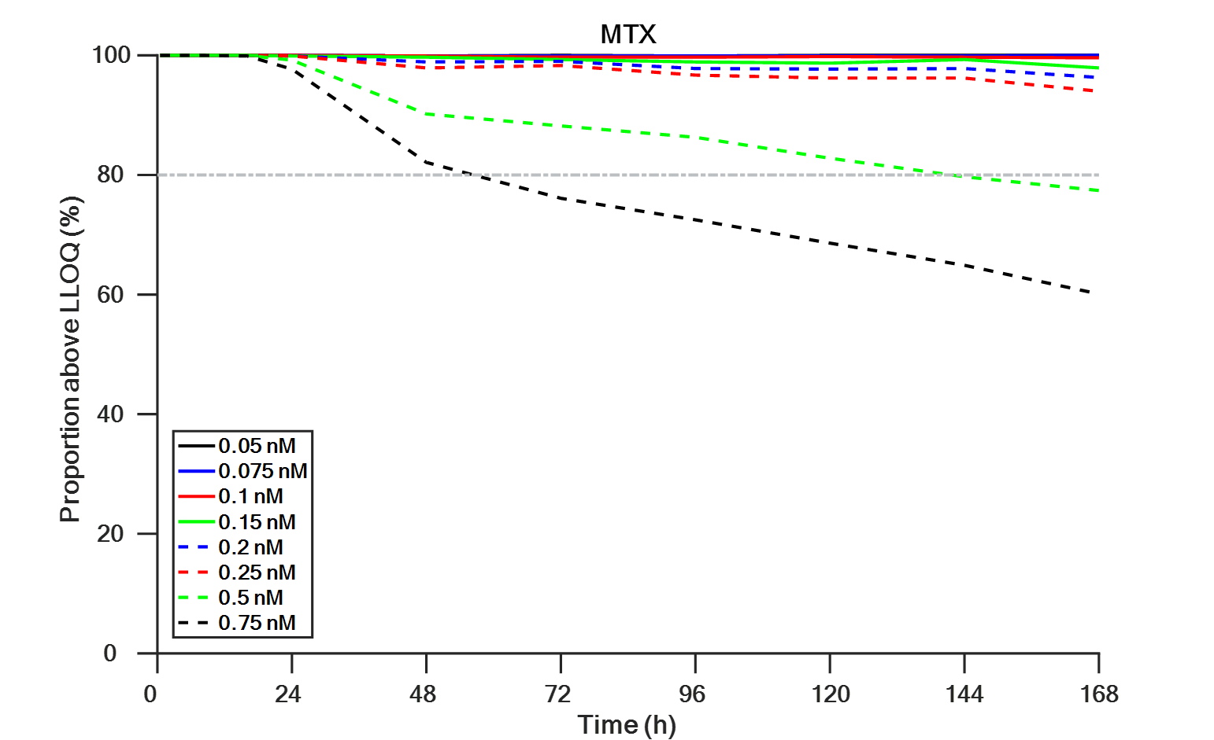S6g)

Supplementary References
1. Bluett J, Riba-Garcia I, Hollywood K, Verstappen SMM, Barton A, Unwin RD. A HPLC-SRM-MS based method for the detection and quantification of methotrexate in urine at doses used in clinical practice for patients with rheumatological disease: a potential measure of adherence. Analyst. 2015;140(6):1981-7.

