SUPPLEMENTARY METHODS
Mice
The animal facility of Biomedical Sciences Research Center (BSRC) “Alexander Fleming” was under a 12:12-h light/dark cycle at a constant temperature of 22 ± 2 °C and relative humidity of ~60%. For anti-TNF treatment, Tg197 mice were treated twice weekly from 4 to 11 weeks of age with 10mg/kg Remicade (Infliximab, Janssen Biotech). All mice were handled according to the guidance of the Institutional Animal Care and Use Committee of BSRC “Alexander Fleming”. All mice were observed for morbidity and euthanized when needed according to animal welfare guidelines. Experimental termination time points were set to a maximum of 12 weeks of age, except for the case of the survival curve experiment, where the mice were not sacrificed until their mortality reached 50%.
Antibodies
Antibodies used for immunohistochemistry included: Gr-1, F4/80 (MCA2387GA; MCA497, AbD Serotec), B220 (553084, BD Pharmigen), CD3 (ab1669, Abcam). Antibodies used for FACS or immunofluorescence included: CD45 (103128), CD31 (102420), CD90.2 (105316), CD105 (120414), Podoplanin (127411), CD106/VCAM-1 (105717) and PDGFRa/CD140a (135905) from Biolegend, CD29 47-0291-80, eBioscience) and CD54/ICAM1 (553253, BD Pharmigen). For intracellular stainings, the antibody used was Vimentin (ab92547, Abcam).
Histological analysis, Immunohistochemistry and immunofluorescence
Paraffin-embedded transverse heart, aortic and lung sections were stained with Hematoxylin/Eosin (H&E) staining, Masson’s Trichrome staining and with specific antibodies in combination with the Vectastain Elite ABC HRP and the Vectastain DAB kits (Vector Laboratories) and images were acquired with Leica DM2500 microscope equipped with Leica SFL4000 camera (Leica Microsystems). Heart transverse OCT cryosections were imaged using a TCS SP8X White Light Laser confocal system (Leica).
Quantification of valvular thickness
To quantify adult valve thickness, the widest portion of the valve leaflets was measured in H&E- stained transverse heart sections using the ImageJ software (NIH). Four independent measurements were taken per leaflet in a blinded to the genotype fashion from 3 consecutive sections. The values were averaged and a minimum of three animals were used per genotype for statistical analysis.
Echocardiography and Electrocardiography
Echocardiography assessment was performed in the Department of Pharmacology, Medical School NKUA, Greece as previously described.¹ Briefly, mice were sedated with intraperitoneal injection of ketamine-midazomal cocktail and, after chest hair removal, they were placed on a heated platform to maintain the body temperature at 37ᵒC. Echocardiographic images in parasternal short and long axes were acquired using a Vivid 7 version Pro ultrasound system (GE Healthcare, Wauwatosa, Wisconsin), equipped with a 14.0-MHz probe (i13L). Recordings were made when heart rate was 300-450 BPM, in a blinded to the genotype fashion. Parameters assessed include LVEDd, LVEDs, LVLd, LVPWd, IVSd, SVPW, LA and were measured using 2D images. The modified Simpson equation was used for the calculation of LVEDV, LVESV and EF. SVPW, determined from two-dimensional guided M-mode recordings obtained at the midventricular level, was used to assess the regional contractile function of the LV myocardium, while EF% was used to determine the global contractile LV function. For the analysis, all measurements (except for EF and SVPW) were normalized with the body weight of each mouse. Doppler analysis was used to determine velocities of the aortic, mitral and pulmonary valve. ECGs were performed during echocardiography. Three ECG leads (I, II, AVf) were recorded via three electrode pads attached to the 3 paws (front limbs and left hind limb) of each animal. Intervals and amplitudes were evaluated from continuous recording of at least 15 ECG signals in the beginning, the middle and the end of the whole procedure. Heart rate was calculated by the Vivid 7 version Pro ultrasound system (GE Healthcare, Wauwatosa, Wisconsin).
Isolation and culturing of SFs and VICs
SFs were isolated as previously described² and cultured up to the 3rd-4th passage when they were used for sequencing. VICs were isolated from the valve leaflets of mice according to a modified protocol.³ Briefly, hearts were dissected to remove their myocardial area surrounding the valves and the part that contains the valve leaflets was cut into 1-2 mm pieces and digested for 10 min at 37ºC in HBSS containing 500U/ml Collagenase XI (Sigma-Aldrich). The digestion process was repeated for a total of 3 times and the final collected cells were plated in cell culture flasks and cultured up to the 3rd-4th passage, when they were used for cellular assays and sequencing.
FACS
For intracellular stainings, cells were fixed and then permeabilized, using Fixation and Permeabilization Buffer Set (eBioscience). For whole tissue analysis, valve leaflets from ColVIcre-Rosa26^{mT/mG} mice were digested with Collagenase XI (as previously described). Cell pellets were resuspended in 1ml of Gey’ s solution on ice, for the removal of erythrocytes and they were subsequently resuspended in PBS supplemented with 5% FBS. FACS experiments were performed using a FACS CantoII flow cytometer (BD) and analysis was performed using the FACS Diva (BD) or FlowJo software (FlowJo, LLC).
Wound-healing assay
To determine the migratory capacity of the cells, we used the wound-healing assay as previously described.⁴ Briefly, cells were seeded and cultured until they reached confluency, at which point a scratch was created using a 10μl white pipette tip. The closure of the wound was imaged live using the Zeiss Axio Observer Z1 Microscope equipped with AxioCam MRm camera (Zeiss) and the percentage of wound closure was calculated for each well at 20-24 hours using the ImageJ software (NIH).
3’ RNAseq analysis and deep sequencing
RNA-seq was performed in three biological replicates of cultured VICs and SFs isolated from Tg197 mice and WT littermates at their 8th week of age. Further analysis is found in supplementary methods. RNA was extracted using TRIzol reagent (Invitrogen) and further purified using the RNeasy Mini Kit (Qiagen). All samples were used to a mean concentration of approximately 100-150ng/μl, measured by ND1000 Spectrophotometer-PEQLAB. The quality of the samples was measured in a bioanalyzer using the Agilent RNA 6000 Nano Kit reagents and protocol (Agilent Technologies) and only RNA samples with RNA Integrity Number (RIN) >7 were chosen for further analysis. For the preparation of the library for each sample, the 3’ mRNA-Seq Library Prep Kit Protocol for Ion Torrent (QuantSeq-LEXOGEN™ Vienna, Austria) was used. Each library’s quality and quantity, was assessed in bioanalyzer using the DNA High Sensitivity Kit reagents and protocol (Agilent Technologies). The quantified libraries were processed together at a final concentration of 50pM, templated and enriched on an Ion Proton Chef instrument. Templating was performed, using the Ion PITM IC200TM Chef Kit (ThermoFisher Scientific) and sequencing, with the Ion PITM Sequencing 200 V3 Kit on Ion Proton PITM V2 chips (ThermoFisher Scientific). 3’RNA-sequencing was performed on an Ion Proton™ System.
RNA seq analysis
The raw bam files were summarized to read counts table using the Bioconductor package Genomic Ranges.⁵ The gene counts table was normalized for inherent systematic or experimental biases using the Bioconductor package DESeq,⁶ after removing genes that had zero counts over all the RNA-Seq samples. The resulting gene counts table was subjected to differential expression analysis using the Bioconductor package DESeq and differentially expressed genes were extracted according to an absolute fold change cutoff value of 1 in log2 scale and pvalue cutoff of 0.05. All the above were performed through the Bioconductor package metaseqr.⁷ Volcano plots were generated in R⁸ with the use of ggplot2and an in-house developed script. Venn diagrams were created with InteractiVenn.⁹ Functional enrichment analysis was performed with enrichr online tool¹⁰ extracting the enriched KEGG pathways⁹ with the use of a pvalue cutoff of 0.05. Alluvial diagrams were drawn with RAWGraphs (http://rawgraphs.io). Regulatory networks were inferred with the use of RNEA tool¹¹ and they were visualized in Cytoscape¹².
REFERENCES
1. Mourouzis I, Kostakou E, Galanopoulos G, et al. Inhibition of thyroid hormone receptor alpha1 impairs post-ischemic cardiac performance after myocardial infarction in mice. Mol Cell Biochem 2013;379:97-105
2. Armaka M, Gkretsi V, Kontoyiannis D, et al. A standardized protocol for the isolation and culture of normal and arthritogenic murine synovial fibroblasts. 2009
3. Hjortnaes J, Shapero K, Goettsch C, et al. Valvular interstitial cells suppress calcification of valvular endothelial cells. Atherosclerosis 2015;242:251-260
4. Rodriguez LG, Wu X, Guan JL. Wound-healing assay. Methods Mol Biol 2005;294:23-29
5. Lawrence M, Huber W, Pages H, et al. Software for computing and annotating genomic ranges. PLoS computational biology 2013;9:e1003118
6. Anders S, Huber W. Differential expression analysis for sequence count data. Genome biology 2010;11:R106
7. Moulos P, Hatzis P. Systematic integration of rna-seq statistical algorithms for accurate detection of differential gene expression patterns. Nucleic acids research 2015;43:e25
8. RCoreTeam. R: A language and environment for statistical computing. . 2014
9. Kanehisa M, Goto S. Kegg: Kyoto encyclopedia of genes and genomes. Nucleic acids research 2000;28:27-30
10. Chen EY, Tan CM, Kou Y, et al. Enrichr: Interactive and collaborative html5 gene list enrichment analysis tool. BMC bioinformatics 2013;14:128
11. Chouvardas P, Kollias G, Nikolaou C. Inferring active regulatory networks from gene expression data using a combination of prior knowledge and enrichment analysis. BMC bioinformatics 2016;17 Suppl 5:181
12. Shannon P, Markiel A, Ozier O, et al. Cytoscape: A software environment for integrated models of biomolecular interaction networks. Genome research 2003;13:2498-2504

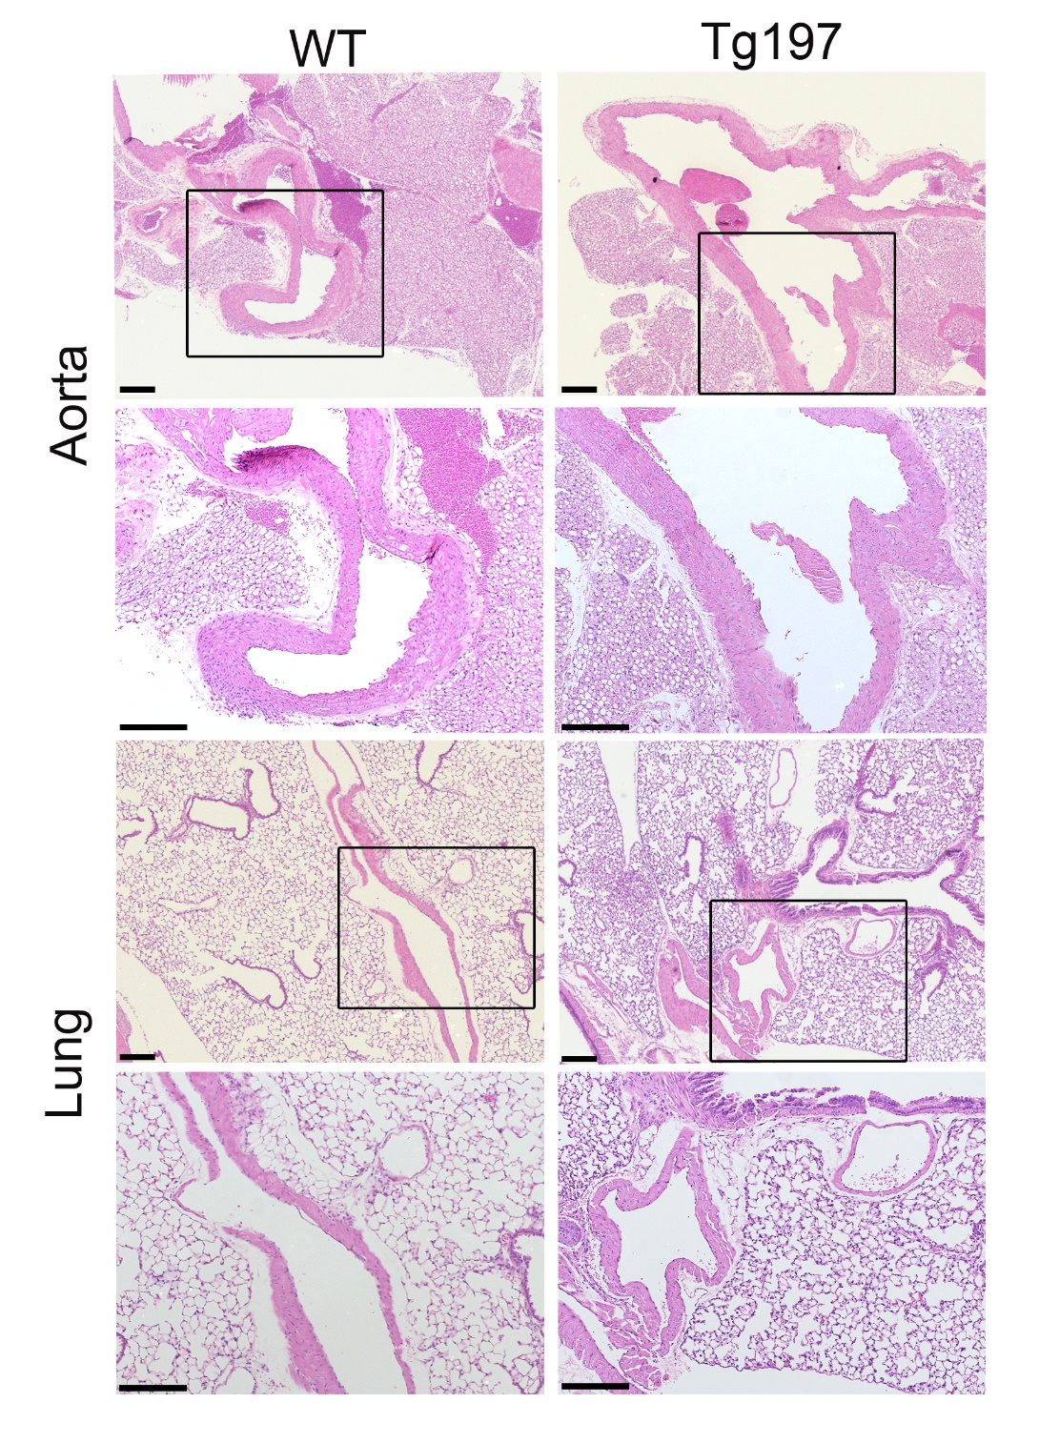

Figure S1. Peripheral vessel wall of the arteries appears unaffected in Tg197 animals. Representative images of hematoxylin/eosin (H&E)- stained aortic and lung sections of Tg197 and WT littermate animals at 12 weeks old of age, where vessels and arteries can be seen (lower panel: higher magnification of the upper panel part specified by the box) (Scale bar, 200μm).

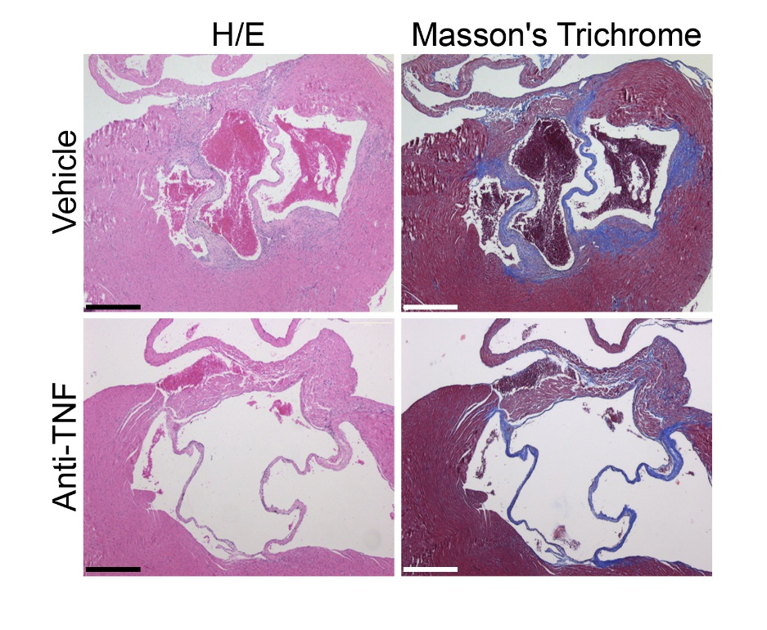

Figure S2. Treatment of Tg197 animals with the anti-TNF Infliximab (Remicade) resulted in the amelioration of the heart valve pathology. Representative images of H&E- and Masson’s Trichrome-stained transverse heart sections of Tg197 animals at 11 weeks of age, treated with vehicle or prophylactic anti-TNF treatment (from 4th-11th week of age) (Scale bar, 400μm).

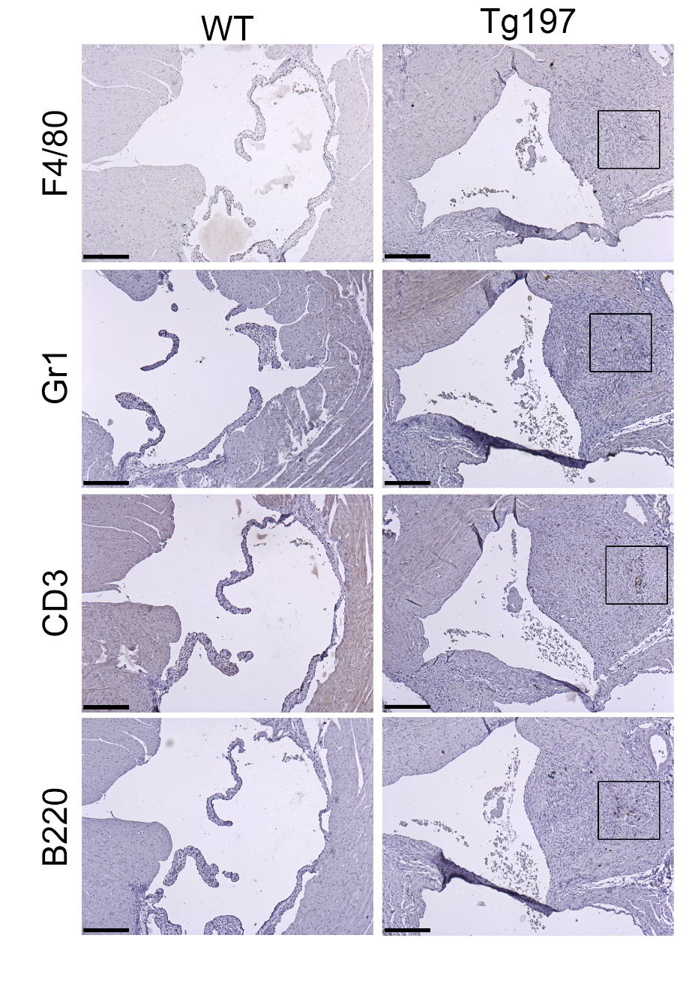

Figure S3. Inflammation has a minimal contribution to the heart valve disease phenotype of Tg197 mice. Representative immunohistochemical stainings for the detection of macrophages (F4/80), neutrophils (Gr1), B cells (B220) and T cells (CD3) on transverse heart sections from WT and Tg197 hearts at 12 weeks of age (positive staining marked in boxed areas) (Scale bar, 200μm).

Figure S4. Tg197 heart valve pathology progresses with time. Representative H&E-stained longitudinal heart sections of WT animals at 8 weeks of age and Tg197 animals at 4, 8 and 12 weeks of age, showing the progression of the heart valve pathology. AV: aortic valve leaflets, LV: left ventricle, MV: mitral valve leaflet, PV: pulmonary valve, RV: right ventricle, Ao: aorta (Scale bar, 200μm).

Figure S5. Valvular regurgitation detected in Tg197 animals by echocardiographic screening. Representative examples of aortic valve (A) and mitral valve (B) regurgitation observed in Tg197 animals at 12 weeks of age (arrows indicate the normal and the backward blood flow in healthy WT and Tg197 animals)

Figure S6. Kaplan Meier survival curve of WT and Tg197 mice. Representative survival curve (n=20) showing the premature mortality observed in Tg197 animals. (The experiment was terminated when mortality was over 50% due to ethical concerns).

Figure S7. Further functional enrichment analysis of the overlapping upregulated/downregulated genes in Tg197 VICs and SFs isolated at 8 weeks of age (A, B) Pathways enriched in the overlapping significantly upregulated (A) and downregulated (B) DEGs in Tg197 VICs and SFs. (C) Extended alluvial diagram which illustrates KEGG pathways in VICs and SFs alone as well as the overlapping KEGG pathways in Tg197 VICs and SFs, grouped according to their KEGG broader categories.

Figure S8. TgA86 SpA model develops TNF-dependent left-sided heart valve pathology. Representative images of H&E- and Masson’s Trichrome-stained transverse heart sections showing the aortic valve of TgA86 animals at 15 weeks, treated with vehicle or prophylactic anti-TNF treatment (from 4th-15th week of age) (Scale bar, 400μm).

