Supplementary Table S1. Key study design features including patient population
 |  | Treatments | Prior RA treatments | Concomitant  therapies | Rescue (from week) | Study length (weeks) | Nuclear magnetic resonance | Adjudicated MACE
PHASE II
NCT01185353  JADAª |  | Placebo  Bari 8 mg  Bari 4 mg  Bari 2 mg  Bari 1 mg | MTX-IR  bDMARD naïve | Optional csDMARDs  no bDMARDs |  | 12: double blind  12: blinded extension (no placebo  104: open-label extension | Yes | -
NCT00902486  JADCª |  | Placebo  Bari 10 mg  Bari 7 mg  Bari 4 mg | DMARD-IR  prior bDMARD allowed | no bDMARDs |  | 12: double blind  12: blinded extension (no placebo) | - | -
NCT01469013  (Japan, JADN) ^{a,b} |  | Placebo  Bari 8 mg  Bari 4 mg  Bari 2 mg  Bari 1 mg | MTX-IR  prior bDMARD allowedª | Optional csDMARDs  no bDMARDs |  | 12: double blind  52: blinded extension (no placebo) | - | -
PHASE III
RA-BEGIN  NCT01711359 |  | MTX alone  Bari 4 mg alone  Bari 4 mg + MTX | DMARD naive |  | 24 | 52: double blind |  | Yes
RA-BEAM  NCT01710358ª |  | Placebo  Bari 4 mg  Adalimumab | MTX-IR  bDMARD naive | Background MTX | 16 | 24: double blind placebo control  28: double blind active control | Yes | Yes
RA-BUILD  NCT01721057ª |  | Placebo  Bari 4 mg  Bari 2 mg | csDMARD-IR  bDMARD naive | Optional csDMARDs  no bDMARDs | 16 | 24: double blind |  | Yes
RA-BEACON  NCT01721044ª |  | Placebo  Bari 4 mg  Bari 2 mg | TNFi-IR | Background  csDMARD | 16 | 24: double blind |  | Yes
Long-term Extension
RA-BEYOND  NCT01885078 | Bari 4 mg  Bari 2 mg |  | Depends on originator study |  | As needed | Ongoing long-term extension^{c} |  | Yes
ªIncluded in the six-study, placebo-controlled set.
^{b}Prior bDMARDs allowable; however, patients could not have stopped treatment due to insufficient response.
^{c}Data as of January 1, 2016.
Bari=baricitinib, bDMARD=biologic disease-modifying antirheumatic drugs; csDMARD=conventional synthetic disease-modifying antirheumatic drugs; IR=inadequate responder; MACE=major adverse cardiovascular events; MTX=methotrexate; TNFi=tumor necrosis factor inhibitor.

Supplementary Table S2. Correlation analysis between lipid changes and clinical endpoints from baseline to week 12 in the baricitinib 2 mg/4 mg analysis set
 | HDL-C | LDL-C | Triglycerides | Total cholesterol
 | Partial Pearson correlation coefficient (r)ª
DAS28-CRP | -0.15 | -0.19 | -0.03 | -0.18
DAS28-ESR | -0.15 | -0.15 | -0.00 | -0.13
SDAI | -0.08 | -0.16 | -0.01 | -0.13
CDAI | -0.05 | -0.13 | 0.01 | -0.09
ªPartial Pearson correlation coefficients were calculated adjusting for treatment group.
CDAI=Clinical Disease Activity Index; DAS28-CRP=Disease Activity Score 28-joint assessment using the C-reactive protein level; DAS28-ESR=DAS28 using the erythrocyte sedimentation rate; HDL-C=high-density lipoprotein cholesterol; LDL=low-density lipoprotein cholesterol; SDAI=Simplified Disease Activity Index.

Supplementary Table S3. Treatment-emergent highest value through week 24 with data censored at rescue
Increased by maximum (and minimum for HDL-C) category, n (%) | Placebo  (N=1070) | Baricitinib 2 mg  (N=479) | Baricitinib 4 mg  (N=997)
LDL-C | n=797 | n=369 | n=836
Borderline high (3.36-4.11 mmol/L) | 56 (7) | 61 (17) | 174 (21)
High (4.14-4.89 mmol/L) | 45 (6) | 45 (12) | 132 (16)
Very high (≥4.91 mmol/L) | 19 (2) | 17 (5) | 63 (8)
HDL-C | n=635 | n=285 | n=672
Low (<1.03 mmol/L for men; <1.29 mmol/L for women) | 80 (13) | 20 (7) | 37 (6)
Triglycerides | n=982 | n=445 | n=945
Borderline high (1.69-2.25 mmol/L) | 82 (8) | 46 (10) | 121 (13)
High (2.26-5.63 mmol/L) | 71 (7) | 49 (11) | 116 (12)
Very high (≥5.64 mmol/L) | 7 (1) | 5 (1) | 5 (1)
HDL-C=high-density lipoprotein cholesterol; LDL-C=low-density lipoprotein cholesterol.

Supplementary Table S4. Change in lipid and GlycA levels from baseline to week 12 according to baseline statin use in the phase III RA-BEAM study
Baseline statin use | Placebo  (N=488) | Baricitinib 4 mg  (N=487) | Adalimumab  (N=330) | Baricitinib 4 mg vs Placebo | Adalimumab vs Placebo
 | LSM (SE) |  |  | LSMD (95% CI)
GlycA, µmol/L
No (n=389) | -13.5 (4.0) | -109.5 (4.0) | -99.5 (4.9) | -96.0 (-107, -85)*** | -86.0 (-98, -74)***
Yes (n=37) | -14.3 (14.1) | -131.0 (14.3) | -94.2 (16.3) | -116.7 (-157, -77)*** | -79.9 (-123, -37)***
Total cholesterol, mmol/L
No (n=412) | -0.0 (0.03) | 0.7 (0.03) | 0.3 (0.04) | 0.7 (0.6, 0.8)*** | 0.3 (0.2, 0.4)***
Yes (n=37) | -0.1 (0.17) | 0.9 (0.17) | 0.3 (0.20) | 1.0 (0.6, 1.5)*** | 0.4 (-0.1, 0.9)
LDL cholesterol, mmol/L
No (n=404) | -0.1 (0.03) | 0.4 (0.03) | 0.2 (0.03) | 0.5 (0.4, 0.5)*** | 0.3 (0.2, 0.3)***
Yes (n=37) | -0.1 (0.14) | 0.5 (0.13) | 0.2 (0.16) | 0.6 (0.3, 1.0)** | 0.3 (-0.1, 0.7)
**p≤0.01, ***p≤0.001 vs placebo
CI=confidence interval; LDL=low-density lipoprotein; LSM=least squares mean; LSMD=least squares mean difference; SE=standard error.

Supplementary Figure S1. Long-term lipid profile for LDL-C and HDL-C in all patients who received baricitinib 4 mg. Data are least squares mean absolute values (mmol/L) from baseline to week 104 with SE depicted by error bars (though the SEs were very tight, and therefore some error bars are not very visible). HDL-C=high-density lipoprotein cholesterol; LDL-C=low-density lipoprotein cholesterol; SE=standard error.

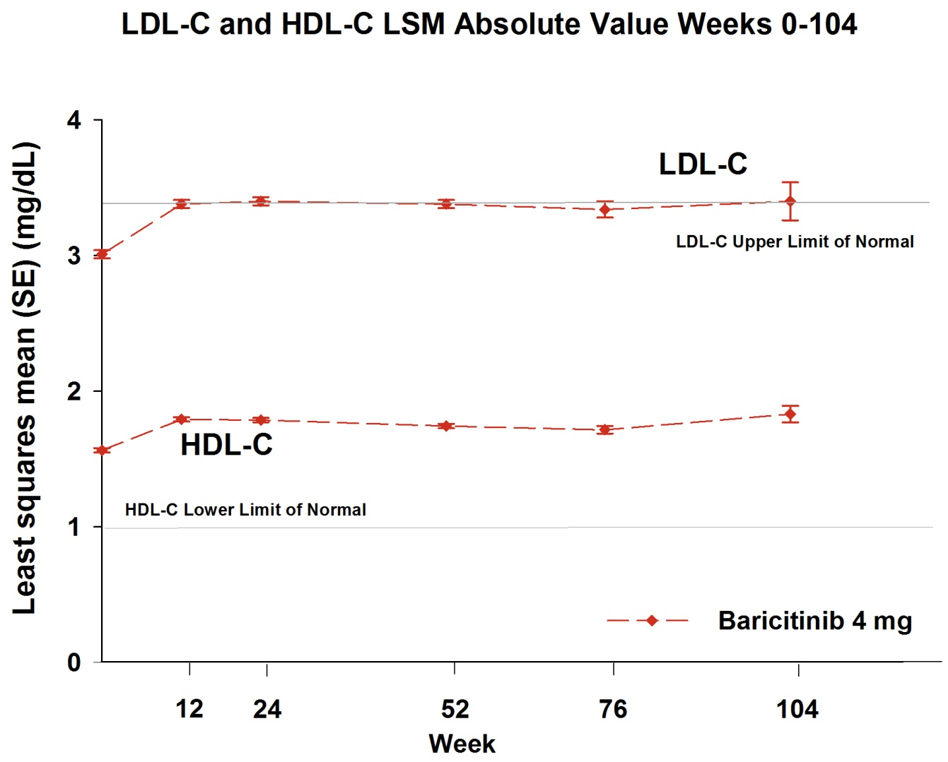

Supplementary Figure S2. Correlation analysis of the changes in low-density lipoprotein cholesterol (LDL-C) and high-density lipoprotein cholesterol (HDL-C) levels from baseline to week 12 versus changes in high sensitivity C-reactive protein level (hsCRP) and GlycA from baseline to week 12. Patients were divided into tertiles of increase in LDL-C (first tertile: ≤-0.08, second tertile: >-0.08 but ≤0.41, and third tertile: >0.41 mmol/L) and HDL-C (first tertile: ≤0.0, second tertile: >0.0 but ≤0.21, and third tertile: >0.21 mmol/L) and in reduction of hsCRP (lowest tertile of reduction: <1.76, second tertile: ≥1.76 but <11.08 and, highest tertile: ≥11.08 mg/L) and glycA (lowest tertile of reduction: <24, second tertile: ≥24 but <104, and highest tertile: ≥104 umol/L). Higher peaks along the east–west diagonal represent an increased relationship between changes in LDL-C/HDL-C levels and changes in hsCRP/glycA.
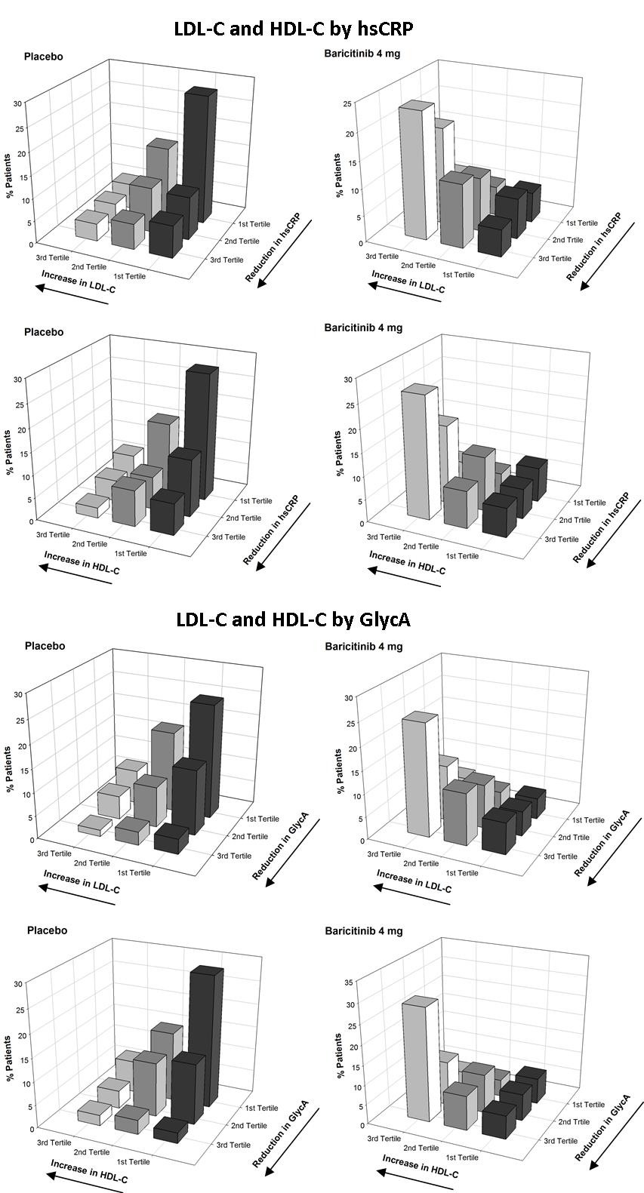
Supplementary Figure S3. Relationship between MACE and change in LDL-C. Plot shows MACE from the all-baricitinib set in phase III studies (N=2890) plotted against change from baseline in LDL-C. Occurrences of positively adjudicated MACE were evenly distributed among patients with increased LDL-C and included some occurrences in patients with decreased LDL-C. Post-baseline LDL was censored at statin initiation, when statin dose increased, or with statin type change. Graph shows all MACEs from the all BARI RA analysis set except 3 MACEs for which the patients did not have any post-baseline LDL data available. LDL-C=low-density lipoprotein cholesterol; MACE=major adverse cardiovascular events.

