Online Supplementary Appendix

Methods

Additional information on spinal radiograph scoring and imputation of missing vertebral corners

According to mSASSS, the anterior vertebral corners (VCs) of the cervical and lumbar spine are scored in the lateral view for the presence of erosion and/or sclerosis and/or squaring (1 point), syndesmophyte (2 points) and bridging syndesmophyte (3 points) with a total score per patient ranging from 0 to 72. Radiograph sets with a total mSASSS score of ≥71 were excluded, as no further progression of at least 2 units per 2 years would be possible (N=8). Only scores of radiographs with ≤3 missing vertebral corners (VC) per segment (either cervical or lumbar) were used. Individual missing VCs were imputed using an adaptation algorithm (Ramiro S. et al, Ann Rheum Dis 2015;74:52-9): first, a missing value for a VC was replaced with the value of the previous observation. Second, the mean spinal segment’s progression score (either cervical or lumbar) per patient was calculated. This segmental progression score was added to the imputed value. In a case of a score missing in a patient with a score of 0 in the same VC at a subsequent time point, the score of 0 for the previous time point(s) was assumed. If the baseline score of a VC was missing, the same procedure was applied, subtracting the mean segment progression from the score of year 3 for a particular patient. If a value of this VC was also missing at year 2, then the average of the other available VCs from this spinal segment at baseline was used to replace the missing VC(s). An independent adjudicator (AC) scored all of the radiographs from patients with an absolute difference in mSASSS status scores between the primary readers of ≥5 units in at least one radiograph set. Averaged scores per VC were used and, in case of adjudication, the score of the primary reader closest to the adjudicator. Using the score of the adjudicator led to similar results (see supplementary Table S7, below). Syndesmophytes were only counted if both readers agreed upon their presence.

Selection of the correlation structure in the generalized estimating equation (GEE) models
An “exchangeable” correlation structure was chosen for the main model, as we assumed that each patient had an individual constant level of radiographic progression probability for all time-points, given all covariates. Other correlation structures (“independence”, “unstructured”, “autoregressive”) were investigated in sensitivity analyses and the resulting coefficient and confidence intervals varied only slightly (full models shown in the supplementary Tables S9-S11, below).

Multiple imputation of missing values
To account for missing values, the GEE was fitted using multiple imputation of missing covariate data (see online supplementary Methods). Out of 616 intervals, 212 (35%) had at least one missing value in one of the 12 variables used in the GEE. The proportion of missing values per variable varied from 0% to 19%. An individual GEE was fitted for each of the imputed dataset. Pooling of model estimates was performed according to Rubin’s rules. A total of 30 imputed datasets were created. The ASDAS was derived by passive imputation. Predictive mean matching was used for continuous variables and logistic regression for binary variables. Convergence of imputations was assessed by visual inspection of the mean and variance changes by iteration and dataset. The same GEE models were also fitted using the subset population with complete data sets to assess the robustness of the results.
R statistical software (R Development Core Team, 2011) was used for all analyses.

Results

Table S1. Multivariable analysis for the identification of factors associated with spinal radiographic progression with 2 year radiographic intervals ±6 months, performed as a sensitivity analysis in a smaller subset of intervals, as in the main analysis patients had been included with an interval duration between radiograph sets of 2 years ±12 months.

Progression defined as
≥2 mSASSS units in 2 years
Variable | OR | 95% CI | P value
TNFi use prior to each radiographic interval yes/no | 0.58 | 0.31-1.08 | 0.09
mSASSS at start of each radiographic interval | 1.06 | 1.03-1.08 | <0.001
Male sex | 2.23 | 1.05-4.73 | 0.04
Symptom duration (5 years) | 1.12 | 0.95-1.33 | 0.18
Current smoking | 1.05 | 0.54-2.03 | 0.88
HLA-B27 | 0.80 | 0.32-1.98 | 0.63
Number exercise sessions per week | 0.91 | 0.77-1.08 | 0.28
Peripheral arthritis | 0.73 | 0.36-1.45 | 0.36
NSAID use at start of each radiographic interval | 0.92 | 0.41-2.07 | 0.84
BMI 25-30 (Reference: BMI <25) | 0.98 | 0.51-1.87 | 0.95
BMI >30 (Reference: BMI <25) | 1.34 | 0.60-2.99 | 0.48
Duration of radiographic interval | 4.24 | 0.94-19.1 | 0.06
Analysis performed in 462 radiographic intervals from 337 patients after multiple imputation of missing covariate data. BMI = Body Mass Index; CI = confidence interval; HLA-B27 = human leucocyte antigen B27; mSASSS = modified Stoke Ankylosing Spondylitis Spine Score; NSAID = Nonsteroidal anti-inflammatory drug; OR = odds ratio; TNFi = Tumour necrosis factor inhibitor.

Table S2. Multivariable analysis for the identification of factors associated with spinal radiographic progression
(complete case analysis*)
 | Progression defined as  ≥2 mSASSS units in 2 years |  |  | Progression defined as  ≥1 new syndesmophytes in 2 years
Variable | OR | 95% CI | P value | OR | 95% CI | P value
TNFi use prior to each radiographic interval yes/no | 0.50 | 0.25-0.99 | 0.05 | 0.47 | 0.24-0.92 | 0.03
mSASSS at start of each radiographic interval | 1.05 | 1.03-1.07 | <0.001
Baseline presence of syndesmophytes at start of each  radiographic interval |  |  |  | 8.79 | 4.29-18.0 | <0.001
Male sex | 3.27 | 1.34-8.00 | 0.01 | 1.80 | 0.79-4.13 | 0.17
Symptom duration (5 years) | 1.14 | 0.97-1.35 | 0.12 | 1.04 | 0.90-1.21 | 0.59
Current smoking | 0.95 | 0.50-1.82 | 0.88 | 0.73 | 0.38-1.40 | 0.34
HLA-B27 | 0.76 | 0.31-1.83 | 0.53 | 0.93 | 0.41-2.10 | 0.86
Number exercise sessions per week | 1.01 | 0.85-1.19 | 0.95 | 0.88 | 0.72-1.08 | 0.21
Peripheral arthritis | 0.88 | 0.73-1.81 | 0.70 | 0.59 | 0.29-1.23 | 0.16
NSAID use at start of each radiographic interval | 0.74 | 0.33-1.63 | 0.45 | 0.80 | 0.35-1.85 | 0.60
BMI 25-30 (Reference: BMI <25) | 1.70 | 0.91-3.19 | 0.10 | 1.09 | 0.59-2.02 | 0.79
BMI >30 (Reference: BMI <25) | 1.76 | 0.69-4.47 | 0.24 | 1.12 | 0.42-2.98 | 0.82
Duration of radiographic interval | 1.22 | 0.56-2.65 | 0.61 | 1.65 | 0.72-3.80 | 0.24
*Analysis performed in 403 radiographic intervals from 301 patients (patients with available data for all covariates; no imputation). BMI = Body Mass Index; CI = confidence interval; HLA-B27 = human leucocyte antigen B27; mSASSS = modified Stoke Ankylosing Spondylitis Spine Score; NSAID = Nonsteroidal anti-inflammatory drug; OR = odds ratio; TNFi = Tumour necrosis factor inhibitor.

Table S3. Multivariable analysis for the identification of factors associated with spinal radiographic progression
(alternative TNFi variable; model corresponds to model 2 in Table 3 of main manuscript)
Progression defined as
≥2 mSASSS units in 2 years
Variable | OR | 95% CI | P value
Number of years of continuous use of TNFi prior to each radiographic interval (estimated effect of TNFi per year of continuous TNFi use) | 0.79 | 0.66-0.94 | 0.01
mSASSS at start of each radiographic interval | 1.07 | 1.05-1.09 | <0.001
Male sex | 2.34 | 1.19-4.64 | 0.02
Symptom duration (5 years) | 1.13 | 0.98-1.29 | 0.08
Current smoking | 1.11 | 0.62-1.95 | 0.73
HLA-B27 | 1.05 | 0.47-2.31 | 0.91
Number exercise sessions per week | 0.95 | 0.82-1.11 | 0.52
Peripheral arthritis | 0.86 | 0.48-1.53 | 0.60
NSAID use at start of each radiographic interval | 0.81 | 0.43-1.54 | 0.52
BMI 25-30 (Reference: BMI <25) | 1.34 | 0.75-2.40 | 0.33
BMI >30 (Reference: BMI <25) | 1.63 | 0.80-3.33 | 0.18
Duration of radiographic interval | 1.60 | 0.81-3.14 | 0.18
*Analysis performed in 616 radiographic intervals from 432 patients (patients with available data for all covariates; no imputation). BMI = Body Mass Index; CI = confidence interval; HLA-B27 = human leucocyte antigen B27; mSASSS = modified Stoke Ankylosing Spondylitis Spine Score; NSAID = Nonsteroidal anti-inflammatory drug; OR = odds ratio; TNFi = Tumour necrosis factor inhibitor.

Table S4. Multivariable analysis for the identification of factors associated with spinal radiographic progression
(alternative TNFi variable; model corresponds to model 3 in Table 3 of main manuscript)
Progression defined as
≥2 mSASSS units in 2 years
Variable | OR | 95% CI | P value
≤4 years of TNFi use prior to each radiographic interval | 0.55 | 0.31-0.98 | 0.04
>4 years of TNFi use prior to each radiographic interval | 0.30 | 0.10-0.90 | 0.03
mSASSS at start of each radiographic interval | 1.07 | 1.04-1.09 | <0.001
Male sex | 2.25 | 1.13-4.46 | 0.02
Symptom duration (5 years) | 1.12 | 0.98-1.28 | 0.11
Current smoking | 1.12 | 0.63-1.98 | 0.71
HLA-B27 | 1.02 | 0.45-2.27 | 0.97
Number exercise sessions per week | 0.95 | 0.81-1.10 | 0.47
Peripheral arthritis | 0.89 | 0.49-1.60 | 0.69
NSAID use at start of each radiographic interval | 0.79 | 0.39-1.60 | 0.51
BMI 25-30 (Reference: BMI <25) | 1.38 | 0.77-2.47 | 0.27
BMI >30 (Reference: BMI <25) | 1.63 | 0.79-3.39 | 0.19
Duration of radiographic interval | 1.65 | 0.86-3.17 | 0.14
*Analysis performed in 616 radiographic intervals from 432 patients (patients with available data for all covariates; no imputation). BMI = Body Mass Index; CI = confidence interval; HLA-B27 = human leucocyte antigen B27; mSASSS = modified Stoke Ankylosing Spondylitis Spine Score; NSAID = Nonsteroidal anti-inflammatory drug; OR = odds ratio; TNFi = Tumour necrosis factor inhibitor.

Table S5. Multivariable analysis for the identification of factors associated with spinal radiographic progression
(alternative TNFi variable; model corresponds to model 4 in Table 3 of main manuscript)
Progression defined as
≥2 mSASSS units in 2 years
Variable | OR | 95% CI | P value
TNFi use prior to each radiographic interval yes vs. no | 0.52 | 0.27-0.98 | 0.05
TNFi use during the radiographic interval yes vs. no | 0.87 | 0.49-1.56 | 0.64
mSASSS at start of each radiographic interval | 1.07 | 1.04-1.09 | <0.001
Male sex | 2.20 | 1.10-4.37 | 0.03
Symptom duration (5 years) | 1.11 | 0.97-1.27 | 0.14
Current smoking | 1.14 | 0.64-2.03 | 0.66
HLA-B27 | 1.04 | 0.46-2.34 | 0.93
Number exercise sessions per week | 0.95 | 0.82-1.10 | 0.48
Peripheral arthritis | 0.92 | 0.51-1.67 | 0.79
NSAID use at start of each radiographic interval | 0.84 | 0.41-1.70 | 0.62
BMI 25-30 (Reference: BMI <25) | 1.38 | 0.77-2.45 | 0.28
BMI >30 (Reference: BMI <25) | 1.68 | 0.81-3.51 | 0.17
Duration of radiographic interval | 1.66 | 0.86-3.20 | 0.13
*Analysis performed in 616 radiographic intervals from 432 patients (patients with available data for all covariates; no imputation). BMI = Body Mass Index; CI = confidence interval; HLA-B27 = human leucocyte antigen B27; mSASSS = modified Stoke Ankylosing Spondylitis Spine Score; NSAID = Nonsteroidal anti-inflammatory drug; OR = odds ratio; TNFi = Tumour necrosis factor inhibitor.

Table S6. Multivariable analysis for the identification of factors associated with spinal radiographic progression
(alternative TNFi variable; model corresponds to model 5 in Table 3 of main manuscript)
Progression defined as
≥2 mSASSS units in 2 years
Variable | OR | 95% CI | P value
TNFi use prior to each radiographic interval yes vs. no | 0.54 | 0.28-1.03 | 0.06
TNFi use during ≤50% of duration of radiographic interval | 1.41 | 0.66-3.00 | 0.37
TNFi use during >50% of duration of radiographic interval | 0.81 | 0.43-1.50 | 0.50
mSASSS at start of each radiographic interval | 1.07 | 1.04-1.09 | <0.001
Male sex | 2.24 | 1.11-4.52 | 0.03
Symptom duration (5 years) | 1.11 | 0.98-1.27 | 0.11
Current smoking | 1.13 | 0.64-2.02 | 0.67
HLA-B27 | 1.02 | 0.45-2.29 | 0.97
Number exercise sessions per week | 0.95 | 0.82-1.09 | 0.45
Peripheral arthritis | 0.90 | 0.50-1.63 | 0.73
NSAID use at start of each radiographic interval | 0.84 | 0.41-1.72 | 0.64
BMI 25-30 (Reference: BMI <25) | 1.34 | 0.75-2.39 | 0.32
BMI >30 (Reference: BMI <25) | 1.63 | 0.79-3.39 | 0.19
Duration of radiographic interval | 1.63 | 0.85-3.15 | 0.14
*Analysis performed in 616 radiographic intervals from 432 patients (patients with available data for all covariates; no imputation). BMI = Body Mass Index; CI = confidence interval; HLA-B27 = human leucocyte antigen B27; mSASSS = modified Stoke Ankylosing Spondylitis Spine Score; NSAID = Nonsteroidal anti-inflammatory drug; OR = odds ratio; TNFi = Tumour necrosis factor inhibitor.

Table S7. Multivariable analysis for the identification of factors associated with spinal radiographic progression
Sensitivity Analysis for Model in Figure 1: alternative scoring adjudication using the score of the adjudicator instead to the score of the primary reader closest to the adjudicator.

Progression defined as
≥2 mSASSS units in 2 years
Variable | OR | 95% CI | P value
TNFi use prior to each radiographic interval yes vs. no | 0.51 | 0.29-0.88 | 0.02
mSASSS at start of each radiographic interval | 1.05 | 1.03-1.07 | <0.001
Male sex | 2.63 | 1.29-5.35 | 0.01
Symptom duration (5 years) | 1.11 | 0.96-1.27 | 0.16
Current smoking | 0.99 | 0.55-1.76 | 0.96
HLA-B27 | 1.00 | 0.45-2.23 | 1.00
Number exercise sessions per week | 0.95 | 0.83-1.10 | 0.50
Peripheral arthritis | 1.02 | 0.58-1.79 | 0.94
NSAIDs use at start of each radiographic interval | 0.90 | 0.45-1.77 | 0.75
BMI 25-30 (Reference: BMI <25) | 1.47 | 0.83-2.61 | 0.18
BMI >30 (Reference: BMI <25) | 1.61 | 0.78-3.31 | 0.20
Duration of radiographic interval | 1.34 | 0.72-2.50 | 0.36
Analysis performed in 616 radiographic intervals from 432 patients (patients with available data for all covariates; no imputation). BMI = Body Mass Index; CI = confidence interval; HLA-B27 = human leucocyte antigen B27; mSASSS = modified Stoke Ankylosing Spondylitis Spine Score; NSAIDs = Nonsteroidal anti-inflammatory drugs; OR = odds ratio; TNFi = Tumour necrosis factor inhibitor.

Table S8. Baseline characteristics of patients with different number of radiographic intervals.

 | Number of radiographic intervals
 | 1  N=304 | 2  N=83 | 3  N=35 | 4  N=9 | 5  N=1 | P value
Male sex, % | 36.5 | 30.1 | 22.9 | 33.3 | 100 | 0.26
HLA-B27 positive, % | 79.6 | 79.2 | 90.3 | 87.5 | 100 | 0.65
Age, years | 41.0 (10.9) | 38.4 (11.7) | 39.5 (9.8) | 39.5 (10.6) | 37.0 (NA) | 0.42
Symptom duration, years | 14.1 (10.0) | 12.7 (9.0) | 15.7 (9.2) | 9.6 (7.4) | 7.2 (NA) | 0.27
BASDAI | 4.3 (2.2) | 4.2 (2.6) | 4.0 (2.0) | 4.0 (2.1) | 3.2 (NA) | 0.93
ASDAS | 2.8 (1.1) | 2.8 (1.2) | 2.9 (1.1) | 2.7 (0.9) | 2.2 (NA) | 0.93
CRP (mg/l), median (IQR) | 8 (3; 11) | 8 (2.2; 13) | 8 (4.2; 15) | 8 (3; 8) | 1.0 (NA) | 0.52
Elevated CRP, % | 41.3 | 39.2 | 44.8 | 12.5 | 0.0 | 0.50
BASFI | 3.0 (2.6) | 3.3 (2.8) | 3.1 (2.1) | 2.7 (2.4) | 0.8 (NA) | 0.86
BASMI | 2.0 (1.9) | 2.5 (2.2) | 2.7 (1.8) | 1.9 (2.6) | 0.0 (NA) | 0.08
mSASSS mean (SD) | 6.4 (12.4) | 6.0 (12.2) | 9.1 (13.9) | 8.5 (15.4) | 0.0 (NA) | 0.13
Syndesmophytes present, % | 34.5 | 27.7 | 45.7 | 44.4 | 0.0 | 0.29
EQ-5D | 65.1 (22.0) | 64.3 (22.2) | 65.0 (20.5) | 74.5 (5.9) | 68.7 (NA) | 0.58
Current peripheral arthritis, % | 30.1 | 30.3 | 9.7 | 37.5 | 0.0 | 0.10
Current enthesitis, % | 53.2 | 61.8 | 38.7 | 87.5 | 0.0 | 0.03
NSAID use, % | 80.9 | 92.4 | 85.2 | 100 | 100 | 0.15
TNFi use, % | 41.1 | 28.9 | 31.4 | 3.3 | 0.0 | 0.21
Current smokers, % | 42.1 | 32.9 | 31.0 | 0.0 | 0.0 | 0.05
Number exercise sessions/week | 2.0 (0.0; 2.0) | 1.0 (0.0; 2.0) | 2.0 (0.0; 3.0) | 2.0 (0.8; 2.2) | 0.0 (NA) | 0.77
BMI | 25.3 (4.5) | 24.9 (3.8) | 25.6 (3.8) | 24.8 (2.9) | 25.4 (NA) | 0.93
Spondylitis Disease Activity Score; BASDAI = Bath Ankylosing Spondylitis Disease Activity Index; BASFI = Bath Ankylosing Spondylitis Functional Index; BASMI = Bath Ankylosing Spondylitis Metrology Index; BMI = Body Mass Index; CRP = C-reactive protein (CRP) levels; EQ-5D = EuroQol 5-domain; HLA-B27 = human leucocyte antigen B27; mSASSS = modified Stoke Ankylosing Spondylitis Spine Score; NSAID = Nonsteroidal anti-inflammatory drug; TNFi = Tumour necrosis factor inhibitor.

Table S9. Multivariable analysis for the identification of factors associated with spinal radiographic progression
Sensitivity Analysis for GEE model in Figure 1 with “Independent” correlation structure
Progression defined as
≥2 mSASSS units in 2 years
Variable | OR | 95% CI | P value
TNFi use prior to each radiographic interval yes vs. no | 0.47 | 0.26-0.83 | 0.01
mSASSS at start of each radiographic interval | 1.07 | 1.04-1.09 | <0.001
Male sex | 1.88 | 0.94-3.78 | 0.07
Symptom duration (5 years) | 1.11 | 0.97-1.27 | 0.12
Current smoking | 1.08 | 0.61-1.91 | 0.78
HLA-B27 | 1.04 | 0.45-2.40 | 0.93
Number exercise sessions per week | 0.95 | 0.82-1.10 | 0.48
Peripheral arthritis | 0.91 | 0.49-1.68 | 0.76
NSAIDs use at start of each radiographic interval | 0.76 | 0.37-1.56 | 0.45
BMI 25-30 (Reference: BMI <25) | 1.55 | 0.87-2.77 | 0.14
BMI >30 (Reference: BMI <25) | 1.95 | 0.93-4.07 | 0.08
Duration of radiographic interval | 1.66 | 0.88-3.12 | 0.12
*Analysis performed in 616 radiographic intervals from 432 patients (patients with available data for all covariates; no imputation). BMI = Body Mass Index; CI = confidence interval; HLA-B27 = human leucocyte antigen B27; mSASSS = modified Stoke Ankylosing Spondylitis Spine Score; NSAIDs = Nonsteroidal anti-inflammatory drugs; OR = odds ratio; TNFi = Tumour necrosis factor inhibitor.

Table S10. Multivariable analysis for the identification of factors associated with spinal radiographic progression
Sensitivity Analysis for GEE model in Figure 1 with “Unstructured” correlation structure
Progression defined as
≥2 mSASSS units in 2 years
Variable | OR | 95% CI | P value
TNFi use prior to each radiographic interval yes vs. no | 0.49 | 0.27-0.88 | 0.02
mSASSS at start of each radiographic interval | 1.06 | 1.04-1.09 | <0.001
Male sex | 2.41 | 1.21-4.79 | 0.01
Symptom duration (5 years) | 1.13 | 0.99-1.29 | 0.08
Current smoking | 1.09 | 0.61-1.95 | 0.77
HLA-B27 | 1.06 | 0.47-2.39 | 0.89
Number exercise sessions per week | 0.94 | 0.81-1.10 | 0.45
Peripheral arthritis | 0.85 | 0.45-1.58 | 0.60
NSAIDs use at start of each radiographic interval | 0.87 | 0.43-1.74 | 0.69
BMI 25-30 (Reference: BMI <25) | 1.46 | 0.82-3.62 | 0.20
BMI >30 (Reference: BMI <25) | 1.74 | 0.83.3.62 | 0.14
Duration of radiographic interval | 1.65 | 0.85-3.18 | 0.14
*Analysis performed in 616 radiographic intervals from 432 patients (patients with available data for all covariates; no imputation). BMI = Body Mass Index; CI = confidence interval; HLA-B27 = human leucocyte antigen B27; mSASSS = modified Stoke Ankylosing Spondylitis Spine Score; NSAIDs = Nonsteroidal anti-inflammatory drugs; OR = odds ratio; TNFi = Tumour necrosis factor inhibitor.

Table S11. Multivariable analysis for the identification of factors associated with spinal radiographic progression
Sensitivity Analysis for GEE model in Figure 1 with “autoregressive” correlation structure
Progression defined as
≥2 mSASSS units in 2 years
Variable | OR | 95% CI | P value
TNFi use prior to each radiographic interval yes vs. no | 0.50 | 0.28-0.88 | 0.02
mSASSS at start of each radiographic interval | 1.06 | 1.04-1.09 | <0.001
Male sex | 2.15 | 1.08-4.28 | 0.03
Symptom duration (5y) at start of each radiographic interval | 1.12 | 0.98-1.27 | 0.10
Current smoking | 1.13 | 0.64-1.99 | 0.67
HLA-B27 | 1.06 | 0.47-2.38 | 0.90
Number of exercise sessions per week at start of each radiographic interval | 0.95 | 0.82-1.10 | 0.51
Peripheral arthritis at start of each radiographic interval | 0.89 | 0.49-1.61 | 0.70
NSAIDs use at start of each radiographic interval | 0.83 | 0.42-1.67 | 0.61
BMI 25-30 (Ref: BMI <25) at start of each radiographic interval | 1.44 | 0.81-2.57 | 0.21
BMI >30 (Ref: BMI <25) at start of each radiographic interval | 1.69 | 0.81-3.49 | 0.16
Duration of radiographic interval | 1.63 | 0.86-3.08 | 0.13
*Analysis performed in 616 radiographic intervals from 432 patients (patients with available data for all covariates; no imputation). BMI = Body Mass Index; CI = confidence interval; HLA-B27 = human leucocyte antigen B27; mSASSS = modified Stoke Ankylosing Spondylitis Spine Score; NSAIDs = Nonsteroidal anti-inflammatory drugs; OR = odds ratio; TNFi = Tumour necrosis factor inhibitor.

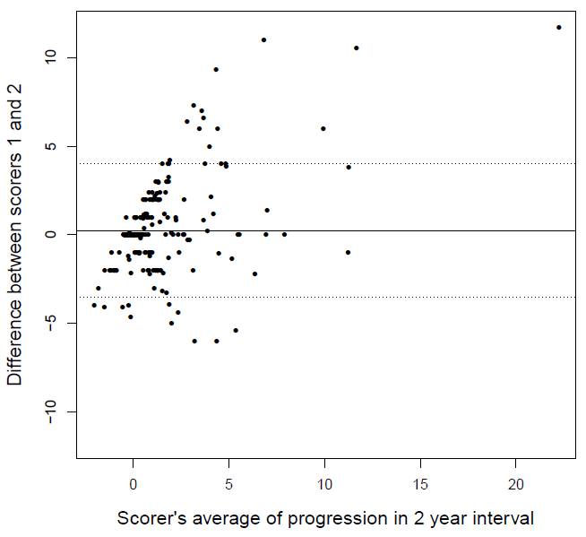

Figure S1. Bland and Altman plot: reliability of the mSASSS progression scores.

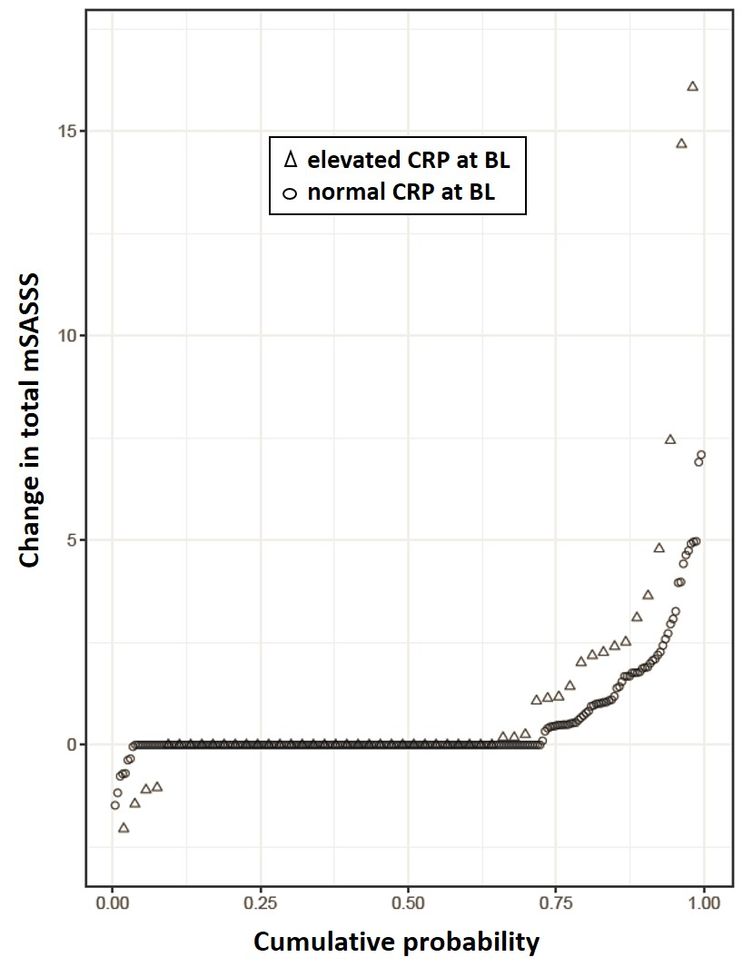
Figure S2. Cumulative probability plot of 2-year progression in the modified Stoke Ankylosing Spine Score (mSASSS), illustrating the change in mSASSS values from baseline of each individual radiographic interval to 2 years in patients already treated with TNFi at start of the respective interval, stratified by the baseline CRP status (elevated CRP (N=50 with 53 radiographic intervals) vs. normal CRP (N=165 with 231 radiographic intervals). BL = baseline (start of each radiographic interval)

