Online Supplementary Figure S1. Box plots of PS distributions for patients treated with belimumab and SoC, used for PS-adjusted analysis of (A) 5-year change in SDI score (n=567) and (B) time to first increase in SDI score (n=965)
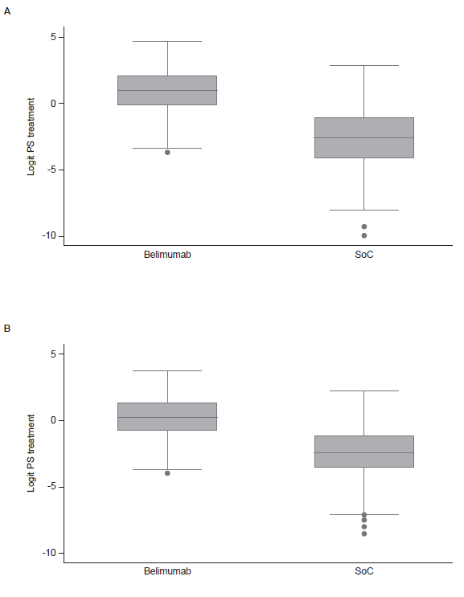
Note: The range of support for PS adjustment is illustrated by the overlap in PS distributions across groups (i.e., the difference between the smallest PS among belimumab patients and the largest PS among SoC patients).
PS, propensity score; SoC, standard of care.

Online Supplementary Table S1. Percentage of patients with corticosteroid use from baseline to Year 5 by treatment
Corticosteroid Dose, mg | None | >0 to <7.5 | ≥7.5 to <20 | ≥20
Baseline, %
SoC | 33 | 9 | 33 | 24
Belimumab | 35 | 25 | 29 | 10
Year 1, %
SoC | 22 | 20 | 40 | 17
Belimumab | 24 | 44 | 30 | 2
Years 2–3, %
SoC | 23 | 30 | 41 | 6
Belimumab | 28 | 47 | 20 | 5
Years 4–5, %
SoC | 33 | 33 | 30 | 5
Belimumab | 35 | 43 | 17 | 5
SoC, standard of care.

Online Supplementary Table S2. Use of immunosuppressive medication in the BLISS LTE and TLC cohorts (N=number of patients treated with an immunosuppressive medication)
Immunosuppressive, n (%)* | TLC (N=48) | BLISS LTE cohort (N=52)
Azathioprine | 29 (60.4) | 11 (21.2)
Methotrexate | 6 (12.5) | 13 (25.0)
Mycophenolate | 10 (20.8) | 26 (50.0)
Other | 3 (6.3) | 2 (3.8)
*Calculated as a percentage of those receiving immunosuppressive medication.
LTE, long-term extension; TLC, Toronto Lupus Cohort

