Burggraaf et al. Effect of a treat-to-target intervention of cardiovascular risk factors on subclinical and clinical atherosclerosis in rheumatoid arthritis: a randomized clinical trial

ONLINE SUPPLEMENTAL MATERIAL

Content
- Table S1. Linear mixed model of progression of carotid intima media thickness
- Table S2. Characteristics of the high-risk cohort at baseline and after five years of follow-up.
- Figure S1. Changes in BMI, DAS28 and ESR
- Figure S2. Progression of carotid intima media thickness in high-risk cohort group

Table S1. Linear mixed model of progression of carotid intima media thickness
 | Parameter Estimates  (95%-confidence interval) | p-value
Intercept | 0.037 (0.002-0.72) | 0.037
Treatment group | 0.028 (0.017-0.039) | <0.001
Female sex | -0.007 (-0.019-0.005) | 0.28
Baseline cIMT | 0.950 (0.898-1.002) | <0.001
Time | 0.000 (0.000-0.001) | <0.001
DAS28 | -0.000 (-0.003-0.002) | 0.54
Biological use | -0.002 (-0.012-0.007) | 0.60
Methrotrexate use | 0.001 (-0.009-0.011) | 0.91
Abbreviations: cIMT, carotid Intima Media Thickness; DAS28, Disease Activity Score with 28 joints counted and the erythrocyte sedimentation rate

Table S2. Characteristics of the high-risk cohort at baseline and after five years of follow-up.
Variable | Baseline  (n=10) | 5 years  (n=9) | p-value
Age, years | 65.6 (2.9) | 70.6 (2.9) | 0.13
Female | 1 (10.0%) | 1 (11.1%) | 0.87
Current smoking | 4 (40.0%) | 2 (22.2%) | 0.38
Disease duration, years | 9.1 (8.0) | 14.1 (8.0) | 0.16
Body mass index, kg/m² | 26.2 (2.5) | 27.3 (2.8) | 0.10
Waist circumference, years | 98.9 (4.6) | 102.0 (6.0) | 0.27
Systolic blood pressure, mmHg | 158.1 (14.6) | 126.4 (12.1) | <0.001
Diastolic blood pressure, mmHg | 91.8 (7.4) | 79.6 (7.1) | 0.03
Total cholesterol, mmol/L | 5.7 (1.3) | 4.2 (0.8) | 0.02
HDL-cholesterol, mmol/L | 1.1 (0.2) | 1.2 (0.3) | 0.29
LDL-cholesterol, mmol/L | 4.0 (1.1) | 2.4 (0.8) | 0.006
Triglycerides, mmol/L | 1.26 (0.76-1.76) | 1.28 (0.87-1.69) | 0.56
Apolipoprotein AI, g/L | 1.51 (0.19) | 1.37 (0.20) | 0.09
Apolipoprotein B, g/L | 1.14 (0.31) | 0.86 (0.32) | 0.02
Glycated hemoglobin, mmol/mol | 36.1 (3.3) | 38.7 (3.0) | 0.09
DAS28 | 2.1 (1.6-2.6) | 1.7 (0.8-2.6) | 0.93
Erythrocyte sedimentation rate, mm/hour | 13.0 (6.0-20.0) | 8.0 (0.0-21.0) | 0.73
C-reactive protein, mg/L | 5.5 (2.5-8.5) | 2.0 (0.0-6.0) | 0.92
Carotid Intima Media Thickness, mm | 0.751 (0.085) | 0.697 (0.082) | 0.009
Presence of plaques | 4 (40.0%) | 5 (50.0%) | 0.17
Statin treatment | 1 (10.0%) | 6 (60.0%) | 0.34
Anti-hypertensive treatment | 1 (10.0%) | 5 (50.0%) | 0.75
DMARD treatment | 10 (100.0%) | 9 (90.0%) | 0.89
Biological use | 2 (20.0%) | 6 (60.0%) | 0.23
Cardiovascular death | 0 (0.0%) | 0 (0.0%) | 0.99
Cardiovascular event | 0 (0.0%) | 1 (10.0%) | 0.78
Data presented as mean (standard deviation), median (interquartile range), or number (percentage)
Abbreviations: DAS28, Disease Activity Score with 28 joints counted and the erythrocyte sedimentation rate; DMARD, disease modifying anti-rheumatic drug; HDL, high-density-lipoprotein; LDL, low-density lipoprotein

Figure S1. Changes in BMI, DAS28 and ESR
Mean (standard error of the mean) of body mass index (Panel A), disease activity score (Panel B) and erythrocyte sedimentation rate (Panel C) during five years of follow-up for those allocated to usual care () and treat-to-target intervention ().
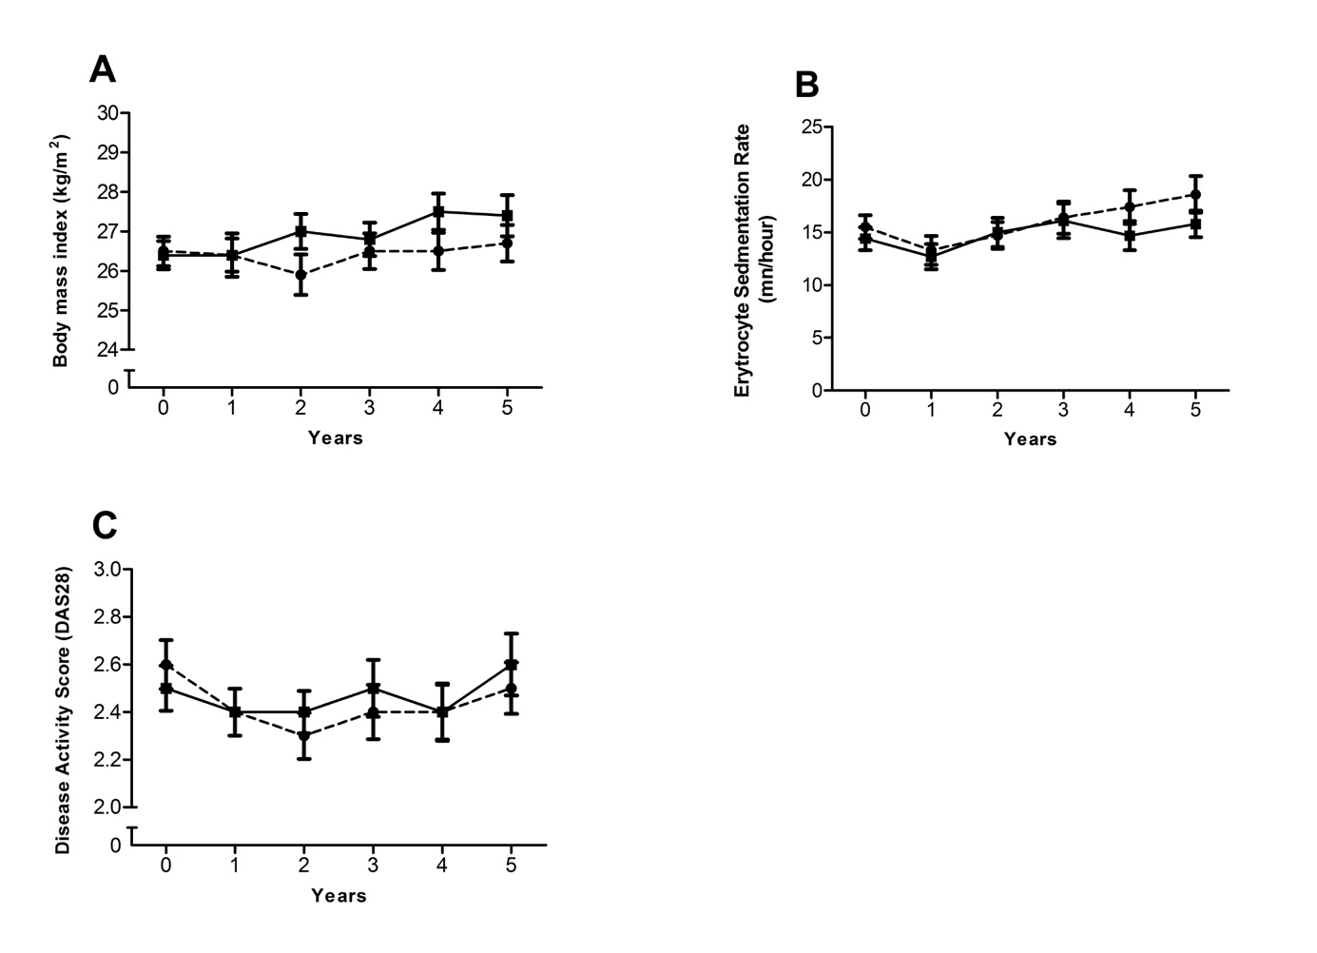
Figure S2. Progression of carotid intima media thickness in high-risk cohort group
Mean (standard error of the mean) of carotid intima media thickness during five years follow-up in the usual care (), treat-to-target intervention () and high-risk cohort () groups.
