|  |  |  |
| --- | --- | --- |
| **Supplementary Table 1. International Classification of Diseases 10th edition (ICD-10) codes used to obtain information about comorbidities in rheumatoid arthritis patients and matched general population comparators in the National Patient Register.** | | |
| **Comorbidity** | **ICD-8 codes** | **ICD-10 codes** |
| Chronic obstructive pulmonary disease | 490-491 | J41-J44 |
| Diabetes mellitus | 249-250 | E10-E14 |
| Ischemic heart disease | 410-414 | I20-I24 |
| Depression | 790.2 | F31-F34, F41, F43, |
| Cancer | 140-209 | C00-C97, D00-D09,  D37-D48 |
| Obesity | 277 | E65-E66, E68.9 |

|  |  |  |  |  |  |  |  |  |
| --- | --- | --- | --- | --- | --- | --- | --- | --- |
| **Supplementary Table 2. Descriptive demographics and characteristics for incident patients with rheumatoid arthritis (RA) from 1996 to May 31st 2011.** | | | | | | | | |
| **Year** | **Incident RA patients** | **Age at RA diagnosis** | **N females** | **% female** | **Required THR within 5 years of diagnosis** | **Age- and sex standardised incidence of THR per 1000 PY** | **Required TKR within 5 years of diagnosis** | **Age- and sex standardised incidence of TKR per 1000 PY** |
| 1996 | 1815 | 58,9 | 1289 | 71 | 79 | 8,07 | 45 | 5,65 |
| 1997 | 1852 | 59,3 | 1288 | 70 | 99 | 9,55 | 55 | 6,56 |
| 1998 | 1808 | 59,2 | 1280 | 71 | 73 | 6,98 | 57 | 7,01 |
| 1999 | 1982 | 59,2 | 1392 | 70 | 98 | 7,98 | 58 | 6,17 |
| 2000 | 1918 | 59,4 | 1378 | 72 | 89 | 6,71 | 51 | 5,74 |
| 2001 | 1857 | 59,2 | 1300 | 70 | 87 | 5,52 | 64 | 7,63 |
| 2002 | 1739 | 58,6 | 1199 | 69 | 92 | 6,84 | 46 | 5,81 |
| 2003 | 1831 | 58,5 | 1272 | 70 | 114 | 8,89 | 64 | 8,08 |
| 2004 | 2110 | 58,5 | 1478 | 70 | 123 | 6,98 | 65 | 6,79 |
| 2005 | 2080 | 58,6 | 1465 | 70 | 110 | 5,96 | 58 | 6,04 |
| 2006 | 2067 | 58,6 | 1465 | 71 | 129 | 7,08 | 62 | 6,83 |
| 2007 | 1865 | 58,4 | 1305 | 70 | 90 | 6,02 | 47 | 5,81 |
| 2008 | 2146 | 58,5 | 1497 | 70 | 127 | 5,86 | 60 | 6,33 |
| 2009 | 2039 | 59 | 1393 | 68 | 143 | 7,04 | 52 | 5,68 |
| 2010 | 2346 | 58,8 | 1638 | 70 | 147 | 5,70 | 53 | 5,10 |
| 2011 | 949* | 58 | 616 | 67 | 46 |  | 28 | 6,72* |
| *\* January 1st - May 31st.*  *Abbreviations: PY, person years; THR, total hip replacement; TKR, total knee replacement.* | | | | | | | | |



Supplementary Figure Population flow-chart for rheumatoid arthritis patients (RA) and matched general population comparators (GPCs).

**Analyses using quarterly derived data.**

|  |  |  |  |  |  |  |
| --- | --- | --- | --- | --- | --- | --- |
| **Supplementary Table 3. Interrupted Time-Series Regression Analysis: 5-year incidence rate of total hip replacements among rheumatoid arthritis (RA) patients and matched general population comparators (GPC) diagnosed /matched in 3-month intervals from Jan 1st 1996- May 31st 2011 with a lag period in 2002.** | | | | | | |
|  | **Parameter** | **Coefficient** | **Lower 95% C.I.** | **Upper 95% C.I.** | **Standard error** | **P-Value** |
| **RA** | **Intercept** | 8,64 | 7,49 | 9,78 | 0,57 | 0,000 |
| **Trend (per 3 months)** | -0,09 | -0,15 | -0,03 | 0,03 | 0,004 |
| **Level change after 2003** | 2,07 | -0,25 | 4,39 | 1,16 | 0,080 |
| **Trend change after 2003** | - | - | - | - | - |
| **GPC** | **Intercept** | 2,91 | 2,63 | 3,19 | 0,14 |  |
| **Trend (per 6 months)** | 0,03 | 0,01 | 0,04 | 0,01 | 0,001 |
| **Level change after 2003** | - | - | - | - | - |
| **Trend change after 2003** | -0,02 | -0,04 | 0,00 | 0,01 | 0,072 |

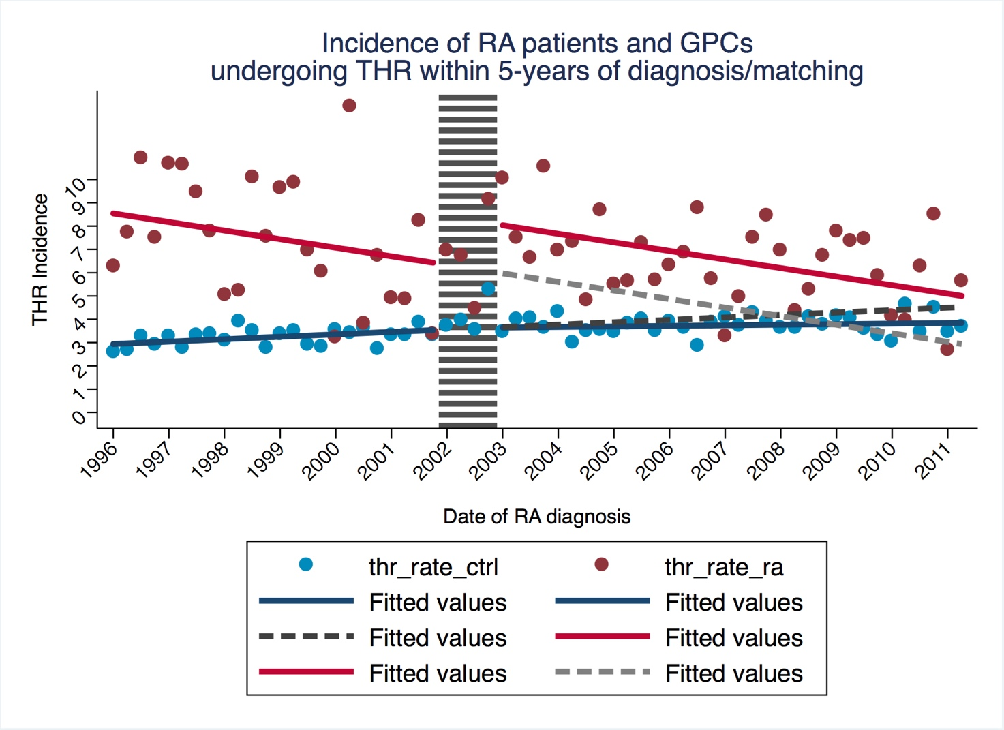

Supplementary Figure . Results from interrupted time series analysis of changes in 5-year incidence rates (per 1000 person years) of total hip replacement in patients with rheumatoid arthritis (RA) and matched general population comparators (GPC) using 3-month period data.

|  |  |  |  |  |  |  |
| --- | --- | --- | --- | --- | --- | --- |
| **Supplementary Table 4. Interrupted Time-Series Regression Analysis: 5-year incidence rate of total knee replacements among rheumatoid arthritis (RA) patients and matched general population comparators (GPC) diagnosed /matched in 3-month intervals from Jan 1st 1996- May 31st 2011 with a lag period in 2002.** | | | | | | |
|  | **Parameter** | **Coefficient** | **Lower 95% C.I.** | **Upper 95% C.I.** | **Standard error** | **P-Value** |
| **RA** | **Intercept** | 5,89 | 4,84 | 6,94 | 0,52 | 0,001 |
| **Trend (per 6 months)** | 0,05 | -0,01 | 0,10 | 0,03 | 0,095 |
| **Level change after 2003** | **-** | - | - | - | - |
| **Trend change after 2003** | -0,10 | -0,19 | 0,01 | 0,05 | 0,030 |
| **GPC** | **Intercept** | 0,46 | 0,25 | 0,67 | 0,10 | 0,001 |
| **Trend (per 6 months)** | 0,05 | 0,04 | 0,06 | 0,01 | 0,001 |
| **Level change after 2003** | - | - | - | - | - |
| **Trend change after 2003** | -0,03 | -0,05 | -0,01 | 0,01 | 0,001 |

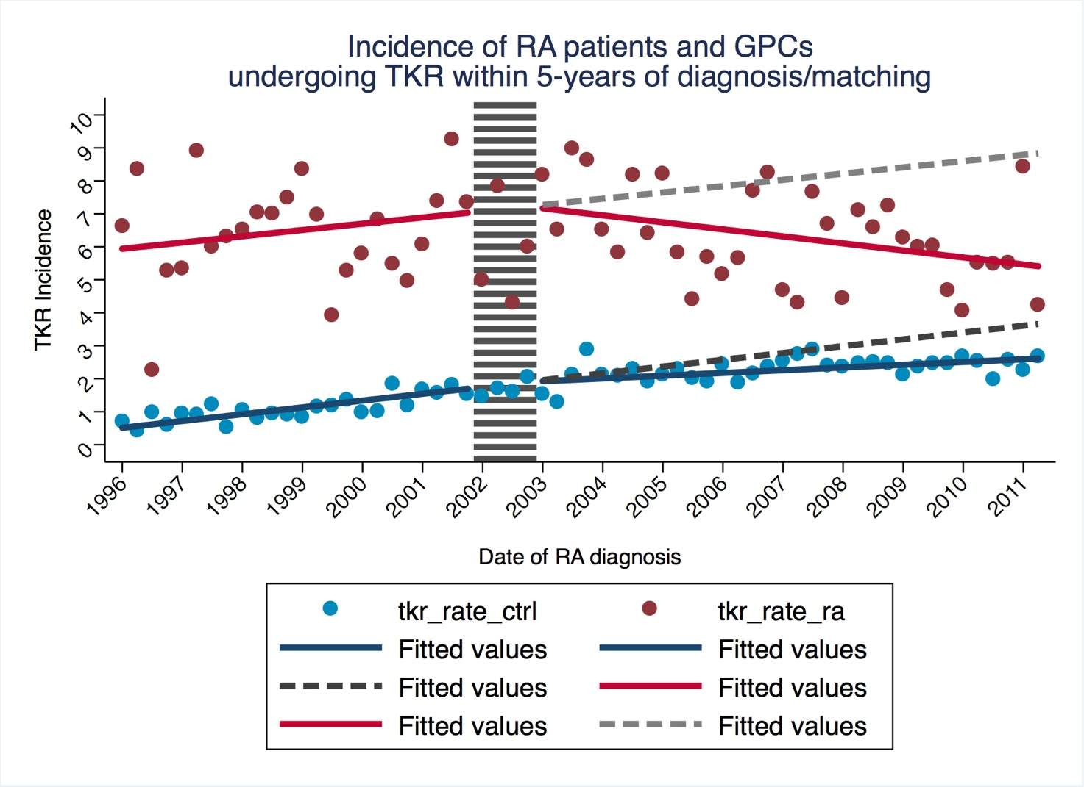

Supplementary Figure . Results from interrupted time series analysis of changes in 5-year incidence rates (per 1000 person years) of total knee replacement in patients with rheumatoid arthritis (RA) and matched general population comparators (GPC) using 3-month period data.

|  |  |  |  |  |  |  |  |  |  |  |  |  |  |  |
| --- | --- | --- | --- | --- | --- | --- | --- | --- | --- | --- | --- | --- | --- | --- |
| **Supplementary Table 5. Prevalence of pre-existing comorbidities among incident rheumatoid arthritis (RA) patients and general population comparators (GPC) according to year of diagnosis.** | | | | | | | | | | | | | | |
|  | **Incident cases, N** | | **Pre-existing  ischemic heart disease** | | **History of cancer  (including skin cancer)** | | **History of depression** | | **Pre-existing diabetes** | | **Pre-existing obesity** | | **Pre-existing COPD** | |
| **Year of diagnosis** | **RA** | **GPC** | **RA** | **GPC** | **RA** | **GPC** | **RA** | **GPC** | **RA** | **GPC** | **RA** | **GPC** | **RA** | **GPC** |
| **1996** | 1,815 | 17,837 | 11% | 9% | 6% | 8% | 1% | 0% | 3% | 3% | 1% | 2% | 4% | 4% |
| **1997** | 1,852 | 18,349 | 12% | 9% | 6% | 8% | 1% | 1% | 4% | 3% | 2% | 2% | 4% | 4% |
| **1998** | 1,808 | 17,770 | 11% | 10% | 6% | 8% | 1% | 1% | 5% | 4% | 2% | 2% | 4% | 4% |
| **1999** | 1,982 | 19,559 | 12% | 10% | 7% | 8% | 1% | 1% | 3% | 3% | 2% | 1% | 4% | 4% |
| **2000** | 1,918 | 18,867 | 14% | 11% | 8% | 9% | 1% | 1% | 5% | 3% | 3% | 2% | 5% | 4% |
| **2001** | 1,857 | 18,313 | 14% | 11% | 8% | 9% | 2% | 1% | 4% | 4% | 2% | 2% | 5% | 4% |
| **2002** | 1,739 | 17,116 | 14% | 11% | 7% | 9% | 2% | 1% | 4% | 4% | 3% | 2% | 6% | 4% |
| **2003** | 1,831 | 17,990 | 15% | 12% | 7% | 9% | 1% | 1% | 5% | 4% | 3% | 2% | 6% | 4% |
| **2004** | 2,110 | 20,656 | 15% | 12% | 7% | 9% | 2% | 1% | 5% | 4% | 3% | 2% | 6% | 4% |
| **2005** | 2,080 | 20,503 | 14% | 12% | 9% | 9% | 2% | 2% | 6% | 4% | 4% | 3% | 6% | 5% |
| **2006** | 2,067 | 20,366 | 15% | 13% | 7% | 9% | 2% | 2% | 6% | 5% | 4% | 3% | 6% | 4% |
| **2007** | 1,865 | 18,365 | 15% | 12% | 7% | 10% | 3% | 2% | 7% | 5% | 5% | 3% | 6% | 5% |
| **2008** | 2,146 | 21,056 | 16% | 13% | 10% | 10% | 3% | 2% | 7% | 5% | 5% | 4% | 6% | 5% |
| **2009** | 2,039 | 20,068 | 16% | 13% | 11% | 10% | 2% | 2% | 7% | 5% | 5% | 4% | 7% | 4% |
| **2010** | 2,346 | 22,999 | 13% | 13% | 9% | 10% | 3% | 2% | 6% | 5% | 6% | 5% | 5% | 4% |
| **2011** | 949 | 9286 | 17% | 13% | 12% | 9% | 4% | 3% | 7% | 5% | 7% | 5% | 7% | 4% |
| **TOTAL** | 30,404 | 299,100 | 14% | 12% | 8% | 9% | 2% | 2% | 5% | 4% | 4% | 3% | 6% | 4% |
| Abbreviations: COPD, chronic obstructive pulmonary disease. | | | | | | | | | | | | | | |