Supplementary Table 1: Fibromyalgia Rapid Screening Tool (FiRST)
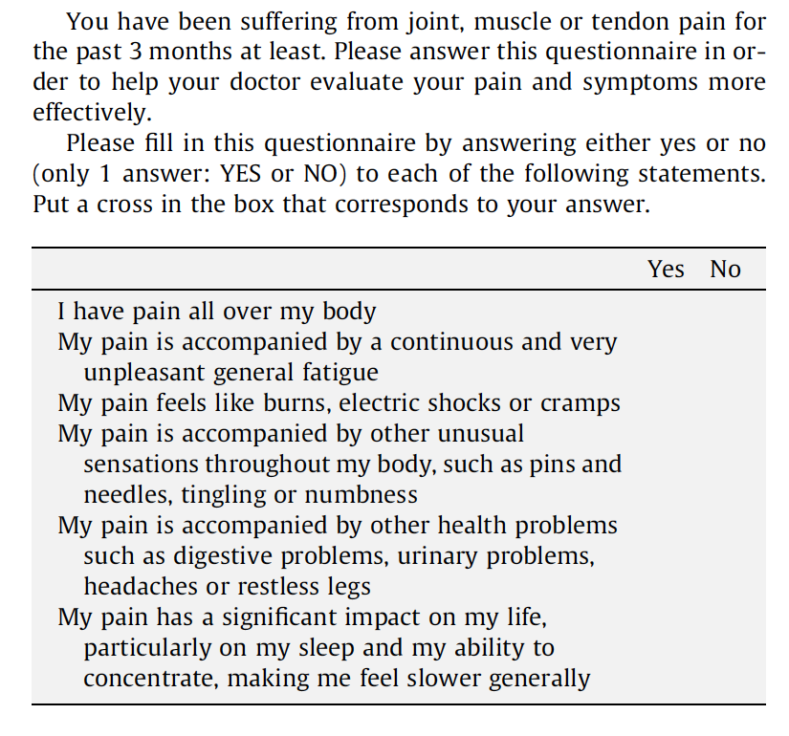
With authorization, from : Perrot S et al. Development and validation of the Fibromyalgia Rapid Screening Tool (FiRST). Pain 2010;150:250–256.

Supplementary table 2: Effectiveness endpoints of the sensitivity analysis using the 1990 ACR criteria and the ‘sustained FiRST’ definitions for fibromyalgia
Effectiveness  endpoints | All patients  N = 508 | FM according to 1990 ACR criteria |  |  |  |  |  |  | FM according to ‘sustained FiRST’***
 |  | FM |  | Crude OR [95% CI]† | p ** | Adjusted OR [95% CI]§ | p |  | FM |  | Crude OR [95% CI]† | p | Adjusted OR [95% CI]§ | p
 |  | Yes  n = 82 | No  n = 426 |  |  |  |  |  | Yes  n = 93 | No  n = 411
BASDAI response* | 258/508 (50.8%) | 38/82 (46.3%) | 220/426 (51.6%) | 0.8 [0.5-1.3] | NS | 0.8 [0.5-1.5] | NS |  | 26/93 (27.7%) | 231/411 (56.2%) | 0.3 [0.2-0.5] | <0.001 | 0.3 [0.2-0.5] | <0.001
ASAS 40 | 201/508 (39.6%) | 25/82 (30.5%) | 176/426 (41.3%) | 0.6 [0.4-1.0] | NS | 0.7 [0.4-1.3] | NS |  | 8/93 (18.5%) | 192/411 (46.7%) | 0.1 [0.1-0.2] | <0.001 | 0.1 [0.1-0.3] | <0.001
ASAS 20 | 268/508 (52.8%) | 40/82 (48.8%) | 228/426 (53.5%) | 0.8 [0.5-1.3] | NS | 1.0 [0.6-1.7] | NS |  | 20/93 (21.5%) | 247/411 (60.1%) | 0.2 [0.1-0.3] | <0.001 | 0.2 [0.1-0.4] | <0.001
ASDAS MI | 117/508 (23.0%) | 14/82 (17.1%) | 103/426 (24.2%) | 0.7[0.4-1.2] | NS | 0.8 [0.4-1.6] | NS |  | 8/93 (8.6%) | 108/411 (26.3%) | 0.3[0.1-0.6] | <0.001 | 0.3 [0.1-0.7] | 0.005
ASDAS CII | 265/508 (52.2%) | 40/82 (48.8%) | 225/426 (52.8%) | 0.9[0.5-1.4] | NS | 1.1[0.6-1.8] | NS |  | 23/93 (24.7%) | 241/411 (58.6%) | 0.2[0.1-0.4] | <0.001 | 0.3[0.2-0.5] | <0.001
Δ NSAID-score ≥50% | 235/508 (46.3%) | 29/82 (35.4%) | 206/426 (48.4%) | 0.6 [0.4-0.9] | 0.03 | 0.6[0.4-1.0] | NS |  | 22/93 (23.7%) | 213/411 (51.8%) | 0.3 [0.2-0.5] | <0.001 | 0.3[0.2-0.6] | <0.001
Δ CRP>0 mg/L | 325/508 (64.0%) | 45/82 (54.9%) | 280/426 (65.7%) | 0.6 [0.4-1.0] | NS | 0.8 [0.4-1.3] | NS |  | 44/93 (47.3%) | 280/411 (68.1%) | 0.4 [0.2-0.6] | <0.001 | 0.4 [0.2-0.7] | 0.001
ASDAS MDA at 12 weeks | 264/508 (52.0%) | 24/82 (29.3%) | 240/426 (56.3%) | 0.3 [0.2-0.5] | <0.0001 | 0.4 [0.2-0.6] | <0.001 |  | 18/93 (19.3%) | 245/411 (59.6%) | 0.2 [0.1-0.3] | <0.001 | 0.2 [0.1-0.3] | <0.001
ASDAS ID at 12 weeks | 126/508 (24.8%) | 5/82 (6.1%) | 121/426 (28.4%) | 0.2 [0.1-0.4] | <0.001 | 0.2 [0.1-0.5] | <0.001 |  | 4/93 (4.3%) | 121/411 (29.4%) | 0.1 [0.0-0.3] | <0.001 | 0.1 [0.0-0.3] | <0.001
NSAID score ≤10 at 12 weeks | 401/508 (78.9%) | 60/82 (73.2%) | 341/426 (80.0%) | 0.7[0.4-1.2] | NS | 0.6 [0.4-1.2] | NS |  | 62/93 (66.7%) | 339/411 (82.4%) | 0.4[0.3-0.7] | <0.001 | 0.4 [0.3-0.7] | 0.001
CRP <6mg/L at 12 weeks | 392/508 (77.2%) | 59/82 (72.0%) | 333/426 (78.2%) | 0.7 [0.4-1.2] | NS | 0.8 [0.5-1.5] | NS |  | 72/93 (77.4%) | 316/411 (76.9%) | 1.0 [0.6-1.7] | NS | 0.9 [0.5-1.6] | NS
*Data in the table are presented number and (%). **Statistical significance was established for p<0.05 ***: defined by a FiRST=>5/6 both at the baseline and effectiveness visits (only available for n=506 patients) : † Crude OR: result of the univariable analysis § Adjusted OR for age (below 40). gender (male)< past or present X-ray sacroiliitis, past or present MRI sacroiliitis, abnormal CRP, Smoking status, HLA B27, and absence of previous TNFb exposure.
Abbreviations: BASDAI: Bath Ankylosing Spondylitis Disease Activity Score; ASDAS: Ankylosing Spondylitis Disease activity Index; ASDAS MI: ASDAS Major Improvement; ASDAS CII: ASDAS clinically important improvement; NSAID: Non-steroidal anti-inflammatory drugs; CRP: C-reactive protein; ASDAS MDA: ASDAS minimal disease activity; ASDAS ID: ASDAS inactive disease

