Supplementary material
Study selection process
The following Boolean keywords were used for the Pubmed, Embase or Cochrane Central search: (“abatacept“ [All fields] or “adalimumab” [All fields] or “certolizumab pegol” [All fields] or “etanercept” [All fields] or “golimumab” [All fields] or “infliximab” [All fields] or “tocilizumab“ [All fields]) and “rheumatoid arthritis” [All fields] ) and ( “reduction” [All fields] or “discontinuation” [All fields] or “withdrawal” [All fields]) and ( “remission” [All fields] or “low disease activity” [All fields]).

Data collection
The following data were systematically collected: name of the first author, year of publication, study design, assessed bDMARD, conventional synthetic DMARD and glucocorticoids comedications, bDMARD tapering schedule, disease duration before inclusion in the trial, bDMARD duration before starting the trial, inclusion criteria in the trial, the endpoint, the number of relapsing patients, defined either by the occurrence of a flare-up or by the loss of remission or LDA, the number of patients with no radiographic progression (defined by a variation in the Sharp-van der Heijde score (ΔmTSS) <0.5), factors associated with an increased risk of relapse, the number of patients returning to remission or LDA after reinstating bDMARDs or after returning to the initial regimen.

Study quality assessment
For each study included, sequence generation, allocation concealment, blinding of participants, personnel and outcome assessors, incomplete outcome data, selective outcome reporting and other possible sources of bias were assessed. This risk of bias was defined as high, uncertain or low for each item.

Among the 17 trials selected, 2 studies were controlled but not randomized,(22,23) bDMARD discontinuation being left up to the patient. Maintaining blinding for the treatment group was not guaranteed in 6 studies. (16,17, 22-24) The reasons justifying the absence of double blinding were 1/ the choice of a spacing strategy, or 2/ the choice of a “treat-to-target” strategy requiring knowledge of the treatments received by the patient to adapt doses. The data from the 4 abstracts (29-31) were insufficient for a reliable assessment of the risks of bias.

Table S1: Evaluation of quality of the selected studies (Cochrane Collaboration’s risk of Bias Assessement Tool) (15). H : High. U : Unclear. L : Low.

RISK OF BIAS  ASSESSMENT TOOL  (Cochrane Library) | Allocation Concealment? | Sequence generation? | Blinding? | Selective reporting? | Incomplete outcome? | Other biases?
AGREE Westhovens ARD 2015 (26) | U | L | L | L | L | L
Takeuchi Rheumatol 2015 (22) | H | H | H | L | L | L
ADMIRE Chatzidionysiou RMD Open 2016 (16) | U | L | H | U | L | U
HONOR Tanaka ARD 2015 (23) | H | H | H | U | L | L
OPTIMA Smolen Lancet 2014 (20) | L | L | L | L | L | L
DOSERA van Vollenhoven ARD 2016 (25) | U | U | L | L | L | L
PRESERVE Smolen Lancet 2013 (21) | L | L | L | U | L | L
DRESS van Herwaarden BMJ 2015 (24) | L | L | H | L | L | L
POET Ghiti Moghadam Arthritis Rheumatol 2016 (18) | L | L | H | L | L | L
STRASS Fautrel ARD 2016 (17) | L | U | H | U | L | L
Raffeiner Clin Exp Rheumatol 2015 (19) | H | L | L | U | L | L
Yamanaka Mod Rheumatol 2016 (27) | H | L | L | U | L | L
Weinblatt ARD 2017 (26) | L | L | L | L | L | L
Botsios EULAR ARD 2007 (28) | U | U | U | U | U | U
OPTTIRA Galloway EULAR ARD 2015 (29) | U | U | U | U | U | U
Okano EULAR ARD 2015 (31) | U | U | U | U | U | U
Giollo EULAR ARD 2015 (30) | H | U | U | U | U | U

Interpretation of risk of bias (Cochran tool):
Risk of bias | Low risk | High risk | Unclear
Allocation concealment | Intervention allocations likely could not have been foreseen in before or during enrollment | Selection bias (biased allocation to interventions) due to inadequate concealment of allocations prior to assignment | Not described in sufficient detail
Random sequence generation | Random sequence generation method should produce comparable group | Selection bias (biased allocation to interventions) due to inadequate generation of a randomized sequence | Not described in sufficient detail
Blinding | Blinding was likely effective. | Performance bias due to knowledge of the allocated interventions by participants and personnel during the study. | Not described in sufficient detail
Selective reporting | Selective outcome reporting bias not detected | Reporting bias due to selective outcome reporting | Insufficient information to permit judgment
Other bias | No other bias detected | Bias due to problems not covered elsewhere in the table | There may be a risk of bias, but there is either insufficient information to assess whether an important risk of bias exists or insufficient rationale or evidence that an identified problem will introduce bias

Figures S2: Funnel plot representing selection bias risk:
- Risk of losing remission in case of bDMARD discontinuation versus continuation
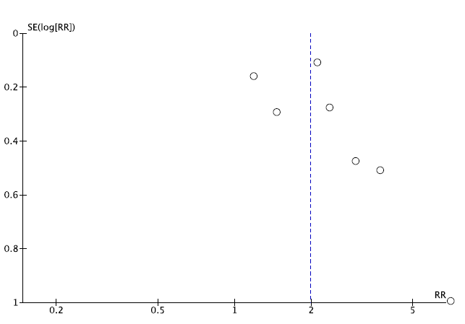
P value (Egger test) = 0.445

- Risk of losing LDA in case of bDMARD discontinuation versus continuation
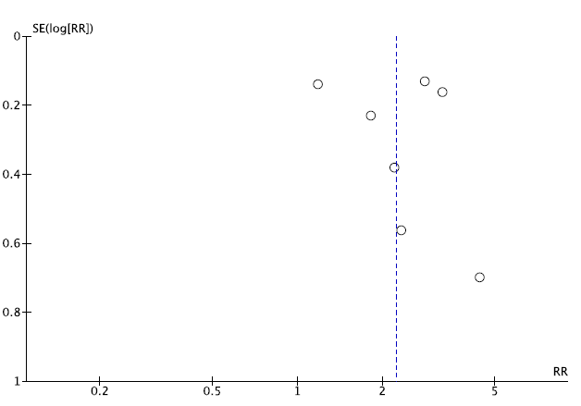
P value (Egger test) = 0.615

- Risk of structural progression in case of bDMARD discontinuation versus continuation

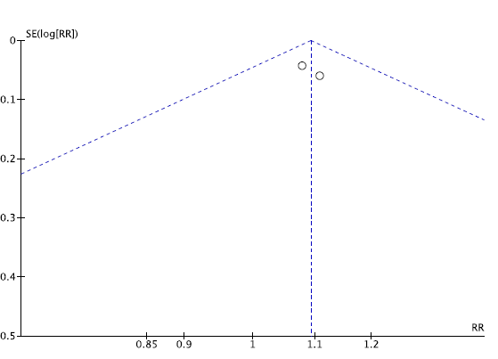
P value (Egger test) = 0.591

- Risk of losing remission in case of bDMARD tapering versus continuation
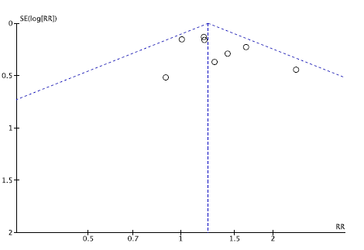
P value (Egger test) = 0.425

- Risk of losing LDA in case of bDMARD tapering versus continuation
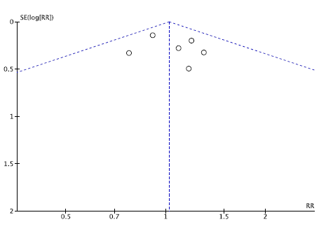
P value (Egger test) = 0.985

- Risk of structural progression in case of bDMARD tapering versus continuation
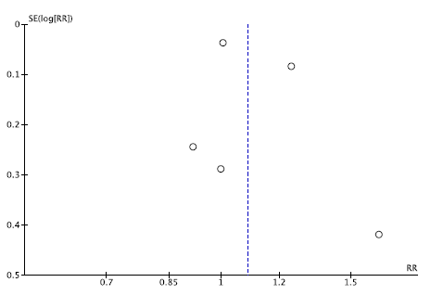
P value (Egger test) = 0.534
Figure S3: Risk of losing remission, LDA or structural progression in case of bDMARD discontinuation versus continuation, sensibility analysis removing observational studies.
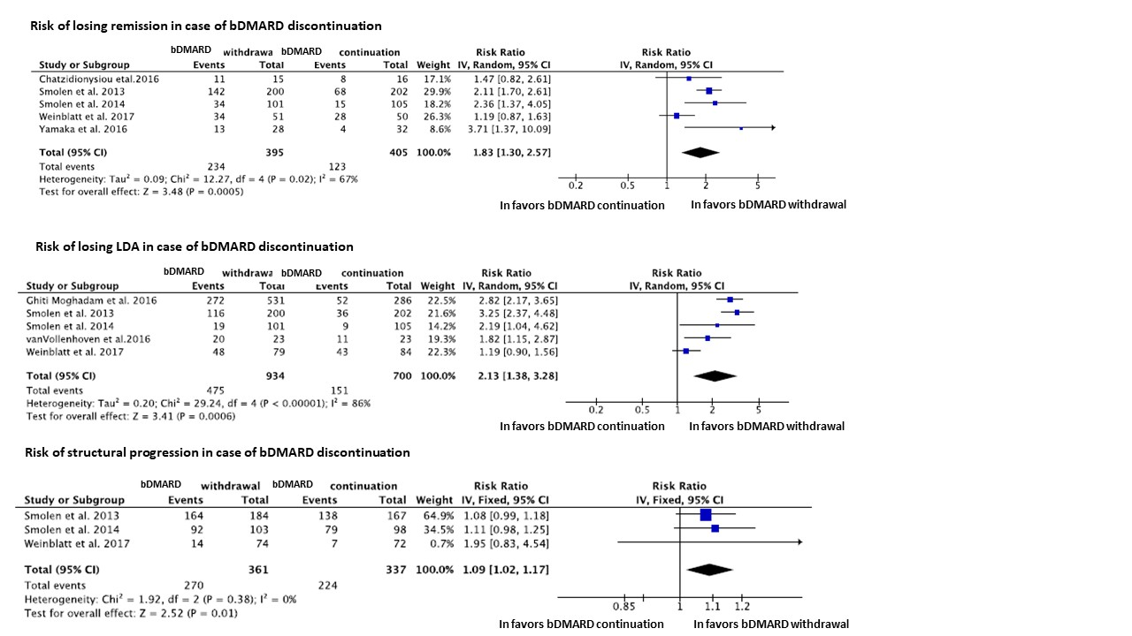
Figure S4: Risk of losing remission in case of bDMARD tapering versus continuation removing the abstract presented in 2007.
Table S5: Factors associated with the risk of losing remission or LDA:

Study | Factor associated with the risk of losing remission or LDA | Comparison
Tanaka [23] | DAS28 | Risk of maintaining remission according to DAS28: OR[95%CI]=0.094 [0.020-0.438], p=0.026
Ghiti Moghadam [1] | Baseline DAS28 score  Disease duration > 10 years | Risk of a shorter time to flare:  DAS28: HR[95%CI]= 1.39 [1.21–1.60]  Disease duration > 10 years :  HR[95%CI]= 1.29[1.03–1.61]
Takeuchi [2] | With remission:  Baseline HAQ  Baseline CRP  With LDA:  Baseline HAQ ≤ 0.5  Mean time-averaged DAS28-CRP | Risk of losing remission:  HAQ: p=0.036  CRP: p=0.048  Risk of losing LDA:  HAQ ≤ 0.5: 100% in patients maintaining LDA versus 41.7% I those losing LDA, p=0.016  Mean time-averaged DAS28-CRP: 1.9 (SD: 0.4) in patients maintaining LDA versus 3.0 (SD: 0.7) in patients losing LDA, p<0.0001
Fautrel [3] | Baseline HAQ score  Positive RF | Risk of flare:  HAQ: HR[95%CI]=2.07[1.23-3.49]  Positive RF: HR[95%CI]=1.99[1.03-3.83]
van Vollenhoven [4] | Patient pain VAS  mESS | Risk of failure:  Pain VAS: OR [95%CI]= 1.08 [1.01-1.15]  mESS : OR [95%CI]= 1.05 [1.02-1.09]
Yamanaka [5] | SDAI | Risk of maintaining remission  SDAI: p=0.015
LAD: low disease activity; DAS28: Disease activity score on 28 joints; HAQ: Health Assessment Questionnaire; OR: Odds ratios: CI: confidence interval; SD: standard deviation; RF: rheumatoid factor; VAS: Visual Analogic score; mESS: van der Heijde modified erosion Sharp score; SDAI: simple disease activity index

