Appendix Figure 1: Flow diagram showing patient selection
Linked to Medicare claims
77,641 MBDA tests
46,088 subjects
Excluded due to conditions, medications or vaccination prior or after MBDA test; these may affect the results of MBDA test
(Tests, not mutually exclusive):
644 with Pneumococcal vaccine within 21 days prior to test
4,756 with Influenza within 21 days prior to test
79 with CPT code for zoster vaccine within 21 days prior to test
94 with NDC code for zoster vaccine within 21 days prior to test
5,767 with NDC for antibiotics within 21 days prior to test
318 with hospitalization discharge within 21 days prior to test
26 with diagnosis code for AMI (Discharge or physician visit) within 7 days after test
336 with diagnosis code for pneumonia or sepsis (Discharge or physician visit) within 14 days after test

With 12 month observable (Fee-for-service) coverage
38,204 MBDA tests
24,910 subjects

With at least one valid
MBDA tests
66,645 MBDA tests
41,179 subjects

Excluded due to not observable:
28,441 MBDA tests
16,269 subjects

Excluded due to (subjects, not mutually exclusive):
6,039 due to AS, IBD, PSA, PSO, AMI, old MI, PCI or CABG
2,590 due to non TNF biologic DMARDS use within 6 months before index date (first valid MBDA test date)

Included in SIE analysis:
17433 subjects

Included in the MI/CHD analysis:
16,796 subjects

Appendix Figure 2
Correlation between MBDA score with MBDA score minus CRP
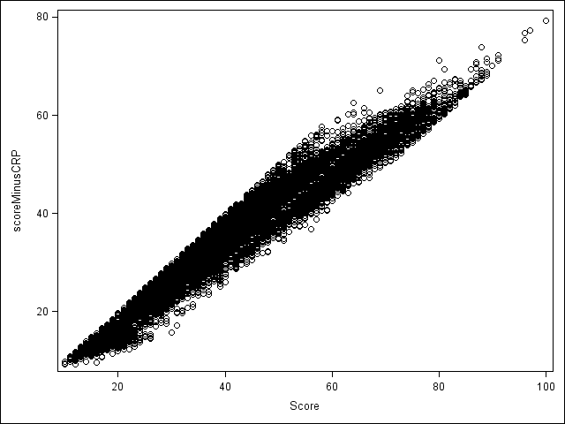

Appendix Table: Crude Incidence Rates and Adjusted Hazard Ratio of Serious Infection Events,
Myocardial Infarction, and CHD Associated with MBDA Score without CRP
 | SIE  (Primary) |  | SIE  (Primary or secondary) |  | MI  (Primary or secondary) |  | CHD  (Primary or secondary)
MBDA | IR  (95% CI) | aHR  (95% CI) | IR  (95%CI) | aHR  (95%CI) | IR  (95%CI) | aHR  (95%CI) | IR  (95%CI) | aHR  (95%CI)
Main Analysis in the overall population, MBDA as a continuous score | 2.75  (2.51, 3.02) | 1.46*  (1.34, 1.61) | 4.00  (3.71, 4.32) | 1.49*  (1.38, 1.61) | 0.82  (0.69, 0.97) | 1.13*  (0.96, 1.32) | 1.13  (0.98, 1.31) | 1.14*  (0.99, 1.32)

MBDA Quartiles
Q1 (<30) | 1.03  (0.77, 1.38) | Referent | 1.53  (1.20, 1.95) | Referent | 0.41  (0.25, 0.66) | Referent | 0.65  (0.45, 0.95) | Referent
Q2 (30-37) | 2.01  (1.62, 2.49) | 1.64  (1.14, 2.35) | 2.83  (2.36, 3.39) | 1.55  (1.14, 2.10) | 0.82  (0.58, 1.15) | 1.64  (0.91, 2.95) | 1.01  (0.75, 1.38) | 1.35  (0.83, 2.19)
Q3 (37-43) | 3.08  (2.59, 3.67) | 2.32  (1.64, 3.28) | 4.31  (3.71, 5.00) | 2.19  (1.64, 2.93) | 1.01  (0.74, 1.37) | 1.85  (1.04, 3.30) | 1.37  (1.05, 1.78) | 1.69  (1.05, 2.70)
Q4 (43-79) | 5.08  (4.42, 5.83) | 3.03  (2.16, 4.27) | 7.64  (6.81, 8.56) | 3.12  (2.35, 4.13) | 1.08  (0.80, 1.46) | 1.62  (0.91, 2.90) | 1.52  (1.18, 1.96) | 1.57  (0.98, 2.51)
*per 10 unit increase in the MBDA

MBDA = multi-biomarker disease activity; SIE = Serious infection event (hospitalized pneumonia or sepsis); MI = myocardial infarction; CHD = MI, PCI, or CABG; IR=incidence rate per 100 patient years
aHR= adjusted hazard ratio, controlling for age, sex and race, acute myocardial infarction, CHD, heart failure, stroke, abdominal aortic aneurysm, peripheral arterial disease, atrial fibrillation, diabetes, hyperlipidemia, hypertension, obesity, smoking, chronic kidney disease, chronic obstructive pulmonary disease, pneumonia, sepsis, fibromyalgia, peptic ulcer disease, fracture, skin ulcer, prostate-specific antigen, Papanicolaou smear, mammography, use of hydroxychloroquine, leflunomide, sulfasalazine, or biologics, glucocorticoid dose, methotrexate dose, and reason for eligibility for Medicare (e.g., disability). The MI and CHD models did not control for prior acute myocardial infarction or CHD events since these patients were excluded from that outcome.

