Supplementary Tables and Figures

Pathway | miRNAs contributing to the enrichment of pathways
Pathways in cancer | hsa-miR-16-5p;hsa-miR-181c-5p;hsa-miR-374a-5p;hsa-let-7e-5p;hsa-miR-27b-3p;  hsa-miR-26a-5p;hsa-miR-665;hsa-miR-222-3p;hsa-miR-31-3p;hsa-miR-30b-5p;  hsa-miR-30c-5p;hsa-miR-28-5p;hsa-miR-155-5p;hsa-miR-378a-3p;  hsa-miR-486-5p;hsa-miR-140-3p;hsa-miR-296-5p;hsa-miR-18a-3p;hsa-miR-425-3p
PI3K-Akt signaling pathway | hsa-miR-26a-5p;hsa-miR-374a-5p;hsa-miR-27b-3p;hsa-let-7e-5p;hsa-miR-30b-5p;  hsa-miR-30c-5p;hsa-miR-28-5p;hsa-miR-16-5p;hsa-miR-155-5p;hsa-miR-486-5; hsa-miR-140-3p;hsa-miR-31-3p;hsa-miR-222-3p;hsa-miR-665;hsa-miR-181c-5p;hsa-miR-18a-3p;hsa-miR-296-5p;hsa-miR-425-3p;hsa-miR-378a-3p
TGF-beta signaling pathway | hsa-miR-374a-5p;hsa-miR-27b-3p;hsa-miR-16-5p;hsa-miR-30b-5p;hsa-miR-30c-5p;  hsa-let-7e-5p;hsa-miR-486-5p;hsa-miR-665;hsa-miR-181c-5p;hsa-miR-155-5p;  hsa-miR-140-3p;hsa-miR-222-3p;hsa-miR-378a-3p;hsa-miR-26a-5p
Supplementary Table 1. MiRNA contributing to the top canonical pathways influenced by differentially expressed miRNAs in T cells.

Pathway | miRNAs contributing to the enrichment of pathways
Wnt signaling pathway | hsa-miR-222-3p;hsa-miR-26a-5p;hsa-miR-141-3p;hsa-miR-582-5p;hsa-miR-20a-5p;hsa-miR-29b-2-5p;hsa-miR-378a-3p;hsa-miR-19b-3p;hsa-miR-148b-3p;hsa-miR-193a-3p;hsa-miR-30b-5p;hsa-miR-505-3p;hsa-miR-107;hsa-miR-195-5p;  hsa-miR-32-5p;hsa-miR-484;hsa-miR-374a-5p;hsa-miR-324-3p;hsa-miR-491-5p;hsa-miR-502-5p;hsa-miR-324-5p
Pathways in cancer | hsa-miR-26a-5p;hsa-miR-374a-5p;hsa-miR-502-5p;hsa-miR-582-5p;hsa-miR-107;hsa-miR-195-5p;hsa-miR-20a-5p;hsa-miR-30b-5p;hsa-miR-141-3p;hsa-miR-222-3p;hsa-miR-148b-3p;hsa-miR-151a-3p;hsa-miR-29b-2-5p;hsa-miR-324-3p;hsa-miR-32-5p;hsa-miR-484;hsa-miR-19b-3p;hsa-miR-491-5p;hsa-miR-193a-3p;  hsa-miR-378a-3p;hsa-miR-18a-3p;hsa-miR-324-5p
PI3K-Akt signaling pathway | hsa-miR-222-3p;hsa-miR-29b-2-5p;hsa-miR-20a-5p;hsa-miR-19b-3p;hsa-miR-491-5p;hsa-miR-374a-5p;hsa-miR-141-3p;hsa-miR-32-5p;hsa-miR-195-5p;hsa-miR-148b-3p;hsa-miR-502-5p;hsa-miR-107;hsa-miR-30b-5p;hsa-miR-193a-3p;hsa-miR-26a-5p;hsa-miR-484;hsa-miR-582-5p;hsa-miR-378a-3p;hsa-miR-324-5p;hsa-miR-18a-3p;hsa-miR-151a-3p
Supplementary Table 2. MiRNA contributing to the top canonical pathways influenced by differentially expressed miRNAs in B cells.

anti-SSA+ patients vs. controls |  |  |  | anti-SSA-patients vs. controls
miRNAs | fold  change  in CD4 cells | p value | miRNAs |  |  | fold  change  in CD4 cells | p value
hsa-let-7d-3p | -2.20 | 1.21•10⁻⁵ | hsa-let-7d-3p |  |  | -3.10 | 2.14•10⁻⁶
hsa-miR-26a-5p | -1.36 | 1.79•10⁻⁴
hsa-miR-378a-3p | -1.44 | 7.07•10⁻⁴ | hsa-miR-378a-3p |  |  | -1.21 | 0.045
hsa-miR-28-5p | 1.34 | 7.34•10⁻⁴ | hsa-miR-28-5p |  |  | 1.40 | 0.002
hsa-miR-30c-5p | -1.18 | 0.002 | hsa-miR-181c-5p |  |  | 1.67 | 0.004
hsa-miR-23b-3p | -1.34 | 0.006 | hsa-miR-874 |  |  | -1.22 | 0.016
hsa-let-7e-5p | -1.45 | 0.006 | hsa-miR-140-5p |  |  | 1.14 | 0.019
hsa-miR-30b-5p | -1.21 | 0.007 | hsa-miR-155-5p |  |  | 1.36 | 0.022
hsa-miR-598 | -1.45 | 0.008 | hsa-miR-665 |  |  | -1.61 | 0.039
hsa-miR-140-3p | 1.17 | 0.012 | hsa-let-7g-5p |  |  | 1.14 | 0.029
hsa-miR-425-3p | -1.30 | 0.013 | hsa-miR-425-3p |  |  | -1.37 | 0.001
hsa-miR-505-3p | -1.56 | 0.014 | hsa-miR-296-5p |  |  | 1.34 | 0.035
hsa-miR-23a-3p | -1.32 | 0.017 | hsa-miR-31-5p |  |  | -1.37 | 0.046
hsa-miR-486-5p | 1.55 | 0.018 | hsa-miR-486-5p |  |  | 1.58 | 0.024
hsa-miR-27b-3p | -1.34 | 0.023 | hsa-miR-95 |  |  | 1.32 | 0.046
hsa-miR-374a-5p | -1.23 | 0.028 | hsa-miR-22-3p |  |  | 1.47 | 0.049
hsa-miR-31-3p | -1.37 | 0.031 | hsa-miR-31-3p |  |  | -1.52 | 0.039
hsa-let-7i-5p | 1.12 | 0.038
hsa-miR-107 | 1.21 | 0.042
hsa-miR-330-3p | 1.48 | 0.042
hsa-miR-146a-5p | 1.33 | 0.044
hsa-miR-484 | 1.30 | 0.047

Supplementary Table 3. Differentially expressed miRNAs with a p-value < 0.05 in the discovery cohort in T lymphocytes (TL) from anti-SSA+ pSS patients and anti-SSA- pSS patients compared to the controls, respectively. MiRNAs present in both anti-SSA positive and negative patients are highlighted in bold letters. Nominal p-values without correction for multiple comparisons are shown.

anti-SSA+ patients vs. controls |  |  |  |  |  | anti-SSA- patients vs. controls
miRNAs | fold  change in CD19 cells | p value | miRNAs | fold  change in CD19 cells | p value | miRNAs | fold  change in CD19 cells | p value
hsa-miR-324-5p | 2.06 | 2.40•10⁻⁴ | hsa-miR-32-5p | -1.77 | 0.013 | hsa-let-7d-3p | -1.99 | 0.003
hsa-miR-26a-5p | -1.55 | 3.30•10⁻⁴ | hsa-miR-29b-2-5p | 1.49 | 0.013 | hsa-miR-210 | 1.52 | 0.006
hsa-miR-20a-5p | -1.25 | 3.82•10⁻⁴ | hsa-miR-29b-3p | -1.81 | 0.015
hsa-miR-107 | 1.43 | 6.44•10⁻⁴ | hsa-miR-199a-5p | 3.23 | 0.016 | hsa-miR-107 | 1.28 | 0.022
hsa-miR-222-3p | 1.60 | 6.70•10⁻⁴ | hsa-miR-362-5p | 1.61 | 0.017 | hsa-miR-222-3p | 1.34 | 0.003
hsa-miR-30b-5p | -1.63 | 7.72•10⁻⁴ | hsa-miR-30c-5p | -1.25 | 0.020 | hsa-miR-30b-5p | -1.41 | 0.002
hsa-miR-19b-3p | -1.58 | 8.10•10⁻⁴ | hsa-miR-505-3p | -1.94 | 0.021
hsa-miR-484 | 1.78 | 9.75•10⁻⁴ | hsa-miR-582-5p | -1.63 | 0.021 | hsa-miR-582-5p | -1.72 | 0.041
hsa-miR-141-3p | -2.50 | 0.001 | hsa-miR-19a-3p | -1.32 | 0.026 | hsa-miR-125b-5p | -2.02 | 0.040
hsa-miR-454-3p | 1.25 | 0.003 | hsa-miR-192-5p | -1.44 | 0.026
hsa-miR-15a-5p | -1.39 | 0.003 | hsa-miR-130b-3p | 1.73 | 0.026 | hsa-miR-148b-3p | -1.21 | 0.044
hsa-miR-652-3p | 1.57 | 0.004 | hsa-miR-18a-5p | 1.46 | 0.027 | hsa-miR-27b-3p | -1.53 | 0.048
hsa-miR-195-5p | -1.89 | 0.004 | hsa-miR-106b-5p | -1.19 | 0.028
hsa-miR-378a-3p | -1.55 | 0.004 | hsa-miR-103a-3p | 1.26 | 0.029
hsa-miR-324-3p | 1.27 | 0.005 | hsa-miR-365a-3p | 1.55 | 0.031 | hsa-miR-324-3p | 1.17 | 0.025
hsa-miR-18b-5p | 1.64 | 0.007 | hsa-miR-26b-5p | -1.39 | 0.032
hsa-miR-128 | 1.69 | 0.007 | hsa-miR-101-3p | -1.62 | 0.033
hsa-miR-18a-3p | 2.05 | 0.008 | hsa-miR-139-5p | 2.46 | 0.035 | hsa-miR-18a-3p | 1.83 | 0.021
hsa-miR-374a-5p | -1.66 | 0.008 | hsa-miR-142-5p | -1.67 | 0.046
hsa-miR-215 | -1.53 | 0.008 | hsa-miR-486-5p | 1.69 | 0.048
hsa-miR-151a-3p | 1.44 | 0.012 |  |  |  | hsa-miR-151a-3p | 1.37 | 0.021

Supplementary Table 4. Differentially expressed miRNAs with a p-value < 0.05 in the discovery cohort in B lymphocytes (BL) from anti-SSA+ pSS patients and anti-SSA- pSS patients compared to the controls, respectively. MiRNAs present in both anti-SSA positive and negative patients are highlighted in bold letters. Nominal p-values without correction for multiple comparisons are shown.

miRNAs | fold change in  CD19 cells | p value
hsa-miR-210 | -1.48 | 5.90•10⁻⁴
hsa-miR-26a-5p | -1.47 | 0.001
hsa-miR-362-5p | 2.00 | 0.002
hsa-miR-484 | 1.75 | 0.005
hsa-miR-199a-5p | 3.82 | 0.007
hsa-miR-652-3p | 1.67 | 0.008
hsa-miR-140-5p | -1.37 | 0.009
hsa-miR-15a-5p | -1.36 | 0.011
hsa-miR-20a-5p | -1.20 | 0.013
hsa-miR-454-3p | 1.25 | 0.013
hsa-miR-18b-5p | 1.60 | 0.014
hsa-miR-99b-5p | 3.45 | 0.016
hsa-miR-19b-3p | -1.44 | 0.018
hsa-miR-103a-3p | 1.31 | 0.018
hsa-miR-128 | 1.68 | 0.019
hsa-miR-145-5p | 4.89 | 0.019
hsa-miR-324-5p | 1.56 | 0.021
hsa-miR-215 | -1.70 | 0.022
hsa-miR-199b-5p | 2.04 | 0.028
hsa-miR-125a-5p | 2.77 | 0.032
hsa-miR-30c-5p | -1.17 | 0.038
hsa-miR-29b-3p | -1.77 | 0.039
hsa-miR-126-5p | 3.39 | 0.040
hsa-miR-25-3p | -1.22 | 0.046
hsa-miR-18a-5p | 1.42 | 0.047

Supplementary Table 5. Differentially expressed miRNAs with a p-value < 0.05 in the discovery cohort in B Lymphocytes from anti-SSA+ pSS patients compared to anti-SSA- pSS patients. Nominal p-values without correction for multiple comparisons are shown.

T cells |  |  |  |  | B cells
miRNAs | in human panel I |  |  | Previous association with diseases |  | miRNAs | in human panel I | Previous association with diseases
hsa-let-7d-3p |  | + | MS [1] |  |  | hsa-miR-30b-5p | + | pSS [2]
hsa-miR-28-5p |  | + | RA [3] |  |  | hsa-miR-222-3p | + | pSS [2]
hsa-miR-378a-3p |  | + | INF [4] |  |  | hsa-miR-18a-3p | + | miR17-92 cluster [5], pSS [6]
hsa-miR-26a-5p |  | + | MS [7], BC[8] |  |  | hsa-miR-19b-3p | + | miR17-92 cluster [5], pSS [6]
hsa-miR-30b-5p |  | + | pSS [2] |  |  | hsa-miR-26a-5p | + | MS [7]
hsa-miR-140-3p |  | + | T1D [9] |  |  | hsa-miR-20a-5p | + | MS [10]
hsa-miR-30c-5p |  | + | T1D [9] |  |  | hsa-miR-32-5p | + | MS [11]
hsa-miR-155-5p |  | + | pSS [12, 13] |  |  | hsa-let-7d-3p | + | MS [1]
hsa-miR-31-3p |  | + | SLE [14] |  |  | hsa-miR-378a-3p | + | INF [4]
hsa-miR-222-3p |  | + | pSS [2] |  |  | hsa-miR-146a-5p | - | pSS [12, 13], SLE [15], RA [16, 17]
hsa-miR-16-5p |  | + | SLE [18]
hsa-miR-146a-5p |  | - | pSS [12, 13], SLE [15], RA [16, 17]

Supplementary Table 6. Significantly differentially expressed miRNAs identified in the discovery cohort that were chosen for validation in the replication cohort. ‘+’ denotes miRNAs that were found significantly differentially expressed in the discovery cohort using the human panel I; ‘-̓ denotes miRNAs that were not found significantly expressed in the discovery cohort human panel I but nonetheless included due to previous reports; INF: Inflammation,;MS: Multiple sclerosis pSS: primary Sjøgren’s syndrome; RA: rheumatoid arthritis; SLE: systemic lupus erythematosus; T1D type 1 diabetes.
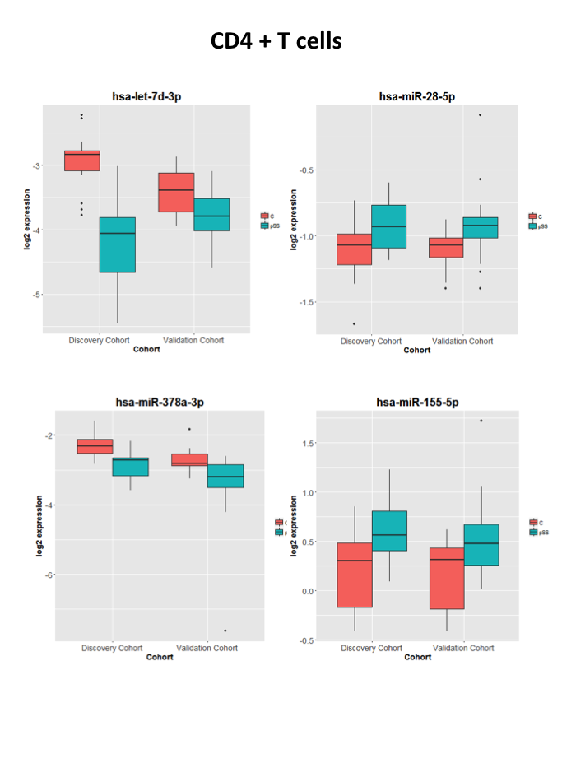
Supplementary Figure 1. Representative boxplots of miRNA expression in both the discovery and the replication cohort in CD4+ T cells. Data from controls is shown in red, data from patients in turquoise.
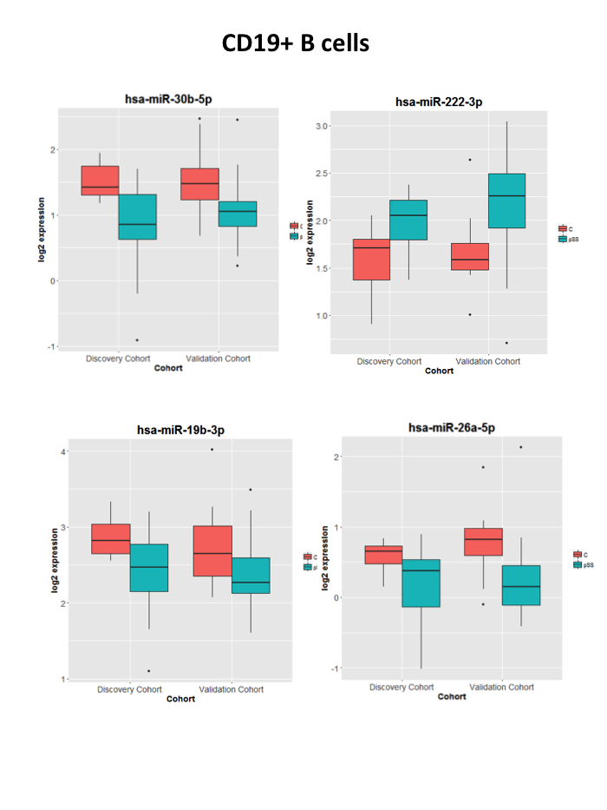
Supplementary Figure 2. Representative boxplots of miRNA expression in both the discovery and the replication cohort in CD19+ B cells. Data from controls is shown in red, data from patients in turquoise.

Supplementary Figure 3. Complementary binding between hsa-miR-30b-5p and the 3’UTR of BAFF mRNA.

Supplementary Figure 4. FACS strategy for the isolation of transfected cells. Transfected cells were analyzed by flow cytometry and only highly positive cells were isolated. A. Lipofectamine Control ; B. Inhibitor hsa-miR-30b-5p at a concentration of 100nM 48 hrs post transfection ; C. Overlay of A (red) and B (green).

Supplementary References
1 Sondergaard HB, Hesse D, Krakauer M, Sorensen PS, Sellebjerg F. Differential microRNA expression in blood in multiple sclerosis. Mult Scler 2013;19(14):1849-57.
2 Alevizos I, Alexander S, Turner RJ, Illei GG. MicroRNA expression profiles as biomarkers of minor salivary gland inflammation and dysfunction in Sjogren's syndrome. Arthritis Rheum 2011;63(2):535-44.
3 Murata K, Furu M, Yoshitomi H, et al. Comprehensive microRNA analysis identifies miR-24 and miR-125a-5p as plasma biomarkers for rheumatoid arthritis. PLoS One 2013;8(7):e69118.
4 Ruckerl D, Jenkins SJ, Laqtom NN, et al. Induction of IL-4Ralpha-dependent microRNAs identifies PI3K/Akt signaling as essential for IL-4-driven murine macrophage proliferation in vivo. Blood 2012;120(11):2307-16.
5 Xiao C, Srinivasan L, Calado DP, et al. Lymphoproliferative disease and autoimmunity in mice with increased miR-17-92 expression in lymphocytes. Nat Immunol 2008;9(4):405-14.
6 Alevizos I, Illei GG. MicroRNAs in Sjogren's syndrome as a prototypic autoimmune disease. Autoimmun Rev 2010;9(9):618-21.
7 Zahednasab H, Balood M. The role of miR-326 and miR-26a in MS disease activity. Gene 2014;548(1):158.
8 Padgett KA, Lan RY, Leung PC, et al. Primary biliary cirrhosis is associated with altered hepatic microRNA expression. J Autoimmunity 2009;32(3-4):246-53.
9 Collares CV, Evangelista AF, Xavier DJ, et al. Identifying common and specific microRNAs expressed in peripheral blood mononuclear cell of type 1, type 2, and gestational diabetes mellitus patients. BMC Res Notes 2013;6:491.
10 Keller A, Leidinger P, Steinmeyer F, et al. Comprehensive analysis of microRNA profiles in multiple sclerosis including next-generation sequencing. Mult Scler 2014;20(3):295-303.
11 Yang D, Wang WZ, Zhang XM, et al. MicroRNA expression aberration in Chinese patients with relapsing remitting multiple sclerosis. J Mol Neurosci 2014;52(1):131-7.
12 Shi H, Zheng LY, Zhang P, Yu CQ. miR-146a and miR-155 expression in PBMCs from patients with Sjogren's syndrome. J Oral Pathol Med 2014;43(10):792-7.
13 Pauley KM, Stewart CM, Gauna AE, et al. Altered miR-146a expression in Sjogren's syndrome and its functional role in innate immunity. Eur J Immunol 2011;41(7):2029-39.
14 Martinez-Ramos R, Garcia-Lozano JR, Lucena JM, et al. Differential expression pattern of microRNAs in CD4+ and CD19+ cells from asymptomatic patients with systemic lupus erythematosus. Lupus 2014;23(4):353-9.
15 Tang Y, Luo X, Cui H, et al. MicroRNA-146A contributes to abnormal activation of the type I interferon pathway in human lupus by targeting the key signaling proteins. Arthritis Rheum 2009;60(4):1065-75.
16 Nakasa T, Miyaki S, Okubo A, et al. Expression of microRNA-146 in rheumatoid arthritis synovial tissue. Arthritis Rheum. 2008;58(5):1284-92.
17 Pauley KM, Satoh M, Chan AL, Bubb MR, Reeves WH, Chan EK. Upregulated miR-146a expression in peripheral blood mononuclear cells from rheumatoid arthritis patients. Arthritis Res Ther 2008;10(4):R101.
18 Wang H, Peng W, Ouyang X, Li W, Dai Y. Circulating microRNAs as candidate biomarkers in patients with systemic lupus erythematosus. Transl Res 2012;160(3):198-206.

