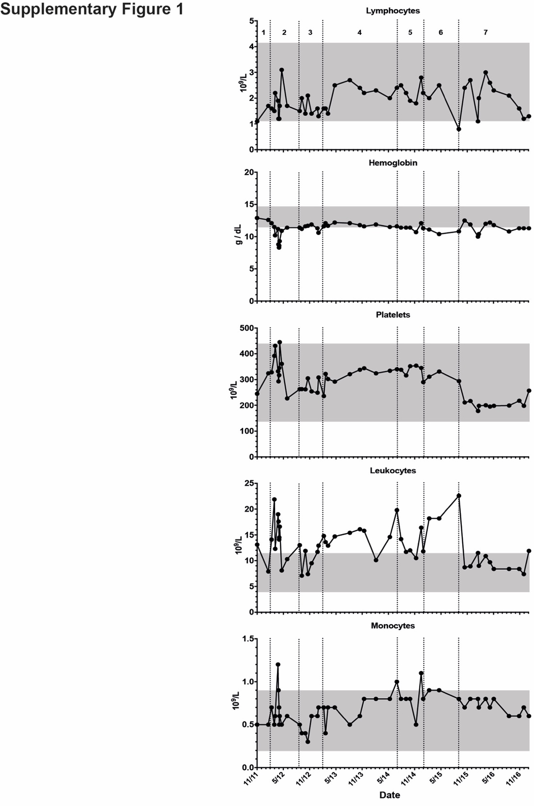
Supplementary Figure 1: Further clinical information. Haematological and biochemical data of index case charted across time, with treatment periods 1. infliximab + methotrexate; 2. prednisolone + cyclosporin A; 3. prednisolone + infliximab; 4. prednisolone + doxycycline; 5. prednisolone + anakinra + clindamycin; 6. prednisolone + clindamycin + moxifloxacin + dapsone; 7. prednisolone + clindamycin + moxifloxacin + dapsone + adalimumab.

Supplementary Figure 2: Pedigree of the family. Solid symbols (squares=male, circles=females) denote affected individuals. Open symbol denotes unaffected individuals. The arrow indicates the proband of the family.

Supplementary Table 1
Control number | Genotype | Symptomatic | Treatment | CRP (<10mg/L)
1 | M694V/M694V | No | Colchicine | 12.7
2 | M694V/M694V | No | Colchicine | 20.3
3 | M694V/M694V | No | Unknown | 3.2
4 | M694V/M694V | No | Unknown | 70.9
5 | M694V/M694V | No | Unknown | 45.2

Supplementary Table 1: Summary of FMF controls. Table of FMF controls on whom serum cytokines assessed. All patients were asymptomatic but four of five had evidence of subclinical inflammation.
Supplementary Figure 3: ASC Speck analysis. (A) Larger field of view of immunofluorescence showing background ASC speck formation, and an increase with WT and pyrin p.E244K transfection. (B) Gating strategy for quantification of ASC speck formation. HEK293T cells were gated on forward and side scatter, selecting live cells. Dual GFP and mCherry positive cells were selected. ASC specks were determined by reduced width and increased area of GFP signal.

Supplementary Figure 4: Binding of PSTPIP1 to PAAND pyrin is unaltered. HEK293T cells were transfected with GST-tagged pyrin, with or without PAAND and FMF mutations, in addition to WT PSTPIP1. GST-immunoprecipitation performed and comparison of PSTPIP1 binding to various MEFV constructs made. Representative of three independent experiments.

