Table S1: Validation analysis using the 36-Item Short Form Survey – Physical Component Score (SF-36 PCS) and SF-36 PCS relative change from baseline instead of the Health Assessment Questionnaire Disability Index (HAQ) and HAQ relative change from baseline as outcome variable in longitudinal analyses to investigate the influence of structural damage on physical function and the responsiveness of physical function.

 | GO-REVEAL remission patients¹ (n = 117) |  | GO-REVEAL major response patients² (n = 76)
Parameter | Estimate (95% CI) | p | Parameter | Estimate (95% CI) | p
Effects of total modified Sharp-van-der-Heijde Score (mSvdHS)
Model 1 |  |  | Model 4
Intercept | 52.841 (51.049 to 54.633) | <0.001 | Intercept | -2.525 (-3.169 to -1.881) | <0.001
Visit | -0.009 (-0.029 to 0.012) | 0.41 | Baseline PCS | 0.06 (0.038 to 0.082) | <0.001
- | - | - | Visit | 0.001 (-0.001 to 0.002) | 0.325
total mSvdHS | -0.023 (-0.048 to 0.001) | 0.063 | total mSvdHS | 0.001 (0.00001 to 0.003) | 0.048
Effects of erosion score (ERO)
Model 2 |  |  | Model 5
Intercept | 52.782 (50.968 to 54.595) | <0.001 | Intercept | -2.505 (-3.15 to -1.861) | <0.001
Visit | -0.008 (-0.029 to 0.012) | 0.417 | Baseline PCS | 0.06 (0.038 to 0.081) | <0.001
- | - | - | Visit | 0.001 (-0.001 to 0.002) | 0.343
ERO score | -0.034 (-0.076 to 0.008) | 0.11 | ERO score | 0.002 (-0.0003 to 0.004) | 0.089
Effects of joint space narrowing score (JSN)
Model 3 |  |  | Model 6
Intercept | 52.858 (51.11 to 54.606) | <0.001 | Intercept | -2.553 (-3.196 to -1.91) | <0.001
Visit | -0.009 (-0.029 to 0.012) | 0.406 | Baseline PCS | 0.061 (0.039 to 0.082) | <0.001
- | - | - | Visit | 0.001 (-0.001 to 0.002) | 0.3
JSN score | -0.062 (-0.116 to -0.007) | 0.026 | JSN score | 0.003 (0.001 to 0.006) | 0.019
¹ Estimates are presented as estimate of SF-36 PCS (95% lower confidence interval to 95% upper confidence interval); Dependent variable = HAQ; Visits in DAPSA remission (DAPSA <=4) of patients with available radiographic scoring. |  |  | ² Estimates are presented as estimate of SF-36 PCS relative change (95% lower confidence interval to 95% upper confidence interval); Dependent variable = SF36-PCS relative change; Visits in DAPSA major response (≥85% change from baseline) and PCS at baseline ≥33; relative SF36-PCS change was defined as (PCS at baseline - PCS at visit) / PCS at baseline.

Table S2: Cross-validation in clinical routine patients. Remission patients were in clinical Disease Activity Index for Psoriatic Arthritis (cDAPSA) remission (cDAPSA ≤ 4). Results from longitudinal analyses of the influence of structural damage on physical function (measured by the Health Assessment Questionnaire Disability Index, HAQ).

 | All clinical patientsª (n = 160) |  | Clinical remission patients^{b} (n = 55)
Parameter | Estimate (95% CI) | p | Estimate (95% CI) | p
Model 1 (effects of total modified Sharp-van-der-Heijde Score, mSvdHS)
Intercept | 0.309 (0.419 to 0.2) | <0.001 | 0.185 (0.106 to 0.263) | <0.001
Visit | -0.004 (0.004 to -0.012) | 0.354 | -0.009 (-0.015 to -0.004) | 0.001
cDAPSA | 0.028 (0.037 to 0.019) | <0.001 | - | -
cDAPSA² | -0.0001 (0.00001 to -0.00023) | 0.082 | - | -
total mSvdHS | 0.002 (0.003 to 0) | 0.021 | 0.003 (0.001 to 0.005) | <0.001
Model 2 (effects of erosion score, ERO)
Intercept | 0.331 (0.441 to 0.221) | <0.001 | 0.217 (0.132 to 0.302) | <0.001
Visit | -0.004 (0.004 to -0.011) | 0.379 | -0.01 (-0.016 to -0.004) | 0.001
cDAPSA | 0.028 (0.036 to 0.019) | <0.001 | - | -
cDAPSA² | -0.0001 (0 to -0.00023) | 0.081 | - | -
ERO score | 0.002 (0.005 to -0.001) | 0.172 | 0.007 (0.003 to 0.01) | <0.001
Model 3 (effects of joint space narrowing score, JSN)
Intercept | 0.292 (0.403 to 0.182) | <0.001 | 0.169 (0.089 to 0.249) | <0.001
Visit | -0.004 (0.004 to -0.011) | 0.338 | -0.009 (-0.014 to -0.003) | 0.002
cDAPSA | 0.028 (0.037 to 0.019) | <0.001 | - | -
cDAPSA² | -0.0001 (0 to -0.00023) | 0.082 | - | -
JSN score | 0.003 (0.005 to 0.001) | 0.004 | 0.005 (0.003 to 0.007) | <0.001
Estimates are presented as estimate of HAQ (95% lower confidence interval to 95% upper confidence interval); ª All visits of clinical patients with available radiographic scoring, HAQ and cDAPSA; ^{b} Visits in cDAPSA remission (cDAPSA <=4);

Table S3: Dropout numbers of the clinical xray database cohort

 | n | %
Total number of patients in xray database | 206 | 100
Number of patients with available data for respective variable
cDAPSA ¹ | 205 | 99.5
HAQ ² | 161 | 78.2
Patients with complete available data | 160 | 77.7
Subgroup achieving cDAPSA¹ remission | 55 | 34.4
¹ clinical Disease Activity Index for Psoriatic Arthritis; ² Health Assessment Questionnaire Disability Index
Table S4: Different disease activity markers in patients in Disease Activity Index for Psoriatic Arthritis (DAPSA) remission (≤4). Results of longitudinal analyses for HAQ in patient global assessment of disease activity, evaluator global assessment of disease activity, patient global assessment of pain, Health Assessment Questionnaire disability index (HAQ), tender joint count 68 and swollen joint count 66.
 | GO-REVEAL remission patients¹ (n = 117)
Parameter | Estimate (95% CI) | p | Parameter | Estimate (95% CI) | p
Patient global assessment of disease activity |  |  | Health Assessment Questionnaire
Intercept | 4.055 (2.512 to 5.598) | <0.001 | Intercept | 0.097 (0.025 to 0.168) | 0.008
Visit | -0.0062 (-0.0217 to 0.0093) | 0.431 | Visit | -0.0004 (-0.0011 to 0.0004) | 0.312
mSvdH Score | 0.02 (-0.0008 to 0.04) | 0.059 | mSvdH Score | 0.002 (0.0002 to 0.004) | 0.029
Evaluator global assessment of disease activity |  |  | Tender Joint Count 68
Intercept | 3.466 (1.614 to 5.317) | <0.001 | Intercept | 0.503 (0.285 to 0.721) | <0.001
Visit | 0.0094 (-0.022 to 0.0408) | 0.556 | Visit | -0.0024 (-0.0052 to 0.0004) | 0.090
mSvdH Score | -0.007 (-0.026 to 0.012) | 0.484 | mSvdH Score | 0 (-0.002 to 0.002) | 0.902
Patients global assessment of pain |  |  | Swollen Joint Count 66
Intercept | 4.39 (3.068 to 5.712) | <0.001 | Intercept | 0.362 (0.192 to 0.531) | <0.001
Visit | -0.0081 (-0.0217 to 0.0055) | 0.243 | Visit | -0.002 (-0.004 to 0.0001) | 0.057
mSvdH Score | 0.012 (-0.008 to 0.032) | 0.231 | mSvdH Score | 0 (-0.002 to 0.001) | 0.898
Estimates are presented as estimate of each individual component (95% lower confidence interval to 95% upper confidence interval); ¹ Visits with DAPSA remission (DAPSA ≤4).

Figure S1. Predicted non-linear association of disease activity on physical function in patients with psoriatic arthritis. Results are estimated for week 24 based on a longitudinal analysis. Shaded areas represent 95% confidence intervals.

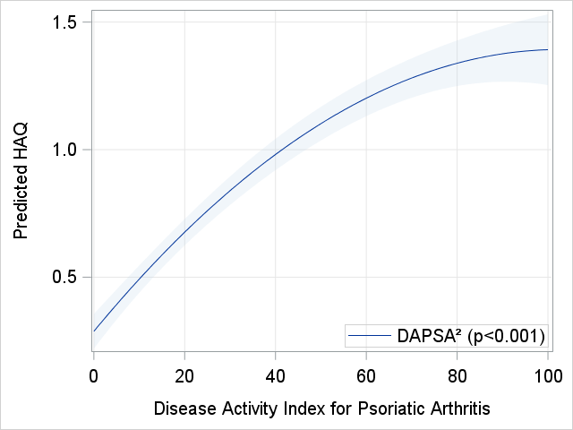
Figure S2: Histogram of the distribution of modified Sharp van der Heijde (mSvdH) scores of all GO-REVEAL patients, utilized for analysis (n=363). Different colours mark quintiles of total mSvdH score.
