Supplementary Appendix
Sirukumab for Rheumatoid Arthritis: the Phase 3 SIRROUND-D Study

Contents
Table S1. Summary of Biologics Taken for RA Prior to the Study 2
Table S2. ACR20 Response Rates at Week 16 Stratified by Baseline Methotrexate Use 3
Table S3. Summary of Percent Improvement in ACR Components at Week 16 4
Table S4. Summary of Safety Through Week 18 (Before EE) 5
Table S5. Incidence Rates for AEs of Interest Through Week 52 6
Figure S1. Study design. 8
Figure S2. Probability plot of change from baseline in SHS at Week 52. 9
Figure S3. Mean observed laboratory assessments by visit through Week 52: A) neutrophils; B) platelets; C) hemoglobin; D) alanine aminotransferase; and E) aspartate aminotransferase. 10

Table S1. Summary of Biologics Taken for RA Prior to the Study
Biologic use, n (%) | Total (N = 1,670)
Took ≥1 biologic | 583 (34.9)
Took 2 biologics | 77 (4.6)
Took ≥3 biologics | 25 (1.5)
Tocilizumab | 128 (7.7)
Golimumab | 96 (5.7)
Etanercept | 66 (4.0)
Adalimumab | 54 (3.2)
Infliximab | 52 (3.1)
Abatacept | 51 (3.1)
Certolizumab | 39 (2.3)
Rituximab | 35 (2.1)
Anakinra | 3 (0.2)
Yisaipu | 1 (0.1)
Other biologicsª | 197 (11.8)
RA, rheumatoid arthritis.
ªMostly composed of investigational biologics.

Table S2. ACR20 Response Rates at Week 16 Stratified by Baseline Methotrexate Use

Patients stratified by baseline MTX | Placebo | Sirukumab  50mg q4w | Sirukumab  100mg q2w
No MTX at baseline, n | 71 | 71 | 71
ACR20 response, n (%) | 10 (14.1) | 34 (47.9) | 35 (49.3)
Difference (95% CIª) |  | 0.338 (0.196, 0.480) | 0.352 (0.210, 0.494)
>0 to <12.5 mg/wk MTX, n | 140 | 139 | 140
ACR20 response, n (%) | 39 (27.9) | 81 (58.3) | 82 (58.6)
Difference (95% CIª) |  | 0.304 (0.194, 0.415) | 0.307(0.197, 0.417)
≥12.5 mg/wk MTX, n | 345 | 347 | 346
ACR20 response, n (%) | 98 (28.4) | 190 (54.8) | 181 (52.3)
Difference (95% CIª) |  | 0.263 (0.193, 0.334) | 0.239 (0.168, 0.310)
ACR, American College of Rheumatology; CI, confidence interval; MTX, methotrexate.
ªThe confidence intervals were based on Wald statistic.

Table S3. Summary of Percent Improvement in ACR Components at Week 16

ACR Componentª | Placebo (n = 556) | Sirukumab 50 mg q4w (n = 557) | Sirukumab 100 mg q2w (n = 557)
Swollen joint count (0-66) | 26.0 (58.2) | 55.3 (41.4) | 55.6 (39.9)
Tender joint count (0-68) | 22.9 (58.2) | 44.8 (45.1) | 48.0 (43.3)
Patient’s assessment of pain (VAS; 0-10) | 6.5 (76.9) | 23.6 (120.9) | 32.0 (54.0)
Patient’s global assessment of disease activity (VAS; 0-10) | 8.4 (74.8) | 26.2 (94.2) | 26.8 (89.6)
Physician’s global assessment of disease activity (VAS; 0-10) | 29.3 (42.1) | 46.3 (34.0) | 48.1 (44.7)
HAQ-DI score (0-3) | 5.6 (72.2) | 24.7 (65.8) | 26.5 (55.0)
CRP (mg/dL) | −36.7 (309.5) | 92.4 (24.0) | 93.9 (24.2)
ªMean (SD) percent improvement at Week 16.
CRP, c-reactive protein; HAQ-DI, Health Assessment Questionnaire – Disability Index; SD, standard deviation; VAS, visual analog scale

Table S4. Summary of Safety Through Week 18 (Before EE)
 |  | Sirukumabª
Variable | Placebo  (n = 556) | 50 mg q4w  (n = 557) | 100 mg q2w  (n = 557) | Combined  (n = 1,114)
Patients with ≥1 TEAE, n (%)  P value vs placebo | 280 (50.4) | 337 (60.6)  <0.001 | 354 (63.4)  <0.001 | 691 (62.0)  <0.001
Patients with ≥1 TESAE, n (%)  P value vs placebo | 17 (3.1) | 16 (2.9)  NS | 26 (4.7)  NS | 42 (3.8)  NS
Discontinuations due to an AE, n (%)  P value vs placebo | 12 (2.2) | 18 (3.2)  NS | 27 (4.8)  0.015 | 45 (4.0)  0.046
Serious infections, n (%)  P value vs placebo^{b} | 5 (0.9) | 4 (0.7)  NS | 5 (0.9)  NS | 9 (0.8)  NS
Injection-site reactions, n (%)  P value vs placebo | 9 (1.6) | 44 (7.9)  <0.001 | 76 (13.6)  <0.001 | 120 (10.8)  <0.001
EE, early escape; q4w, every 4 weeks; q2w, every 2 weeks; TEAE, treatment-emergent adverse event; TESAE, treatment-emergent serious adverse event; NS, not significant; AE, adverse event.
ªP values are nominal and from chi-square tests, unless otherwise noted.
^{b}P values are nominal and from Fisher exact tests.

Table S5. Incidence Rates for AEs of Interest Through Week 52
 |  | Sirukumabª
Variable | Placebo  (n = 556) | 50 mg q4w  (n = 663) | 100 mg q2w  (n = 662) | Combined  (n = 1,325)
Patients with ≥1 serious infection, n | 10 | 27 | 22 | 49
Total PY of exposure, y | 391.21 | 584.30 | 579.64 | 1,163.94
Rate of serious infections per 100 PY (95% CI) | 2.56  (1.23, 4.70) | 4.62  (3.05, 6.72) | 3.8  (2.38, 5.75) | 4.21  (3.11, 5.57)
Patients with a malignancy, n^{b} | 2 | 2 | 5 | 7
Total PY of exposure, y | 393.75 | 591.84 | 584.66 | 1,176.50
Rate of malignancies per 100 PY (95% CI)^{c} | 0.51  (0.06, 1.83) | 0.34  (0.04, 1.22) | 0.86  (0.28, 2.00) | 0.59  (0.24, 1.23)
Patients with a MACE, n | 2 | 8 | 3 | 11
Total PY of exposure, y | 393.70 | 590.68 | 584.86 | 1,175.55
Rate of MACE per 100 PY (95% CI)^{c} | 0.51  (0.06, 1.84) | 1.35  (0.58, 2.67) | 0.51  (0.11, 1.50) | 0.94  (0.47, 1.67)
Patients who died, n^{d} | 1 | 7 | 3 | 10
Total PY of exposure, y | 393.95 | 592.13 | 585.72 | 1,177.85
Mortality per 100 PY (95% CI) | 0.25  (0.01, 1.41) | 1.18  (0.48, 2.44) | 0.51  (0.11, 1.50) | 0.85  (0.41, 1.56)
AE, adverse event; q4w, every 4 weeks; q2w, every 2 weeks; PY, patient-year; CI, confidence interval; MACE, major adverse cardiovascular event.
ªIncludes patients from the placebo group re-randomized to treatment with sirukumab; thus, patients may be represented in >1 treatment group.
^{b}Includes nonmelanoma skin cancers.
^{c}The incidence rate is patient based and only counts 1 occurrence of an AE if a patient has >1 occurrence of that AE. The 95% CIs were exact Poisson CIs.
^{d}Prior to Week 18, there were 3 deaths: 1 in the placebo group (acute respiratory distress syndrome); 1 in the sirukumab 50-mg group (sudden cardiac death); and 1 in the sirukumab 100-mg group (myocardial infarction). From Week 18 to prior to Week 52, there were 8 additional deaths: 3 in the group originally randomized to placebo that switched to sirukumab 50 mg (cerebrovascular accident, road traffic accident, and myocardial infarction); 3 in the sirukumab 50-mg (natural causes, septic shock, and peritonitis); and 2 in the sirukumab 100-mg group (bacterial sepsis, metastatic lung cancer).

Figure S1. Study design.

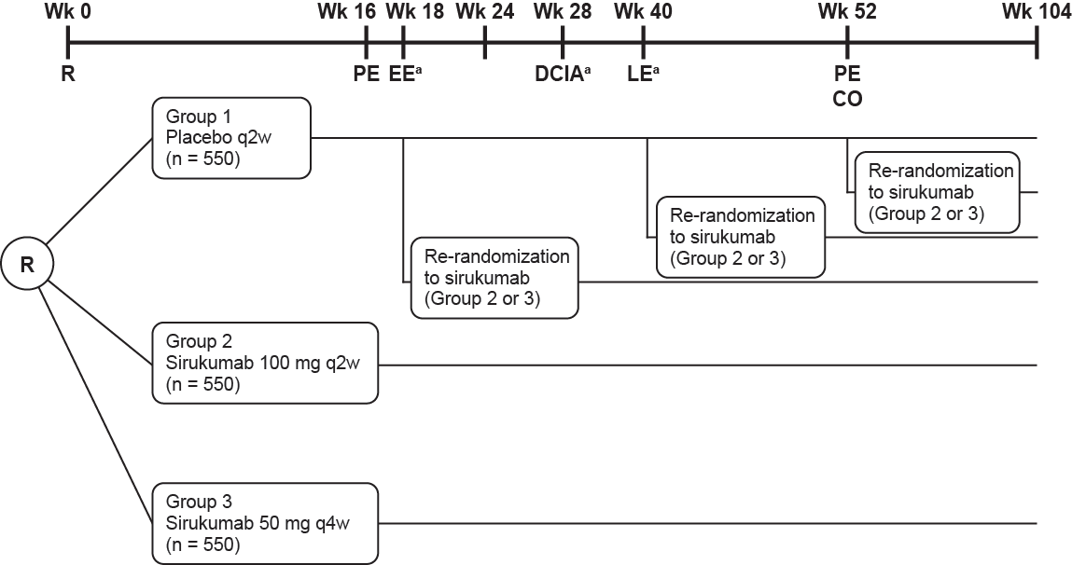

Wk, Week; R, randomization; PE, primary endpoint; EE, early escape; DCIA, initiation/adjustment of DMARDs/corticosteroids; LE, late escape; CO, crossover; q2w, every 2 weeks; q4w, every 4 weeks.
ªPatients who have <20% improvement from baseline in swollen and tender joint counts.

Figure S2. Probability plot of change from baseline in SHS at Week 52.ª
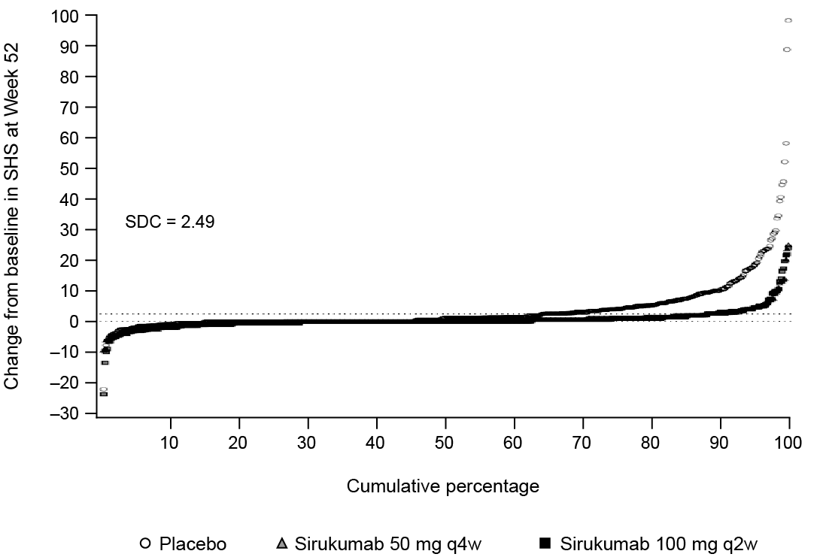

SHS, Sharp/van der Heijde score; SDC, smallest detectable change; q4w, every 4 weeks; q2w, every 2 weeks; EE, early escape.
ªBased on imputed values by EE rules and then missing data rules.

Figure S3. Mean observed laboratory assessments by visit through Week 52: A) neutrophils; B) platelets; C) hemoglobin; D) alanine aminotransferase; and E) aspartate aminotransferase.
A)
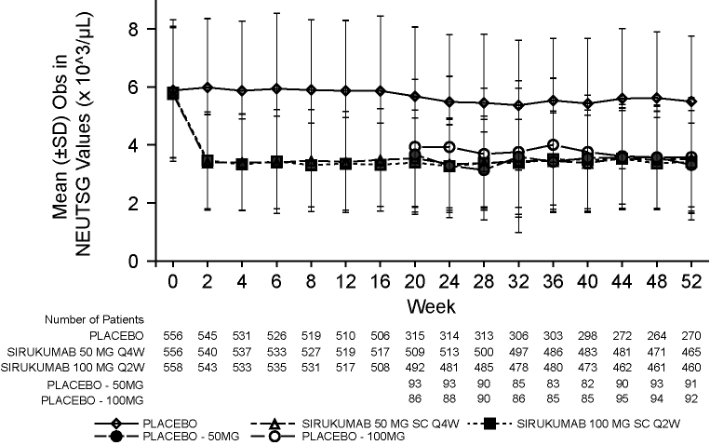
B)
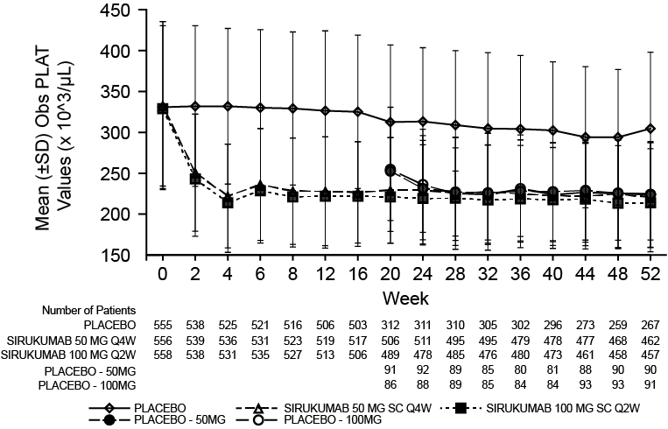
C)
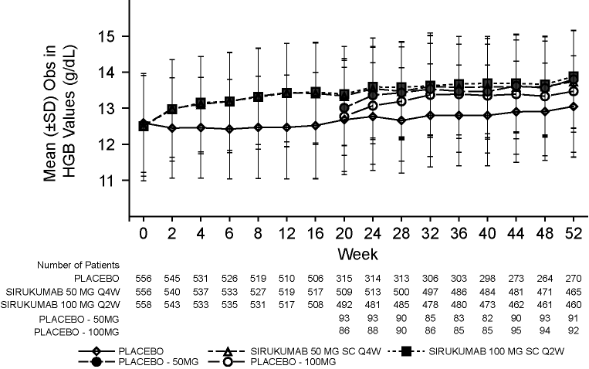
D)
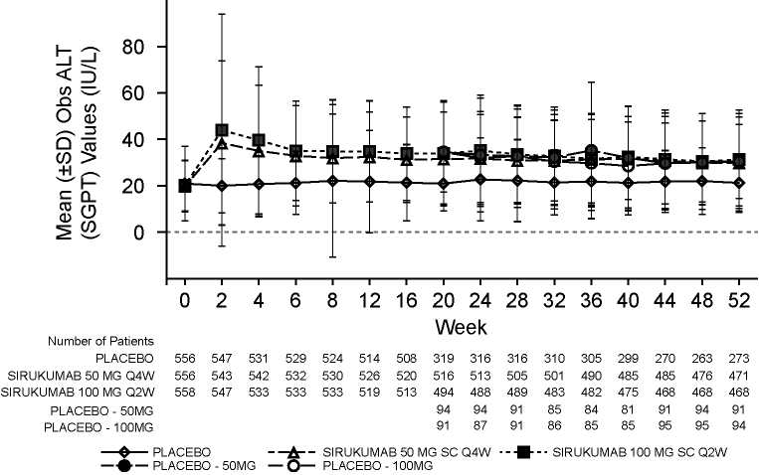

E)
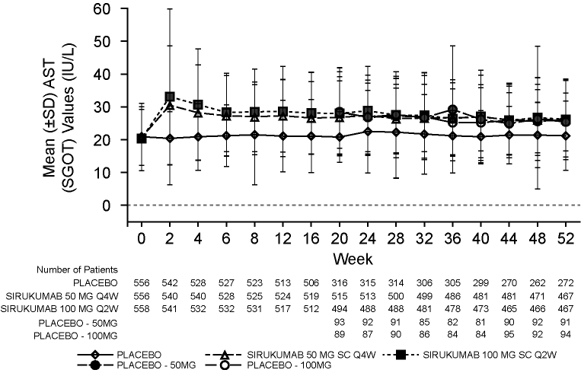
SD, standard deviation; Obs, observed; NEUTSG, neutrophils; Q4W, every 4 weeks; Q2W, every 2 weeks; SC, subcutaneous; PLAT, platelet; HGB, hemoglobin; ALT (SGPT), alanine aminotransferase; AST (SGOT), aspartate aminotransferase.

