SUPPLEMENTARY MATERIALS

Rationale for exclusion of one infant from the per protocol analysis set
One infant exhibited an unexpectedly high plasma CZP concentration at birth (0.485 μg/mL), compared with results from the samples collected from the other 14 infants. By contrast, the week 4 and week 8 sample results in this infant were below the assay LLOQ (<0.032 μg/mL). Knowing that the elimination half-life of IgG in infants is longer than in adults,¹ and in light of evidence that CZP may be eliminated at a slower rate in exposed infants than in adult patients,² this result prompted further investigation.
According to the clinical narrative, the infant’s mother experienced a complicated delivery, and the infant was delivered by emergency caesarean section. Nurse’s notes indicate that the infant’s blood sample had an abnormal colour and was particularly difficult to process. In addition, it was not possible to collect the umbilical cord blood sample, due to umbilical cord collapse.
Using a paediatric population PK model to predict CZP plasma concentrations at 4 weeks from birth (unpublished data from a CZP study in patients with juvenile idiopathic arthritis [NCT01550003]), a CZP concentration at birth of 0.485 μg/mL would result in a median week 4 CZP concentration of 0.182 μg/mL (0.1st–99.9th percentiles: 0.059–0.351 μg/mL; Supplementary Figure S1A). Another, more conservative approach was explored, in which the infant’s blood volume was calculated using their known body weight (0.109 x body weight). This estimated blood volume was set as the volume of distribution (V/F), which represents the smallest possible V/F and a shorter elimination half-life (t_{1/2}) for CZP. With this approach, a CZP concentration at birth of 0.485 μg/mL would result in a median week 4 CZP concentration of 0.186 μg/mL (0.1st–99.9th percentiles: 0.062–0.354 μg/mL; Supplementary Figure S1B). According to these two approaches, there was a very low probability (<0.1%) of an infant with a CZP concentration of 0.485 μg/mL at birth to display levels below the LLOQ (<0.032 μg/mL) at week 4 (i.e. implausibly increased CZP clearance [CL/F] in a newborn).
Based on the evidence summarised above, we surmised that the unexpectedly high CZP plasma level at birth may have resulted from a blood sampling error. Therefore, this sample was considered a protocol deviation, and the infant was excluded from the final per protocol analysis set.

Rationale for non-interpretable infant PEG plasma concentrations
Total PEG concentrations in maternal and umbilical cord blood samples were generally in line with the corresponding CZP measurements. By contrast, PEG concentrations in infant samples were not consistent with CZP levels: while 13/14 infants had no quantifiable CZP plasma levels at birth, and none had quantifiable CZP at weeks 4 and 8, most infant samples at these three time points had quantifiable PEG levels with no consistent pattern over time. This led us to investigate whether the blood collection procedure had contaminated samples with exogenous PEG.
Becton Dickinson tubes were used to collect blood from mothers and umbilical cords. Sarstedt monovette syringes were used to collect blood from infants at all time-points. To assess the risk of sample contamination with exogenous PEG during the collection procedure, 10 non-CZP exposed human blood samples were collected using both tube types. PEG levels were then measured with the same method used in the CRIB study (nuclear magnetic resonance spectroscopy; LLOQ: 2.5 μg/mL). Results showed that samples collected using Becton Dickinson tubes were all below the assay LLOQ, while 7/10 samples collected with Sarstedt monovette syringes had quantifiable PEG levels.
Therefore, we concluded that there was a significant risk of contamination resulting from the procedure used for collecting blood samples with the Sarstedt monovette syringes. Consequently, the infant PEG results could not be interpreted. These data do not affect the validity of the infant CZP data.

Supplementary Figure S1. Predicted profiles of plasma CZP concentration over time for an infant with a CZP level at birth of 0.485 μg/mL
A) Modelling approach based on a paediatric population PK modelª
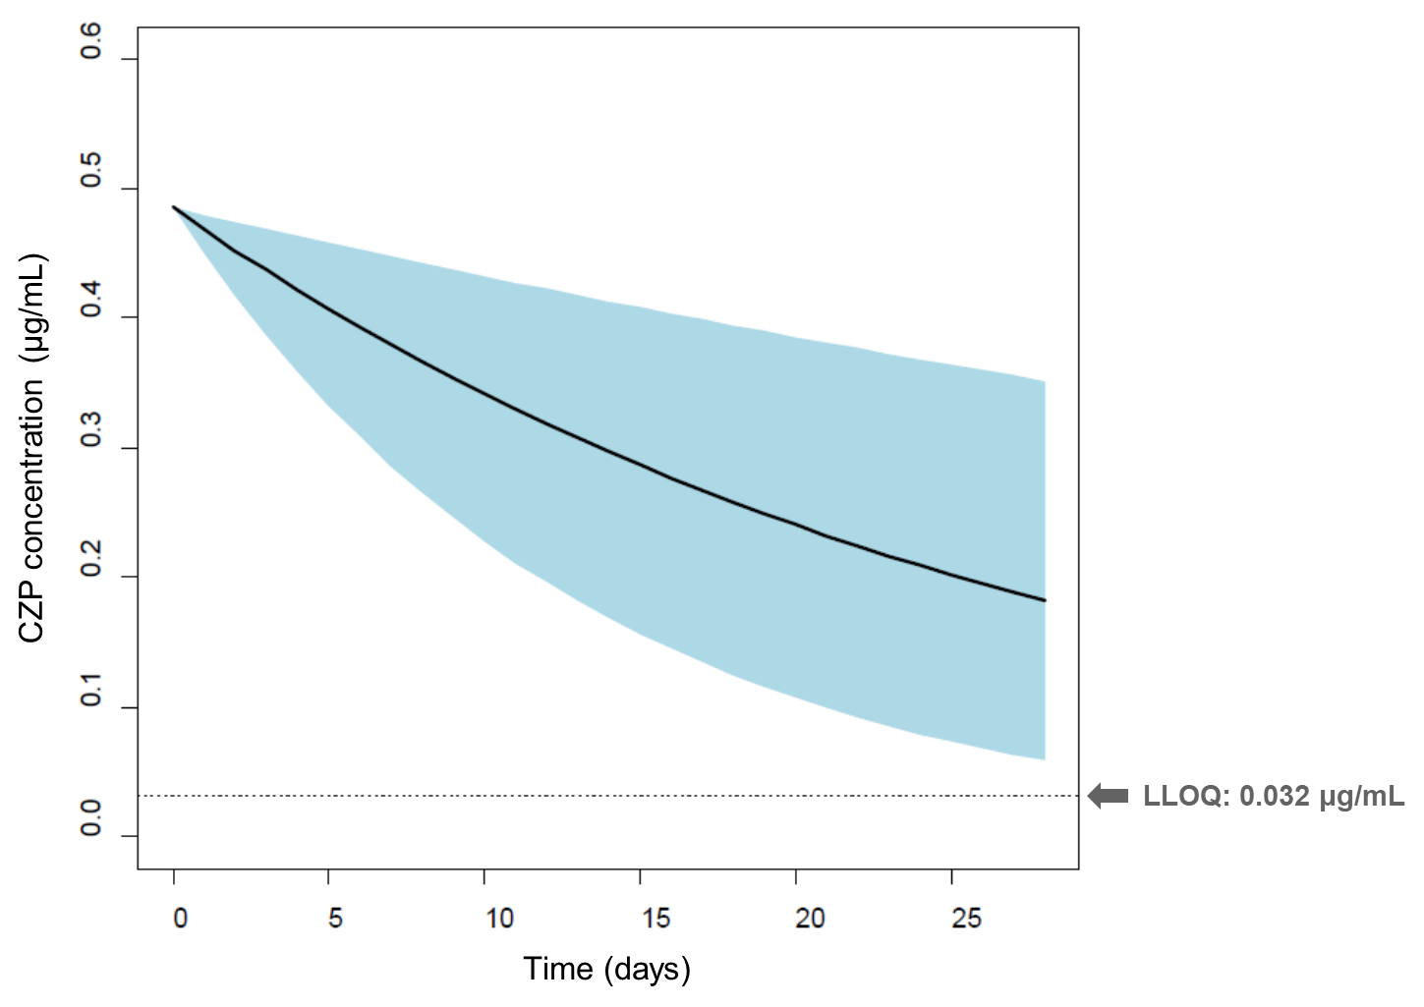
B) Modelling approach based on a paediatric population PK model, in which the infant’s blood volume was calculated using their known body weight^{b}
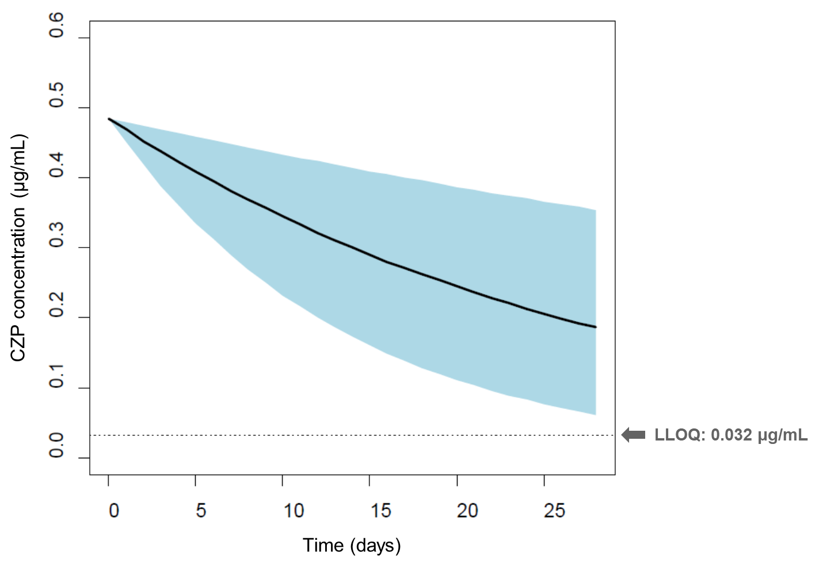
The shaded area in each graph represents the 0.1st–99.9th percentiles. ªThe paediatric population PK model is based on unpublished data from a CZP study in patients with juvenile idiopathic arthritis (NCT01550003); ^{b}Infant blood volume was calculated using their known body weight (0.109 x body weight). This estimated blood volume was set as the volume of distribution (V/F), which represents the smallest possible V/F and a shorter elimination half-life (t_{1/2}) for CZP. CZP: certolizumab pegol; PK: pharmacokinetic; LLOQ: lower limit of quantification.
Supplementary Table S1. Individual plasma CZP concentrations in the mothers, umbilical cords, and infants at birth, week 4, and week 8
Days between delivery and last maternal CZP dose | CZP concentration (μg/mL)
 | Mother | Umbilical cord | Infant
 |  |  | Birth | Week 4 | Week 8
9 | 49.4 | 0.0402 | 0.0422 | BLQ | BLQ
4 | 42.2 | BLQ | NDª | BLQ | BLQ
2 | 39.7 | BLQ | BLQ | BLQ | BLQ
10 | 37.6 | BLQ | BLQ | BLQ | BLQ
7 | 36.5 | BLQ | BLQ | BLQ | BLQ
5 | 33.7 | BLQ | BLQ | BLQ | BLQ
5 | 28.6 | BLQ | BLQ | BLQ | BLQ
1 | 25.3 | BLQ | BLQ | BLQ | BLQ
12 | 23.5 | 0.0354 | BLQ | ND | BLQ
14 | 18.9 | 0.0477 | BLQ | BLQ | BLQ
14 | 17.2 | BLQ | BLQ | BLQ | BLQ
16 | 17.1 | BLQ | BLQ | ND | BLQ
14 | 11.6 | BLQ | BLQ | BLQ | BLQ
19 | 10.8 | ND | 0.485^{b} | BLQ | BLQ
18 | 9.75 | BLQ | BLQ | BLQ | BLQ
27 | 4.96 | BLQ | BLQ | BLQ | BLQ
ªInfant excluded from per protocol analysis set due to missing data (ND) at birth; ^{b}Infant excluded from per protocol analysis set due to implausible pharmacokinetic (PK) data at birth (i.e. data not consistent with a paediatric CZP PK model, based on the expected range of clearance, volume of distribution, and subsequent elimination half-life; see “Rationale for exclusion of one infant from the per protocol analysis set”). CZP: certolizumab pegol; BLQ: below the LLOQ (<0.032 μg/mL); LLOQ: lower limit of quantification; ND: not done.

References
- Sarvas H, Seppälä I, Kurikka S, Siegberg R, Mäkelä O. Half-life of the maternal IgG1 allotype in infants. J Clin Immunol 1993;13(2):145-51.
- FDA. Cimzia® (certolizumab pegol) Prescribing Information, 2016 (Accessed April 15, 2017, at http://www.accessdata.fda.gov/drugsatfda_docs/label/2016/125160s241lbl.pdf).

