SUPPLEMENTARY DATA
Supplementary Figure 1: RAPID-axSpA trial design to Week 204

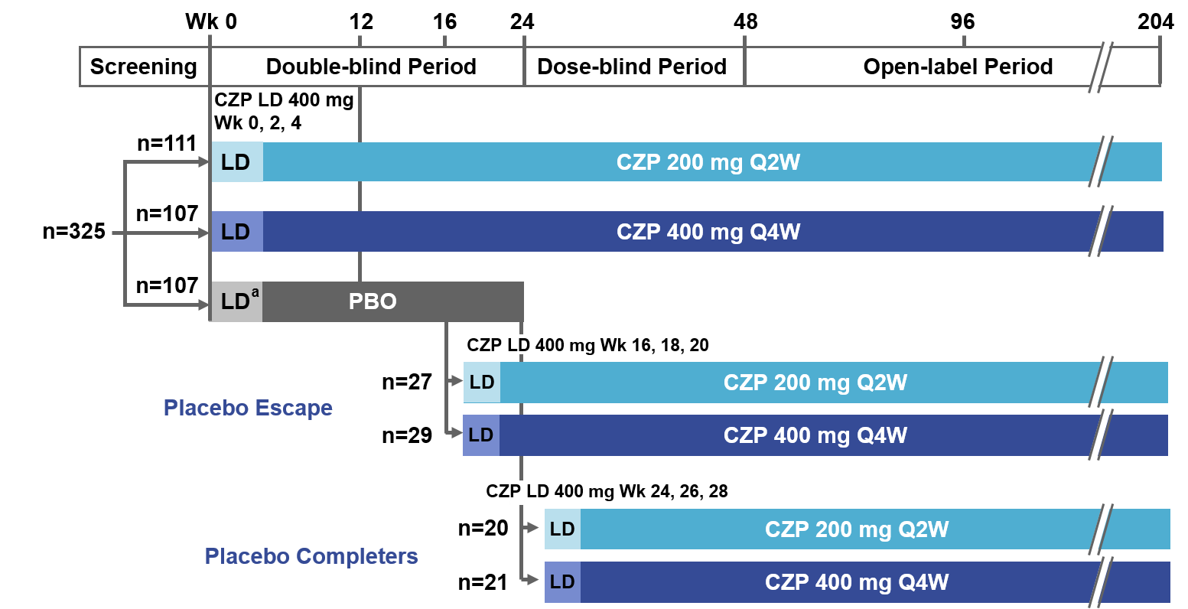

ªLoading dose of PBO. CZP: certolizumab pegol; LD: Loading Dose; Q2W: every other week; Q4W: every 4 weeks; PBO: placebo; Wk: week.

Supplementary Table 1: Number of images available for each imaging modality.
 | Week 0 |  |  | Week 12 |  |  | Week 96 |  |  | Week 204
 | axSpA | AS | nr-axSpA | axSpA | AS | nr-axSpA | axSpA | AS | nr-axSpA | axSpA | AS | nr-axSpA
Berlin | 153 | 92 | 61 | 149 | 90 | 59 | 120 | 74 | 46 | 82 | 50 | 32
SPARCC | 151 | 91 | 60 | 144 | 84 | 60 | 120 | 73 | 47 | 72 | 41 | 31
mSASSS | 190 | 110 | 80 | NA | NA | NA | 141 | 86 | 55 | 106 | 64 | 42
SI joint radiograph | 273 | 180 | 93 | NA | NA | NA | NA | NA | NA | 137 | 101 | 36
Data are presented for all patients who received ≥1 dose CZP at any point in the trial (n=315). SPARCC: Spondyloarthritis Research Consortium for Canada; mSASSS: Modified Stoke Ankylosing Spondylitis Spine Score; SI: sacroiliac; NA: Not Applicable.

Supplementary Table 2: Number of axSpA patients with mSASSS readings at baseline, Week 96 and Week 204.

mSASSS reading
Baseline | Week 96 | Week 204 | n
X | X | X | 93
X |  |  | 45
X | X |  | 45
X |  | X | 10
 | X | X | 3
Data are presented for all patients who received ≥1 mSASSS reading during the trial (n=196).
Supplementary Table 3: ASDAS outcomes for patients with and without mSASSS readings at all timepoints.

AS Population |  | n | Mean ASDAS (LOCF) |  |  |  |  |  |  | Mean ASDAS (observed)
 |  |  | BL | Wk12* |  | Wk96 |  | Wk204 |  | Wk96 |  | Wk204
Group | mSASSS available |  | Mean | Mean | Change from BL | Mean | Change from BL | Mean | Change from BL | Nobs | Mean | Nobs | Mean
1 | BL, Wk96, Wk204 | 59 | 4.07 | 1.95 | -1.97 | 1.98 | -2.09 | 2.08 | -1.98 | 59 | 1.98 | 58 | 2.05
2 | BL, Wk96 | 26 | 3.70 | 2.22 | -1.59 | 1.96 | -1.73 | 1.99 | -1.71 | 25 | 1.84 | 8 | 2.10
3 | BL, Wk204 | 4 | 4.26 | 2.76 | -1.50 | 1.79 | -2.47 | 1.28 | -2.98 | 2 | 2.16 | 4 | 1.28
4 | Only once | 23 | 4.01 | 2.32 | -1.49 | 1.99 | -2.02 | 2.12 | -1.89 | 6 | 1.53 | 4 | 1.87

*Week 0 CZP 200 mg + 400 mg group. ASDAS: Ankylosing spondylitis diseases activity score; mSASSS: modified Stoke Ankylosing Spondylitis Spinal Score; AS: ankylosing spondylitis; LOCF: last observation carried forward; BL: baseline; Wk: week; Nobs: number observed.
Supplementary Figure 2: Radiographic imaging results for the spine in AS and nr-axSpA patients with images available at baseline and Weeks 96 and 204.

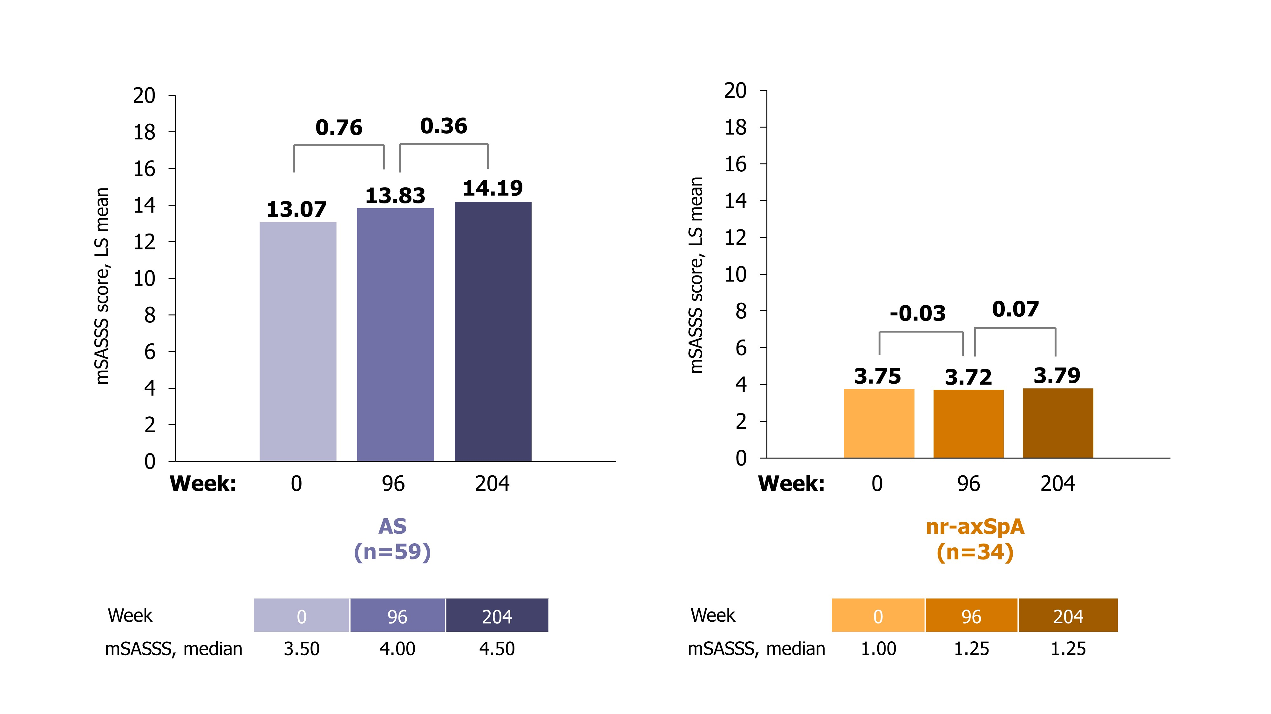
All CZP-treated patients include those re-randomised to placebo from baseline; 200 mg + 400 mg dose groups were combined. mSASSS: modified Stoke Ankylosing Spondylitis Spinal Score; LS: least squares; AS: ankylosing spondylitis; nr-axSpA: non-radiographic spondyloarthritis.

