SUPPLEMENTARY MATERIALS
Supplementary Appendix

Exclusion criteria
Patients were excluded from this study for any of the following reasons:
- History of hypersensitivity to any of the ingredients of the study medication
- Received treatment with an anti-TNF agent (e.g. infliximab, etanercept, adalimumab, golimumab, certolizumab pegol) or another biological product (e.g. abatacept) within 12 weeks before the first dose of study medication
- Previously received tocilizumab
- Previously treated with cell-depleting therapies, including investigational new drugs such as rituximab and muromonab-CD3, and the depleted cell count had not returned to normal by study start
- Treated with methotrexate within 4 weeks before the first dose of study treatment
- Treated with any of the following within 2 weeks before the first dose of study medication
  - Intravenous, intramuscular or suppository administration of a glucocorticoid
  - DMARD or immunosuppressant
  - Plasmapheresis (e.g. leukapheresis)
  - Surgery (excluding local procedure such as cataract surgery)
- Routinely used a glucocorticoid (other than local therapy with a topical agent) for a condition other than Takayasu arteritis and deemed unsuitable as a study subject by the investigator
- Any of the following criteria in tests conducted within 2 weeks before the first dose of study treatment
  - WBC count: <4000/μL
  - Neutrophil count: <1000/μL
  - Lymphocyte count: <500/μL
  - Platelet count: <10 × 10⁴/μL
- Active tuberculosis (other than patients undergoing prophylactic chemotherapy for latent tuberculosis infection)
- Interstitial pneumonia and deemed unsuitable as a study subject by the investigator
- History of intestinal diverticulum or periodic melena and deemed unsuitable as a study subject by the investigator
- Scheduled to have surgery for Takayasu arteritis during the study period
- Active hepatitis B or C at tests at enrolment or history of hepatitis B
- Immunised with a live vaccine within 6 weeks before the first dose of study treatment
- Diagnosed with a malignant tumor within 5 years before the first dose of study treatment
- Serious concurrent disease and deemed unsuitable as a study subject by the investigator
- Obvious infection within 4 weeks before the first dose of study treatment and deemed unsuitable as a study subject by the investigator
- Women who were pregnant or lactating, premenopausal or <1 year postmenopausal and had a positive pregnancy test, or unwilling to use contraception
- Used another investigational new drug within 6 months before the first dose of study treatment
- Deemed unsuitable as a study subject by the investigator for another reason

Imaging protocol
Contrast-enhanced computed tomography (CECT)
Sequential CT scans were obtained using a 64-detector-row CT scanner. The CT protocol was as follows: detector collimation, 0.5 mm; matrix size, 512 × 512 pixels; field of view, 34.5 cm; X-ray voltage, 120 kVp; tube current, Auto mA; noise index, 10. The scan length was from 2 cm above the apex of the lungs to below the ischium. Axial CT images of 1.0-mm and 5.0-mm thickness were reconstructed. A power injector was used for bolus administration of 100 to 150 mL (2.0 mL/kg of body weight) of iodinated contrast media via a cubital vein in 40 seconds. Early phase CT data were acquired as follows: the region of interest was set at the level of the pulmonary artery trunk in the descending aorta. Imaging was initiated when the CT value reached 100 Hounsfield units compared with the CT value for the same region in unenhanced CT (baseline). The late phase was acquired 60 seconds after the early phase. If these settings were not feasible, they could be adjusted appropriately if follow-up CT was conducted with the same settings used at baseline.

Statistical analysis
A sample size of 34 patients was based on the calculation that 19 events of relapse would yield 90% power to detect a hazard ratio of 0.2075 at an alpha level of 0.05, assuming a relapse-free rate of 75% in the tocilizumab group and 25% in the placebo group at week 24, with an estimated dropout rate of 20%.
An interim analysis for efficacy and futility was performed after 13 patients experienced relapse. The O’Brien-Fleming–type alpha spending function was used to determine significance at the interim and primary analyses to control for increased type 1 error associated with interim analyses. The O’Brien-Fleming–type beta spending function was used to ensure sufficient statistical power for the study overall because of the interim futility analysis. Interim analyses were conducted independently of the study sponsor, and the results were reviewed by the Independent Data Monitoring Committee. As a result, the committee concluded that the efficacy and futility criteria were not met and recommended that the study be continued. Considering the alpha used for the efficacy futility analysis, a significance level of 0.0459 was used for the final analysis.
Final analysis was to be conducted when 19 patients experienced relapse; 20 relapses were observed before database locking. Therefore, the additional relapse was censored on the date the 19th relapse occurred in accordance with the statistical analysis plan that was finalized before database locking.
The current analysis, stratified by age category (<18 years, 18-<65 years, ≥65 years), was used instead of the non-stratified analysis planned at study initiation because symptoms of TAK and their intensity are known to differ between children and adults^{1,2} and because a blinded review conducted before unblinding of the study results indicated that the rate of relapse was higher in patients younger than 18 years of age.
A hierarchical ordering of hypothesis testing structure was applied for the primary endpoint and key secondary endpoints. These endpoints were analysed using a fixed-sequence approach to control the overall significance level. The hierarchy consisted of time-to-relapse of TAK according to protocol-defined criteria followed by time-to-relapse of TAK according to Kerr’s definition and lastly by time-to-relapse based on clinical symptoms only. If a significant result was not observed for the first level of the hierarchy, testing could not proceed to the next step, and p values were categorised as nominal (i.e., if the primary endpoint was not significant, p values for all key secondary endpoints would be nominal).

Laboratory parameter results
Alanine aminotransferase (ALT) and aspartate aminotransferase (AST) levels were elevated from normal at baseline to a worst value of CTCAE grade 1 in 7 of 16 (43.8%) and in 3 of 17 (17.6%) patients, respectively, in the tocilizumab group and in 3 of 18 (16.7%) and in 1 of 18 (5.6%) patients, respectively, in the placebo group. No patients experienced ALT or AST elevations above grade 1 during the study. No patient in either group experienced decreased platelet levels. One tocilizumab-treated patient experienced a CTCAE grade 2 neutrophil count decrease. Assessment of changes from baseline in lipid levels as the proportions of patients with changes in high-density lipoprotein (HDL), low-density lipoprotein (LDL) and total cholesterol according to Adult Treatment Panel (ATP) III guidelines³ showing total cholesterol level elevations from <240 mg/dL at baseline to ≥240 mg/dL and LDL cholesterol elevations from <160 mg/dL at baseline to ≥160 mg/dL under non-fasting conditions were reported in 4 of 11 and in 3 of 16 tocilizumab-treated patients, respectively. No patients in the placebo group experienced these elevations. The HDL cholesterol level at baseline was ≥40 mg/dL in all patients in both groups, and only 1 placebo-treated patient experienced a decrease to <40 mg/dL during the study. Elevation of the triglyceride level to CTCAE grade 2 was reported in 2 patients in each group. No patient experienced triglyceride level elevation above grade 2 during the study. No patients experienced adverse events requiring therapeutic intervention for lipid abnormalities.

Supplementary Table S1. Definitions of relapse of Takayasu arteritis
Category | Inclusion criteria definition | End of double-blind period/efficacy evaluation definition
1. Systemic symptoms (objective assessment) | An assessment of ‘signs of relapse present’ should be made for this category if any of the following are observed  - Fever: body temperature ≥38.0°C  - Weight loss: weight loss >2 kg in 4 weeks  - Arthritis: joint symptoms in ≥2 joints (arthralgia, swelling and tenderness in joints) | An assessment of ‘signs of relapse present’ should be made for this category if any of the following are observed  - Fever: body temperature ≥38.0°C  - Weight loss: weight loss >2 kg since the previous measurement  - Arthritis: joint symptoms in ≥2 joints (arthralgia, swelling and tenderness in joints)
2. Systemic symptoms (subjective assessment) | An assessment of ‘signs of relapse present’ should be made for this category if any of the following symptoms are observed at grade 2 or higher  - Malaise  - Myalgia  - Headache  - Dizziness/vertigo | An assessment of ‘signs of relapse present’ should be made for this category if there is an increase in the CTCAE grade from baseline for any of the following  - Malaise  - Myalgia  - Headache  - Dizziness/vertigo
3. Elevated inflammation markers | An assessment of ‘signs of relapse present’ should be made for this category if any of the following are observed  - CRP ≥1.0 mg/dL and ESR ≥30 mm/h  - SAA ≥20 μg/mL and ESR ≥30 mm/h | An assessment of ‘signs of relapse present’ should be made for this category if any of the following are observed  - CRP ≥1.0 mg/dL and ESR ≥30 mm/h  - SAA ≥20 μg/mL and ESR ≥30 mm/h  - WBC ≥10,000/μL and has increased by a factor of 1.3 since baseline
4. Vascular signs and symptoms | An assessment of ‘signs of relapse present’ should be made for this category if any of the following are observed  - Renovascular hypertension  - Normal blood pressure <120/80 mm Hg: has risen to 140/90 mm Hg or higher  - Normal blood pressure ≥120/80 mm Hg: diastolic blood pressure has risen by ≥20 mm Hg  - New vascular bruits (carotid artery, subclavian artery, renal artery)  - New loss of pulse (carotid artery, subclavian artery, brachial artery, radial artery, femoral artery, popliteal artery, posterior tibial artery, dorsalis pedis artery)  - New difference in blood pressure between left and right: new difference in systolic blood pressure between left and right ≥10 mm Hg  - Tenderness or spontaneous pain in carotid artery: symptoms of CTCAE grade 2 or higher  - Spontaneous pain in chest region or back region: symptoms of CTCAE grade 2 or higher  - Onset of aortic valve incompetence (moderate or severe) | An assessment of ‘signs of relapse present’ should be made for this category if any of the following are observed. If severe aortic valve incompetence accompanied by symptoms of cardiac failure occurs, it should be deemed that relapse of Takayasu arteritis has occurred, even if none of the criteria for categories 1-3 or 5 are met  - Renovascular hypertension  - <120/80 mm Hg at baseline: has risen to ≥140/90 mm Hg  - ≥120/80 mm Hg at baseline: diastolic blood pressure has risen by ≥20 mm Hg  - New vascular bruits (carotid artery, subclavian artery, renal artery)  - New loss of pulse (carotid artery, subclavian artery, brachial artery, radial artery, femoral artery, popliteal artery, posterior tibial artery, dorsalis pedis artery)  - New difference in blood pressure between left and right: new difference in systolic blood pressure between left and right of ≥10 mm Hg  - Tenderness or spontaneous pain in carotid artery: increase in CTCAE grade since baseline  - Spontaneous pain in chest region or back region: increase in CTCAE grade since baseline  - Aortic valve incompetence (worsening from ‘no symptoms’ or ‘mild’ to at least ‘moderate’ or worsening from ‘moderate’ to ‘severe’)
5. Ischaemic symptoms | An assessment of ‘signs of relapse present’ should be made for this category if any of the following symptoms are observed at grade 2 or higher  - Abdominal pain  - Seizure  - Syncope  - Intermittent claudication  - Ischaemic cardiac pain | An assessment of ‘signs of relapse present’ should be made for this category if there is an increase in the CTCAE grade from baseline for any of the following events. If symptoms of grade 2 or higher (grade 3 or higher for myocardial infarction) occur, it should be deemed that Takayasu arteritis has occurred, even if none of the criteria for categories 1-4 are met  - Abdominal pain  - Stroke  - Seizure  - Syncope  - Intermittent claudication  - Ischaemic cardiac pain  - Myocardial infarction

Supplementary Figure S1. Subgroup analysis showing hazard ratio for relapse (protocol definition, ITT population). Data are based on a Cox regression analysis and stratified by age (<18, 18-<65, ≥65 years). Hazard ratios and 95% CIs are shown in the plot. *Category is defined by median of pooled data. DMARDs, disease-modifying antirheumatic drugs; SC, subcutaneous; TCZ, tocilizumab.
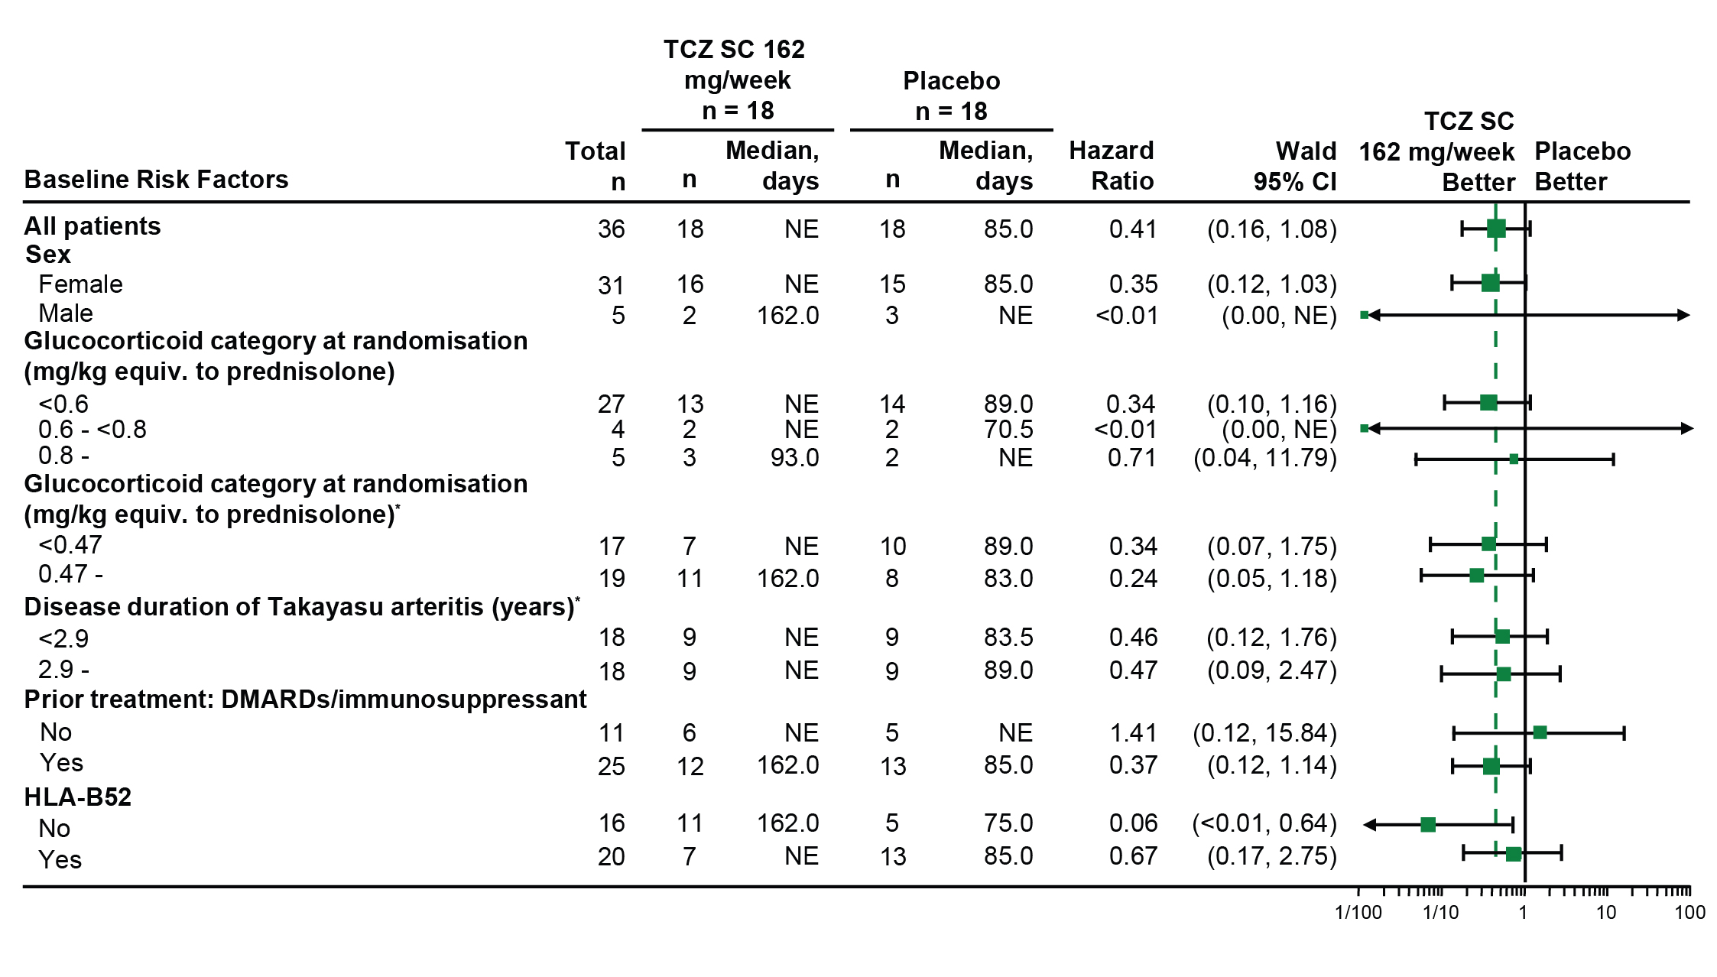

REFERENCES

1 Brunner J, Feldman BM, Tyrrell PN, et al. Takayasu arteritis in children and adolescents. Rheumatology 2010;49):1806-14.

2 Ozen S, Ruperto N, Dillon MJ, et al. EULAR/PReS endorsed consensus criteria for the classification of childhood vasculitides. Ann Rheum Dis 2006;65:936-41.

3 National Cholesterol Education Program, National Heart, Lung, and Blood Institute, National Institutes of Health. Third report of the National Cholesterol Education Program (NCEP) Expert panel on detection, evaluation, and treatment of high blood cholesterol in adults (Adult Treatment Panel III) final report. NIH Publication No. 02-5215; 2002. https://www.nhlbi.nih.gov/sites/www.nhlbi.nih.gov/files/Circulation-2002-ATP-III-Final-Report-PDF-3143.pdf. Accessed August 31, 2017.

